Chicken shish kebabs

Ingredients
Complexity: medium-high

1 large or 2 small garlic cloves

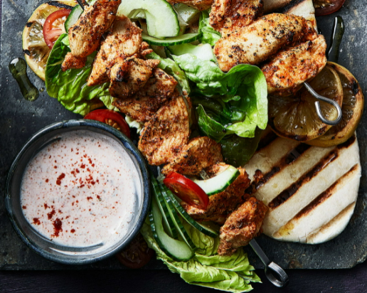
1 lemon

325g chicken breast

100g low fat natural yogurt

¼ x 5ml spoon ground cumin

1 x 5ml spoon smoked paprika

½ x 5ml spoon dried oregano

Black pepper

Optional for serving

2 wholemeal pitta breads

½ little gem lettuce

¼ cucumber

75g cherry tomatoes

Equipment

Chopping board, garlic press, lemon squeezer, vegetable knife, red chopping board, mixing bowl, measuring spoons, mixing spoon, zester or grater, baking tray, grill pan, tin foil, bread knife.

Method
- Prepare the ingredients:
- peel and crush the garlic clove;
- zest and juice the lemon.

Optional for serving:
- tear the lettuce into pieces;
- slice the cucumber;
- quarter the cherry tomatoes.
- Dice the chicken breast into equal size pieces. Thoroughly wash and dry your hands after touching the raw meat.
- Place half the yogurt in a bowl.
- Add the crushed garlic (retain a little for the sauce for serving), cumin, paprika, oregano to the yogurt and mix.
- Add half the zest and half the lemon juice. Season with black pepper and mix well.
- Add the chicken and stir until it is all coated with the yogurt mixture.
- Preheat a grill (medium). Line a baking tray with foil.
- Skewer the chicken onto 4 short metal skewers and place on the baking tray. Remember to wash and dry your hands again!
- Cook the chicken under the preheated grill for 10-15 minutes turning regularly.
- Mix the remaining yogurt, garlic and lemon zest with a little of the lemon juice. Sprinkle over a little paprika and oregano.

Optional for serving:
- Toast the pitta bread and cut down one long side.
- Stuff the pitta pockets with the lettuce, cucumber and tomatoes.
- Add the chicken to the pittas and drizzle over the yogurt sauce.
Top tips
- Use metal skewers help to conduct the heat more evenly. Bamboo skewers can be used but as they are naturally fibrous, they can split easily. Wooden skewers are not so good for very high heat like grilling; soaking them in water helps a little, but the ends are may still burn.
- To add to your 5 A Day and make the meat go further, alternate meat with vegetables such as chopped onions, peppers and mushrooms on the skewer.

Food skills
- Weigh
- Measure
- Peel
- Crush
- Dice
- Juice
- Zest
- Mix
- Grill

Did you know?
Shish kebab is an English version of the Turkish words şiş meaning sword or skewer and kebap, a roasted meat dish. There is historical and artistic evidence that the Greeks of the Byzantine era cooked shish kebabs.

Today, shish kebabs have expanded into most cultures in different forms. In several Asian countries, there is satay or sate, which is roasted skewered meat, served with a dipping sauce often made from peanuts.

Japan has yakitori which is grilled skewered fowl. In France, shish kebabs are called brochettes, meaning "skewers." Portuguese espetadas are beef shish kebabs marinated in wine and roasted on an open fire.

Lahm mishwy is the equivalent of shish kebab in Arabic. The meat is usually lamb, and it is cooked over a fire on a skewer holder, so the meat never touches the grill itself.

This recipe was adapted from a recipe for Chicken shish kebabs, which was kindly donated by Tesco plc.

