Session: Pancake Parlour

Welcome
This session is about cooking pancakes, both savoury and sweet. As with other sessions, students will revisit many skills and techniques, therefore making them more confident cooks. It also provides you with the opportunity to assess students' practical capability. You could use the practical observation sheet to help.
During this session, students will make either Sweet mini-pancakes or Savoury pancakes. These have been chosen as they improve essential batter making and shallow frying skills, act as a reminder for the safe use of the hob and can be cooked by students easily at home for breakfast, lunch or even dinner. If your students are intolerant to gluten, use gluten free flour.
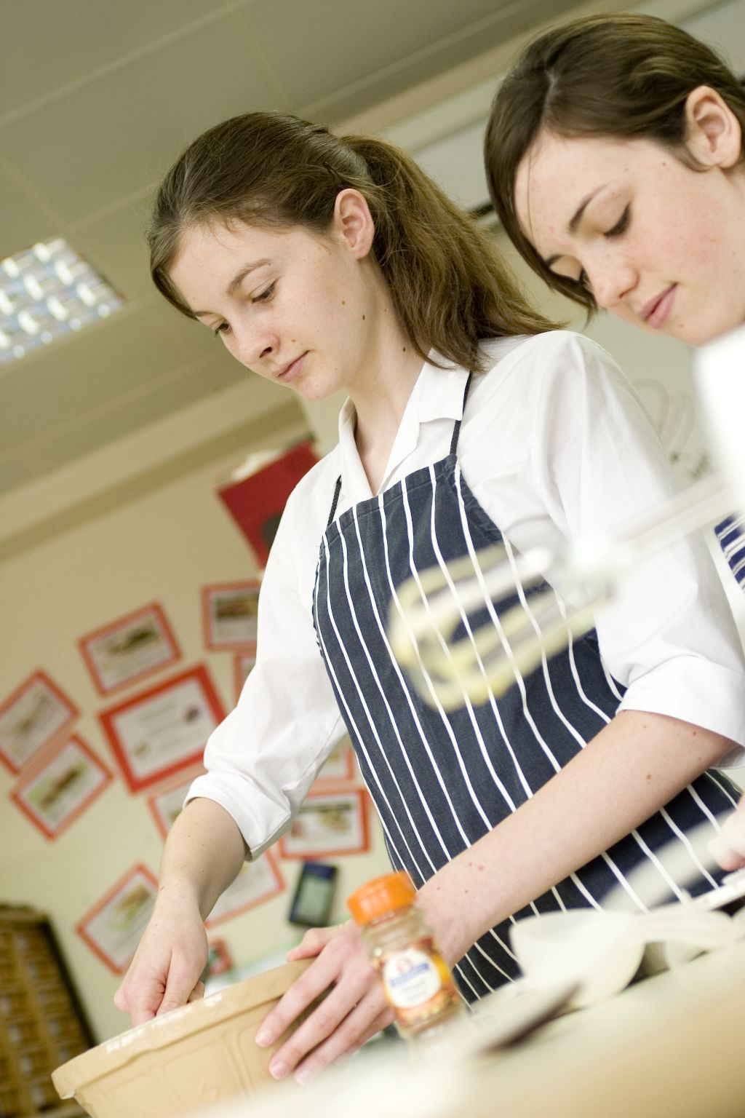
There is lots of room for students to be creative, selecting different types of ingredients that could be combined into the dishes. You could get your students to use the Sweet pancakes or Savoury pancakes recipe writing frames before cooking to develop their own ideas. The students’ own recipe creations could then be used in this session.
If you have an established lesson plan and/or recipe, which supports the aims and objectives of this session, feel free to use it instead. Look at the support materials provided within this session as they support this activity and may well be useful in your own lessons, e.g. worksheets, presentations.
This session can act as a stand-alone lesson, focusing on batter making and shallow frying skills. Alternatively, it could be integrated into a series of lessons, e.g. shallow frying, cultural differences in pancakes around the world and ingredients in pancake cooking.
Aims and objectives
Aim
For students to:
- become more confident in making a batter and shallow frying.
Objectives
Students should be able to:
- demonstrate skills in preparing a pancake batter;
- prepare a range of ingredients, e.g. grating cheese, chopping fruit;
- use the hob safely to shallow fry ingredients;
- make a pancake dish, e.g. Sweet mini- pancakes or Savoury pancakes.

Cooking session
Two cooking session plans, based on the Licence to Cook recipes are supplied within this session.

If you have your own tried and tested Sweet pancake or Savoury pancake recipe, feel free to use it instead. In addition, you may wish to make other types of dishes, such as baked pancake or crepes.
Each plan refers to aspects of healthy eating, wise food shopping and food safety and hygiene which are theme which run through each session.
Before the cooking session
There are a number of factors that you need to consider before the cooking session. More detailed guidance is available in the Cooking session guide.

You will need to consider:
- Ingredients: who will be providing the ingredients and where will they be stored? The recipes call for a little oil for shallow frying. It may be easier for the school to provide the oil for students to share.
- Recipe: are students going to use a printed-out copy or follow instructions on an interactive whiteboard?
- Equipment: is all the equipment needed for the session available, clean and in good working order? Check that all the hobs are in good working order and clean. Students will require the use of a frying pan - check that there are enough. You may ask students to share a frying pan. It might be easier for each student to use a fish slice to turn the pancakes, as they will have more control.
- Aprons: do you have enough and are they clean?
- Hair: do you have ties/bands for long hair?
- Containers: will students be able to take away the dishes they make? If so, in what?
- Waste: do you have adequate disposal facilities, including recycling or composting?
- Cooking area: is it clean and ready to use?

Differentiation and inclusion
Before this practical session, you will need to consider the age, ability, previous experience and any special requirements of your students. This will determine recipe selection, any advanced ingredient preparation and equipment used.
Do any of your students need:
- pre-prepared ingredients, such as grated cheese?
- to use packet pancake batter due to time limitations?
- support using the frying pan to shallow fry?
- to follow different recipes? The Sweet pancake recipe is slightly easier than the Savoury pancake recipe, and good for making in pairs.
- to be challenged, perhaps allowing them to prepare and cook a range of sauces for the sweet pancakes?
- gluten free alternatives?

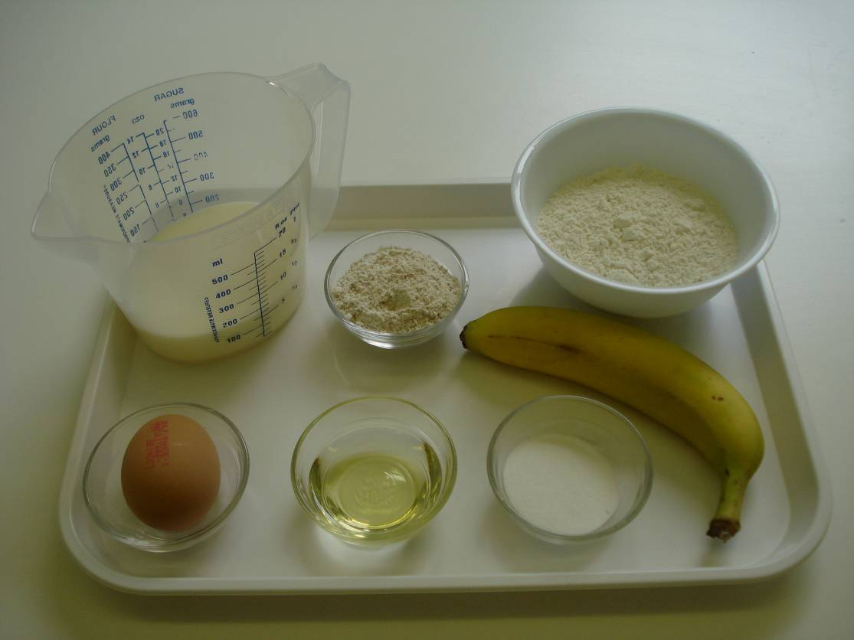
Demonstration
During the session you will be demonstrating how to use a frying pan safely. Show students how to prepare a fold and serve pancakes in a variety of ways. You may also need to remind students on safety issues concerning the hob. Comment on the importance of mixing the batter well to remove all lumps.

Ensure that you have all the ingredients and equipment you need before the session, perhaps on trays for ease, for your demonstration.
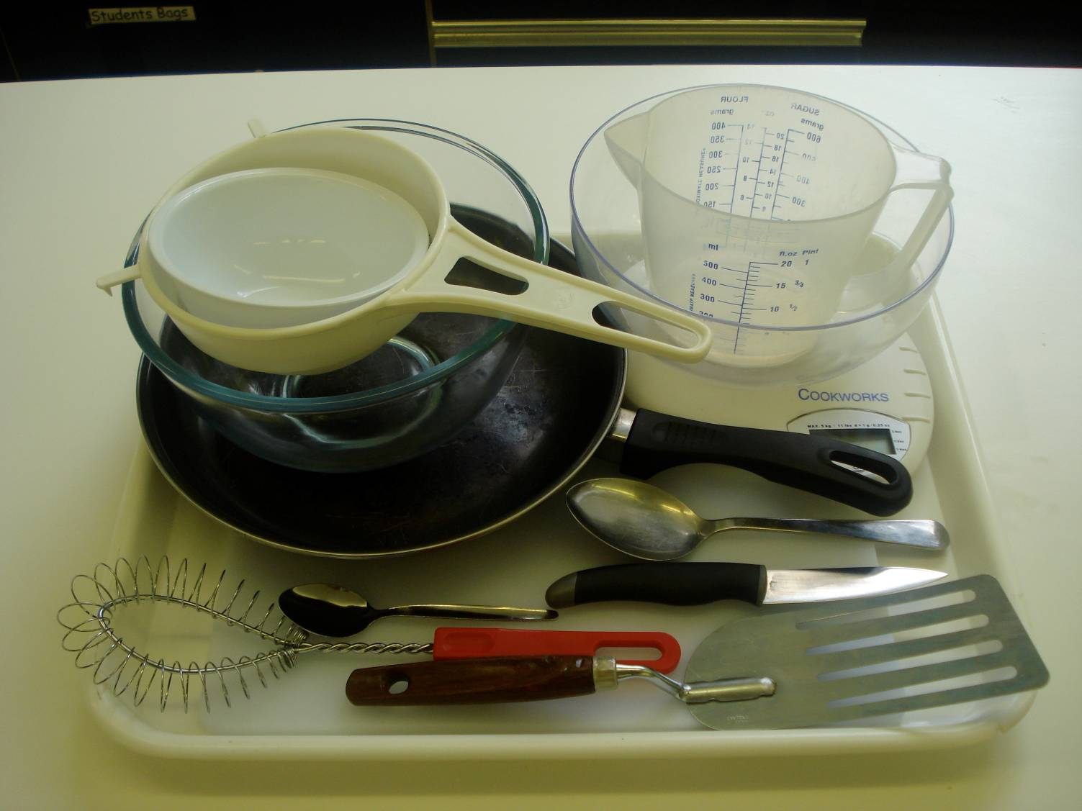
Think about:
- describing the ingredients and equipment used;
- the consistency of the batter to make thin pancakes;
- showing how to use a frying pan;
- demonstrating turning or tossing a pancake;
- ensuring that students have followed and understood the method.

More detailed guidance is available in the Demonstrating guide.

Risk assessment

The two cooking session plans and recipes highlight a number of different hygiene and safety issues which need to be considered before, during and after the cooking session.
Before the cooking session, you will need to assess these risks in relation to the number of students being taught, as well as their experience, and consider measures that can be put into place to manage the risk. Below are examples of potential risks, along with preventative measures.

Sweet mini-pancakes
Potential risk | Measure | Likelihood
Salmonella from raw egg | Remind students to wash their hands after touching raw egg and to not eat the raw pancake mixture | Low/Med
Contamination from egg shell in mixture | Crack egg into a separate bowl to check for shell, then add to main bowl | Low/Med
Burn from using the hob and/or hot frying pan | Demonstrate safe use of the hob and monitor students’ use | Low/Med
Frying pan knocked off hob | Ensure that frying pan handles are turned away from the edge | Low/Med

Savoury pancakes
Potential risk | Measure | Likelihood
Burn from using the hob and/or hot saucepan | Demonstrate safe use of the hob and monitor students’ use | Low/Med
Raw meat and vegetables prepared on same chopping board, leading to cross contamination | Use different chopping boards and knives for raw meat other vegetables | Med
Bacteria from meat are transferred to handles and other work surfaces | Ensure that students wash hands periodically throughout the cooking session, especially after handling raw meat | Med
Salmonella from raw egg | Remind students to wash their hands after touching raw egg and not to eat the raw pancake mixture | Low/Med
Time
The session plans are based on a 60 minute session.
If you have less time available, you will need to modify the session plan to better suit your circumstances. For example, within this session you might:
- demonstrate the safe use of the hob and frying pan another time;
- demonstrate key aspects from the recipe, rather than every stage;
- have ingredients pre-measured;
- use canned fruit, that is already chopped or dried fruit;
- use pre-prepared ingredients, packet pancake mixtures;
- allow students to work with a partner – sharing a frying pan.
During the lesson
Time (mins) | Activity: Sweet mini-pancakes | Equipment/ Resources
0 | Registration.  Explain to the students that they will be making Sweet mini-pancakes. Go through the aims and objectives for the lesson. | PowerPoint Sweet mini pancakes  Recipe
5  10 | Gather the students around a demonstration area, with your tray of ingredients and equipment. Ensure that all students have their apron on, hair tied back and hands washed.  Briefly talk through the recipe – note your expectations, for example:  * preparing the ingredients carefully and accurately;  * preparing a batter;  * using a frying-pan to shallow fry;  * using the hob safely;  * being hygienic and safe when preparing food. | Aprons  Demonstration ingredient and equipment tray  Fire blanket
Demonstration
* Place out the chopping board, vegetable knife, mixing bowl, sieve, whisk, and fish slice.
* Explain that you will be showing how to shallow fry safely.
* Prepare the fruit using a knife, chopping board and the Bridge hold and Claw grip. Stress the importance of using the Bridge hold and Claw grip technique. Fruit scraps must be put away either in the compost or the bin to prevent them from falling on the floor and causing someone to slip. Wash your hands.
* Show students how to prepare the batter by sieving the flour into a bowl and adding the sugar. Whisk the egg and milk into the flour and then gently stir in the fruit. Stir the fruit gently so the fruit structure is not destroyed. Remind students about washing their hands before and after touching raw eggs.
* Explain how to use a frying pan – it is a quick method of cooking. Place the pan on the hob and turn on the heat (you may need to remind students about using different types of hobs and temperature control). Add a little oil and allow to heat for 20 seconds. It is important for students not to over heat the oil as it will start to burn and produce flames. Carefully pour in 2 x 15ml spoons of mixture for each pancake. This can be done with a spoon, ladle or transferring the mixture into a jug (to reduce messy drips). Keep the frying pan handle away from the front of the hob.
* Cook the pancake until the top shows bubbles and has a dull gloss. Carefully turn the pancake over and cook for a further minute. This side will need less time than the first side.
 | Ensure that all students wash their hands. Allow them to start making their Sweet mini-pancakes.
20 | During this time, circulate the room to ensure that students are preparing ingredients and using the hob and wok safely. In this time, students should:  * prepare their ingredients;  * wash and slice the fruit;  * sieve flour and add sugar;  * use a frying pan to shallow fry the pancakes – heat the oil and cook the batter. | Basic equipment  Ingredients
40 | All the batter should be used. During the remaining time students should be washing up, cleaning work surfaces and putting away equipment.
50 | Give a 5 minute time warning. Remind students that all washing-up should be completed, work surfaces should be clean, and their Sweet pancakes should be placed in a container. Circulate the room, ensuring that sinks are clean, and equipment is put away properly.
55 | Plenary  Pose the following questions to the students:  * What were the main skills demonstrated today?  * Name 5 skills that you used.  * When would you serve sweet pancakes?
60 | Finish

After the session
Check that the room is clean and tidy. Students should leave the room as they find it.

The Sweet mini-pancakes may need to be refrigerated until the end of the school day, if so, ensure that each container is loosely covered and clearly labelled with the student’s name and group. The refrigerator should be between 0-5ºC.

If time, you may wish for the students to eat the pancakes as part of the lesson.

If the same students are with you for another cooking session in the next few days or week, remind them of the ingredients and/or containers they need to bring, if appropriate. You may wish to provide students with recipes or writing frames.
During the lesson
Time (mins) | Activity: Savoury pancakes | Equipment/ Resources
0 | Registration.  Explain to the students that they will be making Savoury pancakes. Go through the aims and objectives for the lesson. | PowerPoint Savoury pancakes  Recipe
5  10 | Gather the students around a demonstration area, with your tray of ingredients and equipment. Ensure that all students have their apron on, hair tied back and hands washed.  Briefly talk through the recipe – note your expectations, for example:  * preparing the ingredients carefully and accurately;  * making a batter;  * using a frying pan to shallow-fry;  * using the hob safely;  * being hygienic and safe when preparing food. | Aprons  Demonstration ingredient and equipment tray
 | Demonstration  * Place out the mixing bowl, sieve, whisk, and fish slice.  * Explain that you will be showing how to shallow fry safely.  * Show students how to prepare the batter by sieving the flour into a bowl. Whisk the egg and milk into the flour. Remind students about washing their hands before and after touching raw eggs.  * Explain how to use a frying pan – it is a quick method of cooking. Place the pan on the hob and turn on the heat (you may need to remind students about using different types of hobs and temperature control). Add the oil and allow to heat for 20 seconds. It is important for students not to over heat the oil as it will start to burn and, produce flames. Carefully pour in 2 x 15ml spoons of mixture for each pancake. This can be done by a spoon, a ladle or even transferring the mixture to a jug to reduce messy drips. Keep the frying pan handle away from the front of the hob.  * Cook the pancake until the top shows bubbles and has a dull gloss to the top. Carefully turn the pancake over and cook for a further minute. This side will need less time than the first side. | Aprons  Demonstration ingredient and equipment tray
 | Ensure that students all wash their hands. Allow them to start making their Savoury pancakes.
15 | During this time, circulate the room to ensure that students are preparing ingredients and using the hob safely. In this time, students should:  * prepare their ingredients;  * sieve flour;  * mix flour with egg, milk thoroughly;  * use a frying pan to shallow fry the pancakes – heat the oil and cook the pancakes. | Basic equipment  Wok or saucepan  Ingredients
25 | Demonstration  * Place out grater and chopping board.  * If time, demonstrate how to grate safely.  * Show the students how to roll up the pancake with the ham, drained pineapple pieces and grated cheese.  During this time, circulate the room to ensure that students are preparing ingredients and using the hob safely. In this time, students should:  * prepare their ingredients;  * roll the pancakes with fillings.  Students should be assembling their Savoury pancakes and then washing up, cleaning work surfaces and putting away equipment.
50 | Give a 5 minute time warning.  Remind students that all washing up should be completed, work surfaces should be clean, and their Savoury pancakes should be placed in a container.  Circulate the room, ensuring that sinks are clean, and equipment is put away properly.
55 | Plenary  Pose the following questions to the students:  * What were the main skills demonstrated today?  * Name 5 different coloured vegetables that could be added or served with your pancakes.  * What other types of meat, fish or alternatives would work well in savoury sauce?
60 | Finish

After the session
Check that the room is clean and tidy. Students should leave the room as they find it.

The Savoury pancakes may need to be refrigerated until the end of the school day, if so, ensure that each container is loosely covered and clearly labelled with the student’s name and group. The refrigerator should be between 0-5ºC.

If the same students are with you for another cooking session in the next few days or week, remind them of the ingredients and/or containers they need to bring, if appropriate. You may wish to provide students with recipes or writing frames.
Areas of learning
Healthy eating
- Try to reduce the oil further - use 1 x 5ml spoon or a spray and a non-stick frying pan.
- Go for skimmed or semi skimmed fat milk.
- Serve the savoury pancakes with plenty of salad, plus either rice or noodles, preferably brown or wholemeal.

Wise food shopping
- Home-made batters are less expensive than shop ready-made batters.
- Use seasonal fruits or vegetables in the pancakes.

Food safety and hygiene
- When getting ready to cook, always wear an apron, tie back long hair, roll up long sleeves, remove any jewellery and wash your hands.
- Use a clean chopping board and knife after preparing raw meat to avoid cross contamination.
- Handle raw meat carefully. Wash your hands and surfaces after handling.
- Keep eggs in the refrigerator until needed and always check the date mark on the shell.

Extending this activity
This session provides a great opportunity to be integrated into existing lessons or be developed into a mini-scheme of work.
For example, students could:
- explore different types of pancakes in different cultures across the world;
- plan and create a range of pancake based dishes that could be cooked by hungry teenagers for dinner with their mates;
- evaluate different types of side dishes and sauces that can be served with pancakes, testing these for ease of making and student appeal.

Appropriate aspects of ICT could also be integrated, including:
- recording sensory data;
- creating a recipe plan or flow-chart;
- modelling recipe costs, looking at the use of more pre-prepared ingredients versus prepared from scratch.

Shopping list
Sweet pancakes
Ingredient | x 1 | x 10 | x 20
Self raising flour | 100g | 1g | 2kg
Wholemeal self raising flour | 25g | 250g | 500g
Sugar | 1x 15ml spoon | 10 x 15ml spoon | 20 x 15ml spoon
Semi skimmed milk | 180ml | 1.8L | 3.6L
Egg (medium) | 1 | 10 | 20
Banana | 100g | 1kg | 2kg
Oil | Extra | Extra | Extra

Savoury pancakes
Ingredient | x 1 | x 10 | x 20
White plain flour | 100g | 1kg | 2kg
Wholemeal plain flour | 25g | 25g | 25g
Eggs (medium) | 2 | 20 | 40
Paprika powder | ½ x 5ml spoon | 5 x 5ml spoon | 10 x 5ml spoon
Oil for frying | 30ml | 300ml | 600ml
Milk | 275ml | 3.25L | 6.5L
Sliced ham | 8 slices | 80 slices | 160 slices
Canned pineapple pieces in natural juice | 60g | 600g | 1.2kg
Cheddar cheese | 60g | 600g | 1.2g

Equipment list

Sweet pancakes

Chopping board, knife, sieve, whisk, bowl, measuring jug non-stick frying pan, fish slice, metal spoon.

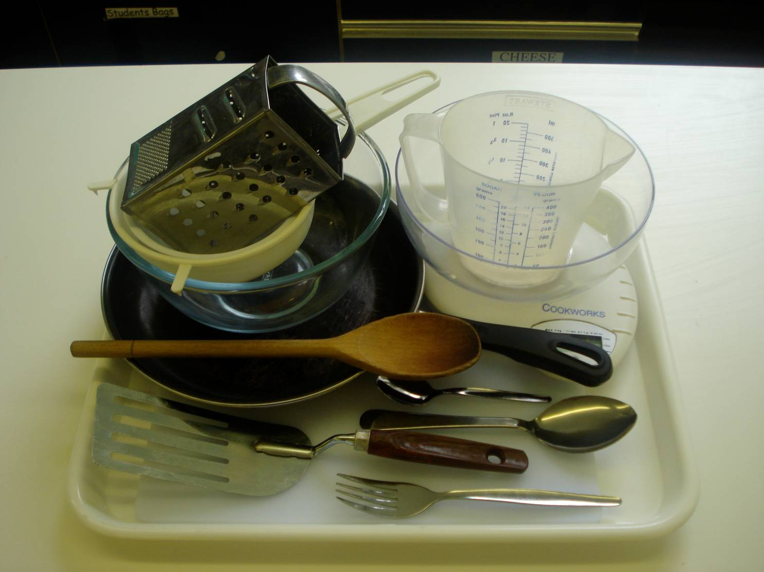
Savoury pancakes

Weighing scales, measuring jug, palette knife, mixing bowl, fish slice, large metal spoon, knife, chopping boards, frying pan and serving plate.

Containers

If students take their dishes, they will need to bring (or be provided with by the school) a suitable container, such as a foil container with a lid.

