UK food labels
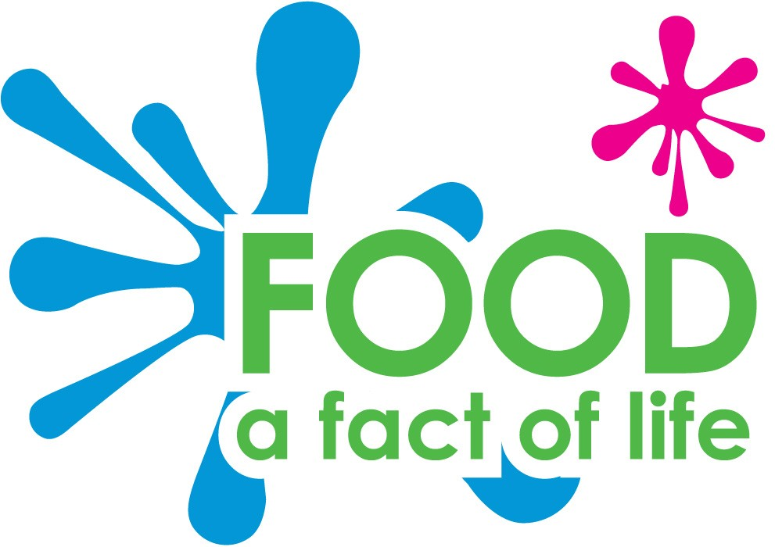
Blackberries
Argyll
Scotland
Shortbread
West Lothian
Scotland

Soda bread
County Down
Northern Ireland
Potato
County Antrim
Northern Ireland

Leek
Flintshire
Wales
Lamb chops
Monmouthshire
Wales

Cheddar cheese
Somerset
England
Plum
Worcestershire
England

Cornish pasty
Cornwall
England
Beef
Yorkshire
England

Pork
Norfolk
England
Apple
Kent
England
Cauliflower
Penzance
England
Chicken
Somerset
England
Salmon
Aberdeenshire
Scotland
Oysters
Kent
England

