Testing food for vitamin C

(ascorbic acid)

Introduction
A blue substance called 2, 6-dichlorophenolindophenol (or DCPIP for short) acts as an indicator. It changes from blue to red with acids but loses its colour in the presence of certain chemicals, one of which is ascorbic acid (vitamin C).

DCPIP solution can be used to test for the presence of vitamin C in food (but not for other vitamins which are entirely different kinds of chemical).

You will need
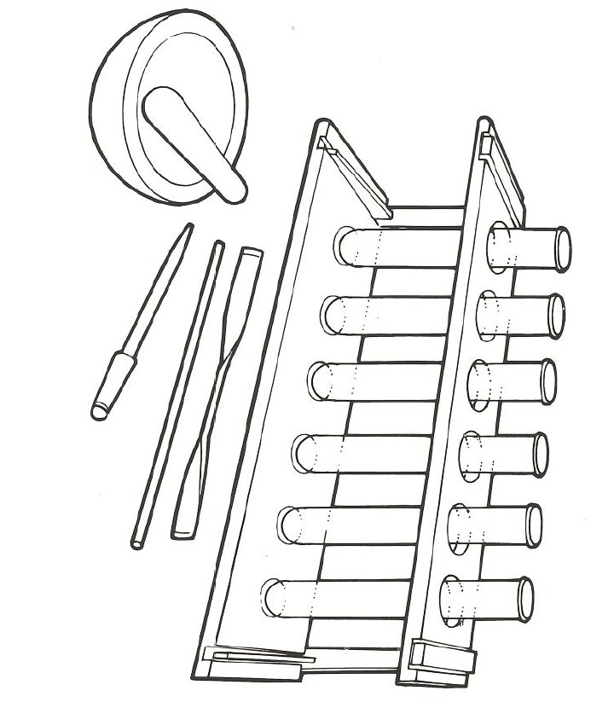
Equipment
Test tubes
Test tube rack
Glass rod
Spatula
Mechanical grinder or pestle and mortar
Dropping pipette

Materials
Food samples including citrus and other fruit
Distilled water
2,6 dichlorophenolindophenol (DCPIP) solution




Some people are allergic or intolerant to a particular food or ingredient. Refer to the 14 allergens and check against student records before completing this experiment.

In case of spillage of DCPIP, consult regulations.
Do not consume food in a laboratory, or any food used for experiments, because it may contaminated.

Method
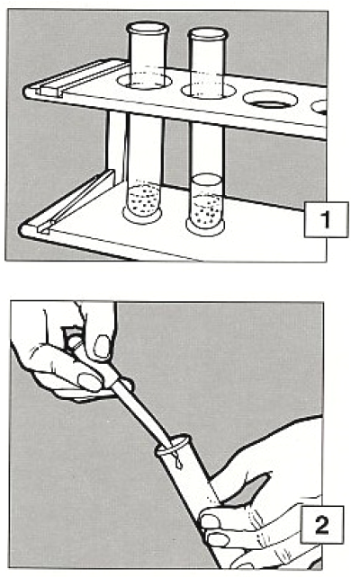
- If the food to be tested is liquid, go to 2. If the food to be tested is solid, make an extract. Grind, crush or chop a small amount and put it into a test tube to a depth of about 2cm. Add a similar amount of distilled water and stir with a glass rod. Allow to stand for a few minutes.

- Draw up some of the clear liquid into a pipette and then add it, one drop at a time, to a test tube containing a light blue solution of DCPIP. If the extract is acid the colour will change from blue to red. Continue to add more and see if the colour disappears altogether.

- Decolourisation of DCPIP shows that a vitamin C is probably present.

Other chemicals can do this in food and drink, but vitamin C is the main one.

Extension work
The method can be adapted to make a rough comparison between the amounts of vitamin C in two (or more) different foods.
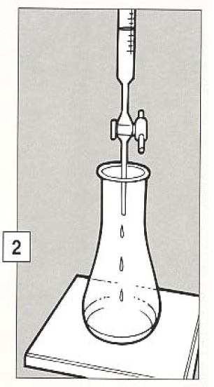
- Begin with exactly the same quantities of two food samples. If it is necessary to add water, then add exactly the same amount to each extract.

- Draw the liquid from the first extract into a burette and run it, drop by drop, into a measured amount of standard * DCPIP solution until the colour just disappears. Note the amount of DCPIP used.

- Do the same with the second extract using the same amount of DCPIP solution.

Comparison of the amounts of extract used will give some indication of the relative quantities of vitamin C in the food samples. If less extract is used, the sample contains more vitamin C.

* Standard solution: one solution is prepared in advance and identical portions are used for each test.

