Chelsea buns

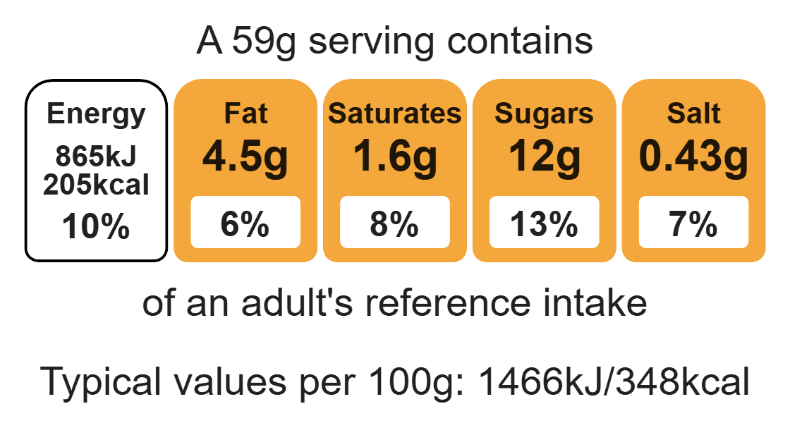
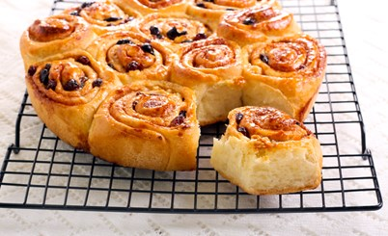

Ingredients (makes 8-10)
Complexity: medium

250g strong white flour

1 x 2.5ml spoon salt

Equipment

Weighing scales

Round or square baking tin

Mixing bowl

Sieve

Measuring jug

Mixing spoon

Rolling pin

Flour dredger (optional)

Small saucepan

Pastry brush

Cooling rack

40g baking fat/block

125ml semi-skimmed milk

7g pack of fast action dried yeast

75g currants

25g mixed peel

25g Demerara sugar

1 x 5ml spoon mixed spices or cinnamon

Method
- Preheat the oven to 220ºC or gas mark 7.
- Grease or line a deep-sided roasting tin or Swiss roll tin.
- Sift the flour and salt into a mixing bowl.
- Rub in 15g of the baking fat/block using your fingertips.
- Add the yeast.
- Warm the milk until lukewarm.
- Gradually add the warm milk into the flour mixture.
- Mix to form a soft dough.
- Knead the dough for 10 minutes until smooth and elastic.
- Roll out into a square (25cm x 25cm) on a floured surface.
- Melt the remaining hard baking fat in a small saucepan, then brush over the dough.
- Sprinkle the currants, mixed peel, spices and sugar over the dough.
- Roll up the dough like a Swiss roll.
- Cut into 8 slices.
- Arrange slices in baking tin, cover and leave to rise (until they double in size).
- Bake for 20 minutes, until golden brown.

Top tips
- Reduce food waste: Use up any leftover fruit such as, apples and add to the dried fruit mix.
- Turn up the flavour: Zest and juice an orange. Add the juice to the dough instead of some milk and add the zest to the dried fruit mix.
- Focus on fibre: Replace half the flour with strong wholemeal flour to boost the fibre content of the chelsea buns.

Food skills
Weigh, measure, sift, rub-in, mix, stir and combine, knead, melt, simmer and boil, glaze and coat, cut, chop, slide, dice and trim, prove, bake.

