Chicken fajitas

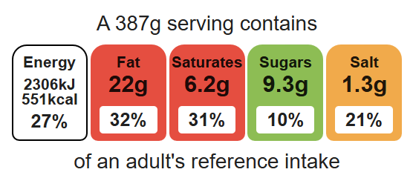
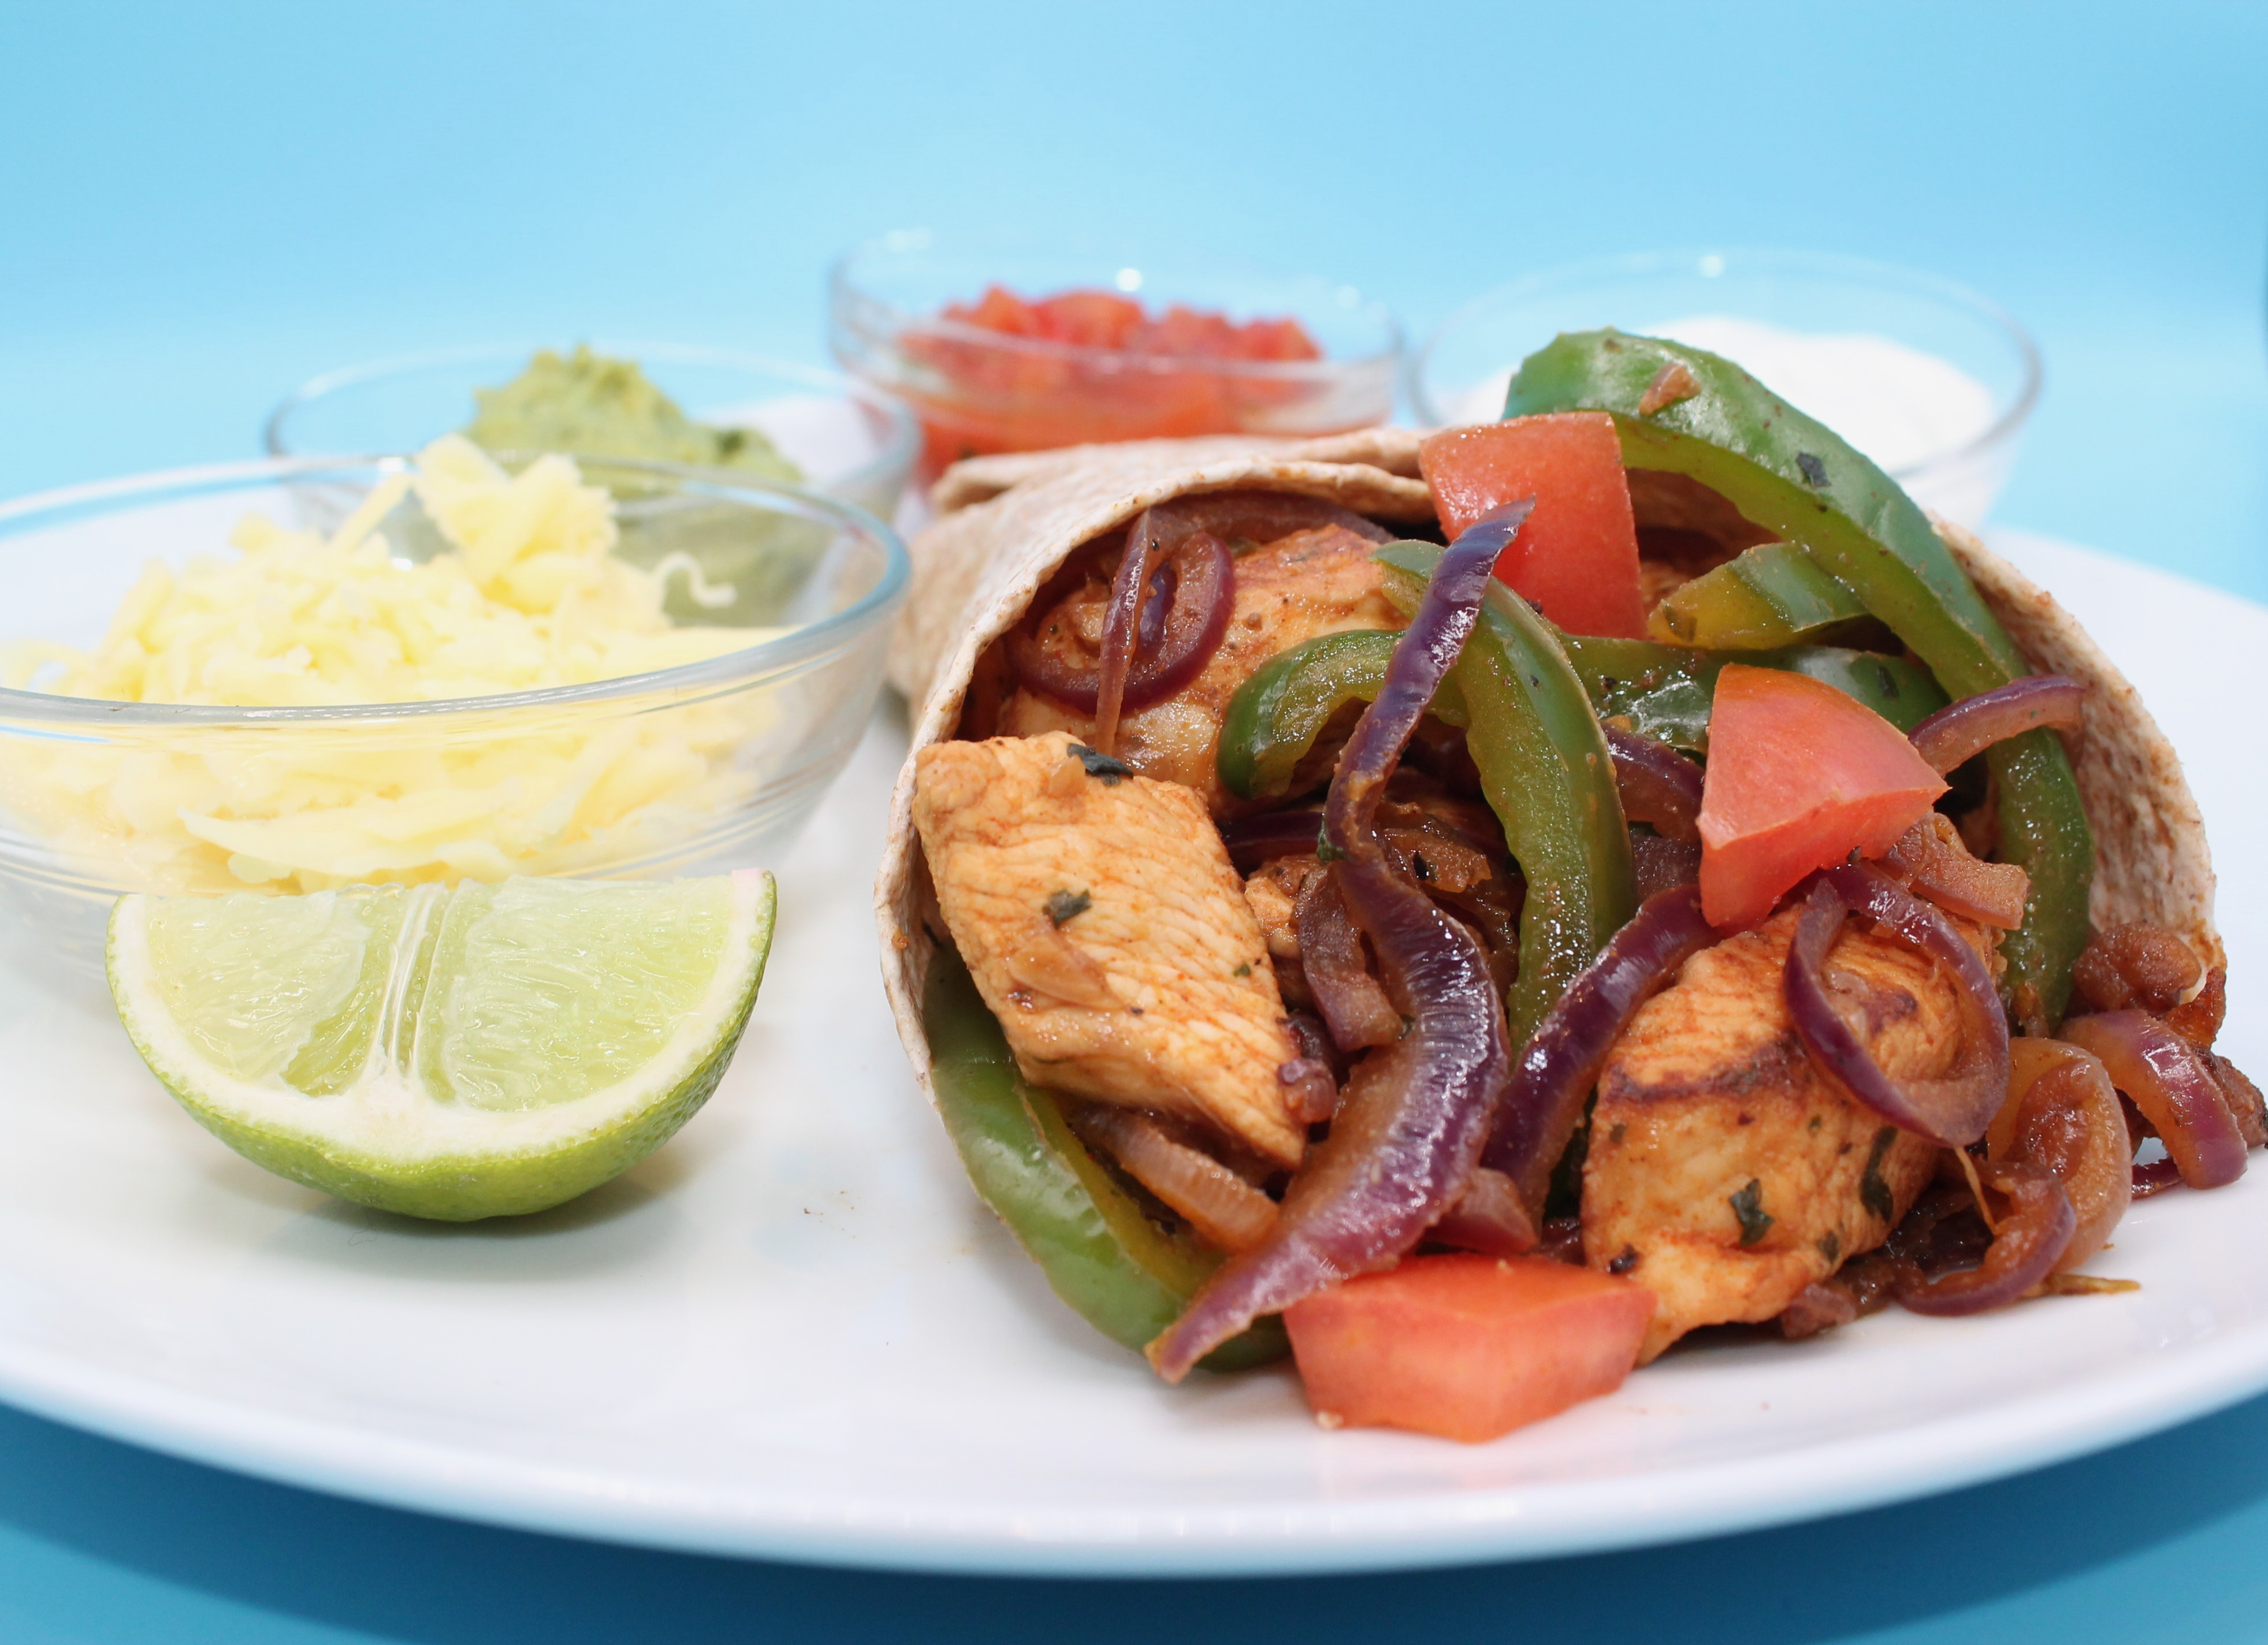
Complexity: medium- high

Ingredients (serves 1)

Equipment

Weighing scales

Chopping boards

Sharp knives

Juicer

Garlic press

Mixing bowl

Grater

Wok or frying pan

Heat resistant spoon

Measuring spoons

2 metal spoons

½ lime
½ chilli
1 clove garlic
1 x 15ml spoon coriander
1 x 15ml spoon oil or spray oil
1 x 5ml spoon smoked paprika
1 small chicken breast (or 3-4 thighs)
½ onion
½ pepper
1 tomato
25g reduced-fat cheddar cheese
1 wholemeal tortilla wrap
Top tips
- Vary your protein: Try thin slices of beef, pork, lamb fish or minced meat
- Serving suggestion: Add optional toppings of guacamole, salsa and natural yoghurt.
- For a vegetarian alternative: Omit the meat and add extra vegetables, beans, pulses or halloumi.
- Warm the tortillas in the oven or in the frying pan for 20 seconds to make them easier to fold.

Method
- Prepare the marinade ingredients and place in a bowl:
- juice the lime;
- peel and crush the garlic;
- de-seed and slice the chilli;
- chop the coriander.
- Add the paprika and oil. Stir everything together.
- On a red chopping board, remove any gristle from the chicken and cut into strips. Thoroughly wash and dry hands after touching the raw meat. Mix with the marinade, cover and place in the fridge until needed.
- Prepare the remaining ingredients with a clean knife on a clean chopping board:
- peel and slice the onion;
- de-seed and slice pepper;
- chop the tomato;
- grate the cheese.
- Add the marinated chicken to a hot wok or frying pan and stir-fry for about 4 minutes. Check that the chicken is cooked throughout, and no pink remains.
- Add the onion and pepper and continue to cook for a further 2 minutes until softened.
- Spread a little of the fajita mix in the centre of the tortilla, add some tomato, cheese and any optional ingredients such as guacamole, salsa or natural yogurt and then roll up.

Food skills

Weigh, measure, juice, cut, chop, slice, dice and trim, crush, mix, stir and combine, grate, portion/ divide, stir- fry.

