Caribbean-style jerk chicken traybake

Ingredients
Complexity: medium

1 sweet potato (approx. 300g)
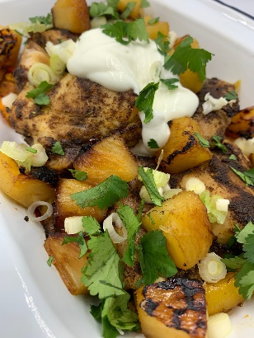
1 pepper
1 x small can pineapple chunks in juice
1 lime
4 chicken thigh fillets
2 x 5ml spoons jerk seasoning
Spray oil

Optional - garnish
2 spring onions
25g coriander
50g low fat Greek-style yogurt

Equipment

Chopping board, vegetable knife, juicer, sieve, red chopping board, large roasting tray, measuring spoons, small frying pan, mixing spoon.

Method
- Pre-heat the oven to 200°C or gas mark 5.
- Prepare the ingredients:
  - peel and slice the sweet potato into wedges;
  - deseed and slice the pepper;
  - juice the lime;
  - drain the pineapple chunks;
  - remove any fat from the chicken thighs, thoroughly washing and drying hands after touching the raw meat;
  - remove the end of the spring onions and slice into rings;
  - roughly chop the coriander, if using.
- Place the sweet potatoes and peppers into a large roasting tray, then lay the chicken thighs on top.
- Pour over half the lime juice.
- Spray the vegetables and chicken with oil and sprinkle over the jerk seasoning.
- Bake for around 30-35 minutes, until the chicken is cooked and the vegetables are soft.
- Pour over the remaining lime juice.
- When there are around 5 minutes of the cooking time remaining, spray a small frying pan with oil, add the pineapple and cook for a few minutes on each side until charred.
- Serve with a scattering of spring onions, the chargrilled pineapple and a spoonful of yogurt. Garnish with chopped coriander.

Top tips
- Sweet potatoes are in season from October to March. When selecting sweet potatoes, they should be firm, with smooth, unblemished skin and no holes or nicks. Sweet potatoes perish more quickly than potatoes and are best kept in a cool, dark, dry place for no more than a week. Avoid placing them in the fridge as the cold affects the flavour.
- Try using fresh mango slices or sautéed plantains as an alternative to the pineapple chunks.

Food skills
- Weigh
- Measure
- Peel
- Cut
- Slice
- Chop
- Juice
- Bake
- Fry

Did you know?
The sweet potato is widely cultivated in tropical and warm temperate climates and is an important food crop in the southern United States, tropical America and the Caribbean, the warmer islands of the Pacific, Japan, and parts of Russia.

Sweet potatoes are tubers with bright orange flesh (other varieties are cream and even purple), a creamy texture and a sweet-spicy flavour. They are sometimes referred to as ‘yams’ in the USA but sweet potatoes are unrelated to true yams.

The Spanish, who introduced the sweet potato to Europe in the late 1490s, called it "patata" (or potato in English). It was a combination of the indigenous Taíno word "batata" and the Quecha word "papa." It wasn't until the 1740s that the "sweet" part was added by American colonists to distinguish it from the popular Irish potato.

This recipe was adapted from a recipe for Caribbean-style jerk chicken traybake, kindly donated by Marks and Spencer.

