Eatwell Guide food list
Food group | Food included in this group
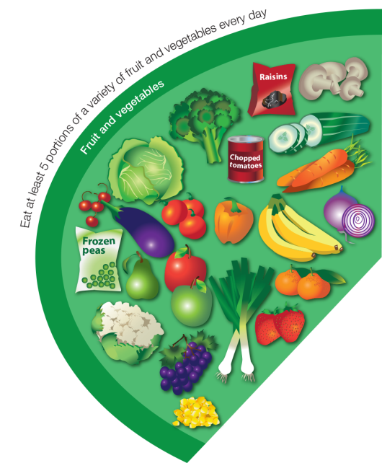  Fruit and vegetables | Apple, Baked beans, Banana, Broccoli, Cabbage, Carrots, Cauliflower, Cucumber, Fruit juice, Fruit smoothie, Kiwi, Lettuce, Melon, Oranges, Pears, Peas, Pineapple, Plums, Raisins, Strawberries, Sweetcorn  Fresh, frozen, dried, canned and juiced all count.
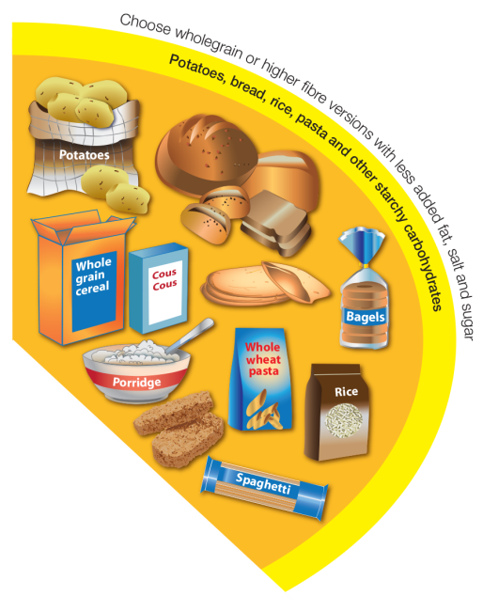  Potatoes, bread, rice, pasta and other starchy carbohydrates | Bread: soda bread, rye bread, pitta, flour tortilla, baguettes, chapatti, bagels  Rice, potatoes, breakfast cereal, oats, pasta, noodles, maize, cornmeal, couscous, bulgar, polenta, millet, spelt, wheat, pearl barley, yams, plantains.
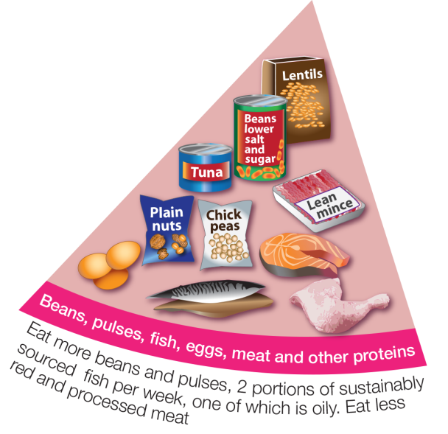  Beans, pulses, fish, eggs, meat and other proteins | Meat, poultry and game including: lamb, beef, pork, chicken, bacon, sausages, burgers  White fish (fresh frozen or canned) including: haddock, plaice, pollock, coley, cod, canned tuna  Oily fish (fresh frozen or canned) including: prawns, mussels, crab, squid oysters  Nuts, eggs, beans and other pulses including: lentils, chickpeas, baked beans, kidney beans, butter beans  Vegetarian meat alternatives e.g. tofu, mycoprotein.
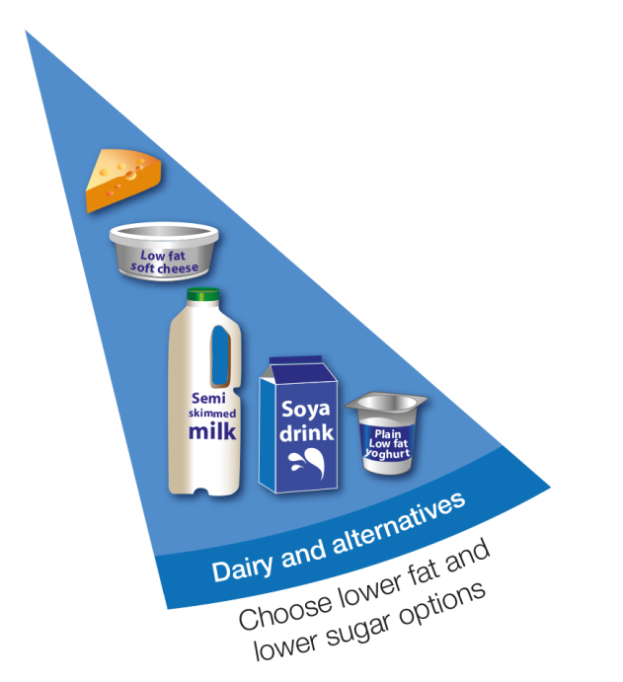  Dairy and alternatives | Milk, cheese, yogurt, fromage frais, quark, cream cheese.  This includes non-diary alternatives to these foods, e.g. soya milk, oat milk.
  Oils and spreads | Vegetable oil, rapeseed oil, olive oil, sunflower oil.  Soft spreads made from unsaturated oils.

