Setting the table

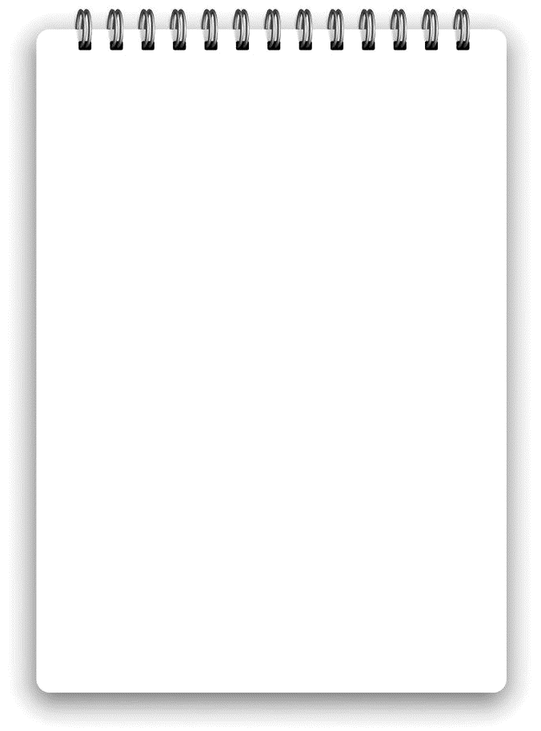
Don’t forget…
- Knives
- Forks
- Spoons
- Plates
- A glass
- Food in the middle of the table
- A napkin

