Cottage pie

Complexity: medium-high
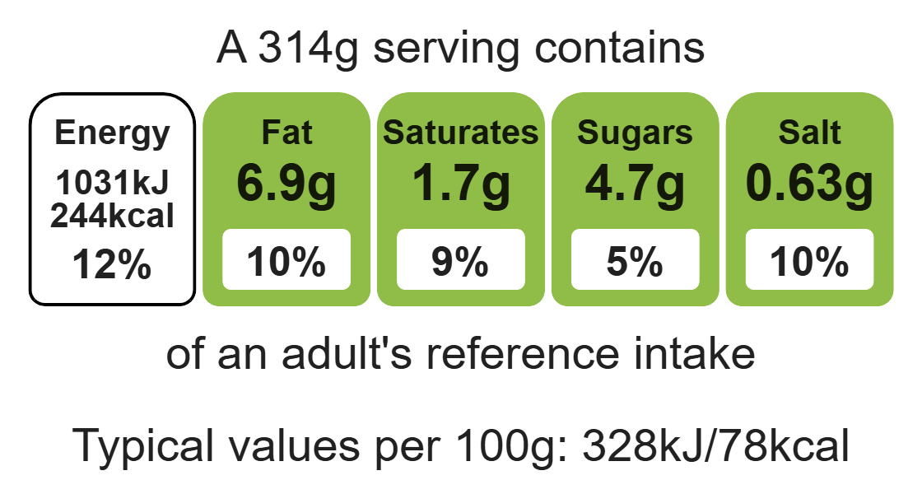

Ingredients (serves 3)
1 onion
1 garlic clove
1 carrot
1 celery stick
1 x 15ml spoon olive oil

Equipment

Chopping board

Vegetable peeler

Sharp knife

Two saucepans with lids

Heat-resistant spoon

Potato masher

Colander

Spoon

Grater

Ovenproof dish

200g lean minced beef
1 x 15ml spoon tomato purée
½ reduced-salt beef stock cube
300ml water
1 x 5ml spoon Worcestershire sauce
1 x 5ml spoon reduced-salt light soy sauce
3-4 potatoes
20g reduced-fat cheddar

Method
- Prepare the vegetables:
- peel and finely chop the onion and the garlic;
- peel and slice the carrot;
- slice the celery;
- Heat the oil in a large pan and add the chopped onion, carrot, celery and garlic and stir for 4 minutes or so, until the onion starts to brown.
- Add the beef mince and cook over a medium heat until the mince has browned.
- Drain off any excess fat before adding the tomato purée and stock. Add the Worcestershire sauce and reduced-salt soy sauce.
- Cover and simmer for 25 minutes, adding more stock if the mince starts to stick to the pan.
- While the mince is simmering, put a saucepan of water onto boil.
- Peel and cube the potatoes and boil in the water for about ten minutes until they are soft. Drain over the sink.
- Mash the potato using either a fork or a potato masher. You may wish to add a small amount of semi-skimmed milk or low-fat spread when mashing the potatoes.
- Pre-heat the grill to a medium heat.
- Spoon the mince into an ovenproof dish and top with the mash. Grate the reduced-fat cheese on top.
- Grill until the potato and cheese on top starts to brown and turn crisp.

Top tips
- Serving suggestion: Serve your cottage pie with broccoli, green beans.
- Reduce food waste: Use up any leftover vegetables in your cottage pie e.g. leeks.
- Turn up the flavour: Experiment with toppings, use other vegetables to make the mash e.g. parsnips, sweet potatoes, carrots.
- Transform your leftovers: Use your leftover mince to create a new dish like spaghetti bolognese or chilli con carne.
- For a vegetarian alternative: Swap the minced beef for lentils or beans.

Food skills
Measure, cut, chop, slice, dice and trim, fry and saute, peel, mix, stir and combine, melt, simmer and boil, drain, mash, grate, grill.

