Comparison of melting point of fats

Introduction
This test shows the temperature at which a fat starts to melt. Fats and oils are chemically similar, but generally fats are solid and oils are liquid at room temperature.

Each fat has a different melting temperature which is dictated by its chemical composition.

You will need
Equipment
Capillary tube
Paper tissue
0-100ºC Thermometer
Elastic band
Retort stand and clamp
250cm³ beaker
Bunsen burner, tripod, gauze
mat (or a small pan of
water on a hotplate or hob)
Glass rod
Eye protection

Materials
Samples of solid fats

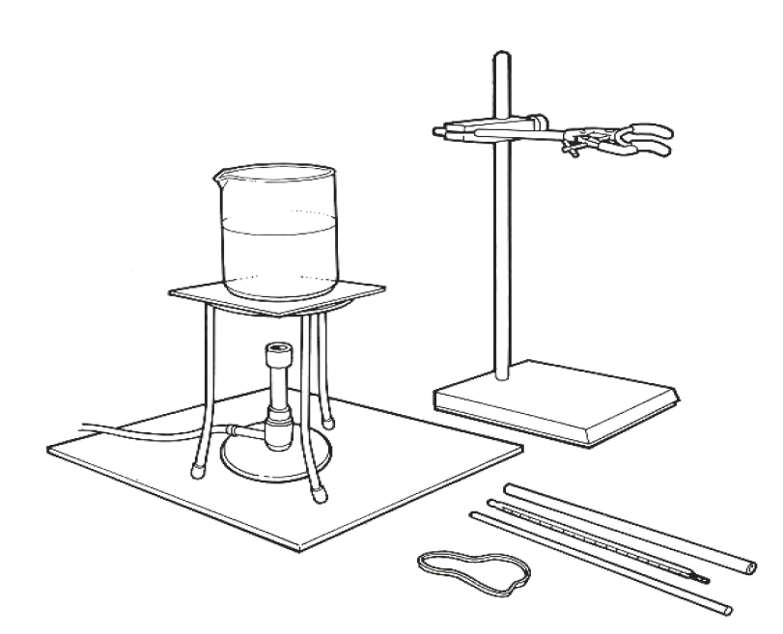

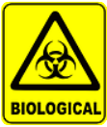
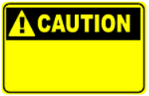


Some people are allergic or intolerant to a particular food or ingredient. Refer to the 14 allergens and check against student records before completing this experiment.

Wear eye protection.
Be careful not to burn yourself with hot fat.
Do not consume food in a laboratory, or any food used for experiments, because it may contaminated.

Method
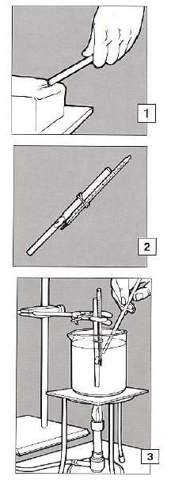
- Scrape a capillary tube along a block of fat. Wipe the outside of the tube.

- Attach a thermometer to the capillary tube with an elastic band, so that the bulb of the thermometer is next to the plug of fat.

- Using a retort stand, clamp the tube and
thermometer in a beaker of cold water, so that they do not touch the sides or bottom of the beaker.

- Heat the water gently with a Bunsen burner, stirring occasionally.

- Observe the fat and note the temperature at which it becomes clear and begins to run out of the tube.

Extension work
Repeat the test using a range of different fats such as butter, baking fat/block, soft spread and lard to compare their melting points.

