Emulsions

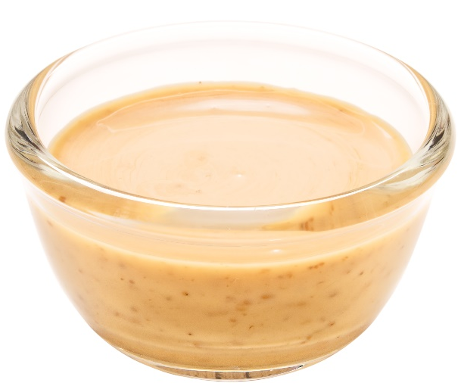
Learning
The aim of this session is to:
- demonstrate how emulsions are formed;
- show which ingredients act as effective emulsifiers.

You will need:
- 6 small jars with lids;
- 2 small bowls;
- 180ml oil;
- 180ml vinegar;
- 1 x 5ml spoon Dijon mustard;
- pinch of salt;
- pinch of pepper;
- 5g sugar;
- 1 large egg.

Instructions:
- Fill each of the small jars with 10ml of vinegar and 30ml of oil.
- Crack the egg and separate the white and the yolk into small bowls.
- Then, to each jar, add one of the following:
  - 1 x 5ml spoon Dijon mustard;
  - salt and pepper;
  - 5g sugar;
  - egg yolk;
  - egg white;
  - nothing (control jar).
Label the jars clearly, so you know which is which.
- Place the lids on the jars and shake each around 50 times.
- Leave the jars to one side and observe each after two, five and ten minutes.

Questions
Think about these questions after you have completed the experiment:
- Which emulsions are the most stable (i.e. the oil and vinegar stay mixed)?
- Which emulsions are the least stable (i.e. the oil and vinegar separate?
- The addition of which substances make the emulsions most stable?
- Explain how an emulsifier helps to hold the vinegar (water-based) and oil together.

