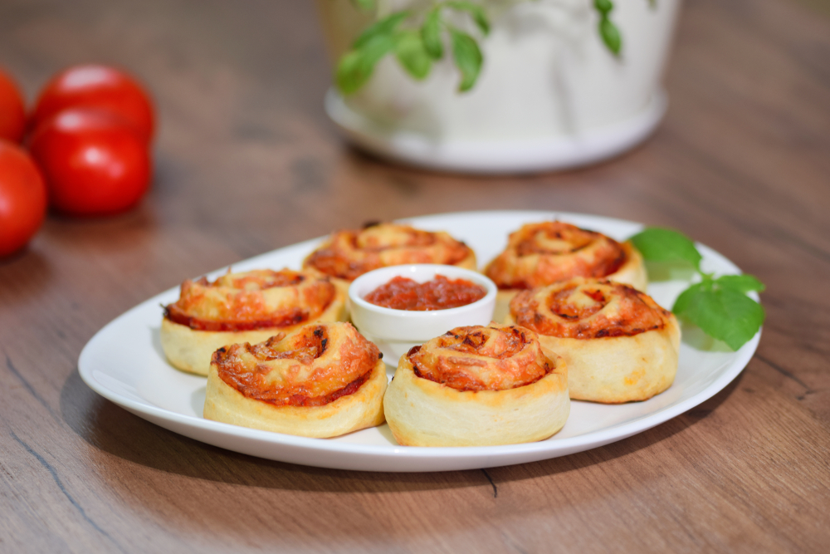
Pizza wheels

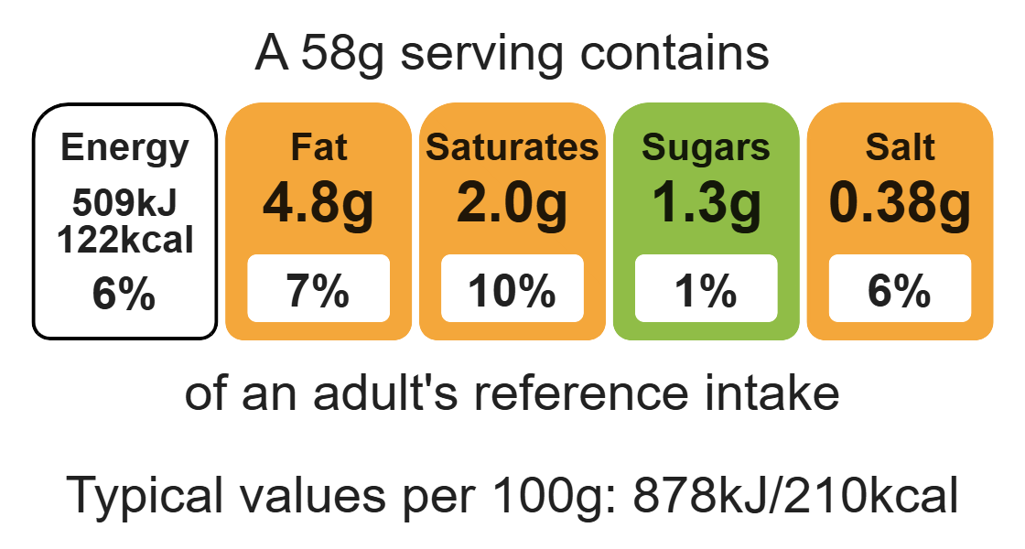

Ingredients (makes 8)

150g self-raising wholemeal flour

25g baking fat/block
Complexity: medium

1 egg

Equipment

Baking tray

Weighing scales

Mixing bowl

Sieve

Small bowl

Fork

Measuring jug

Mixing spoon

Flour dredger (optional)

Rolling pin

Sharp knife

Chopping board

Measuring spoons

Grater

Cooling rack

50ml semi-skimmed milk

25g tomato pizza sauce or passata

1 tomato

3 mushrooms

½ onion

50g reduced-fat Cheddar cheese

1 x 5ml spoon mixed dried herbs

Method
1. Preheat the oven to 200ºC or gas mark 6.
2. Grease or line a baking tray.
3. Sift the flour into a large mixing bowl. Add the fat.
4. Rub the fat into the flour, using your fingertips, until it resembles fine breadcrumbs.
5. Whisk the egg and milk together in a small bowl with a fork.
6. Gradually add the egg mixture to the mixing bowl. Mix to form a soft dough ball.
7. Roll out the dough on a floured surface to form a rectangle.
8. Prepare the pizza toppings on a clean chopping board:
- slice the tomato;
- peel and slice the onion;
- slice the mushroom.
9. Spread the tomato pizza sauce over the dough and scatter on the onion, tomatoes and mushrooms. Leave a 2cm gap around the edges.
10. Grate the cheese.
11. Sprinkle the grated cheese and herbs on top.
12. Roll up from the long end sealing the filling inside.
13. Cut into 4cm slices.
14. Place flat on the baking tray and bake for 10 minutes, until golden brown.
15. After baking, place on a cooling rack.

Top tips
- Reduce food waste: Use any leftover vegetables as a topping on your pizza wheels e.g. peppers, courgette.
- Turn up the flavour: Why not try some different flavour combinations? Try slices of ham, spinach, chopped black and green olives, capers, tuna or sweetcorn.

Food skills
Weigh, measure, sift, rub-in, whisk, mix, stir and combine, roll-out, cut, chop, slice, dice and trim, peel, spread, grate, portion or divide, bake.

