Beef pho (soup noodles)

Ingredients
Complexity: medium-high
200g flat rice noodles
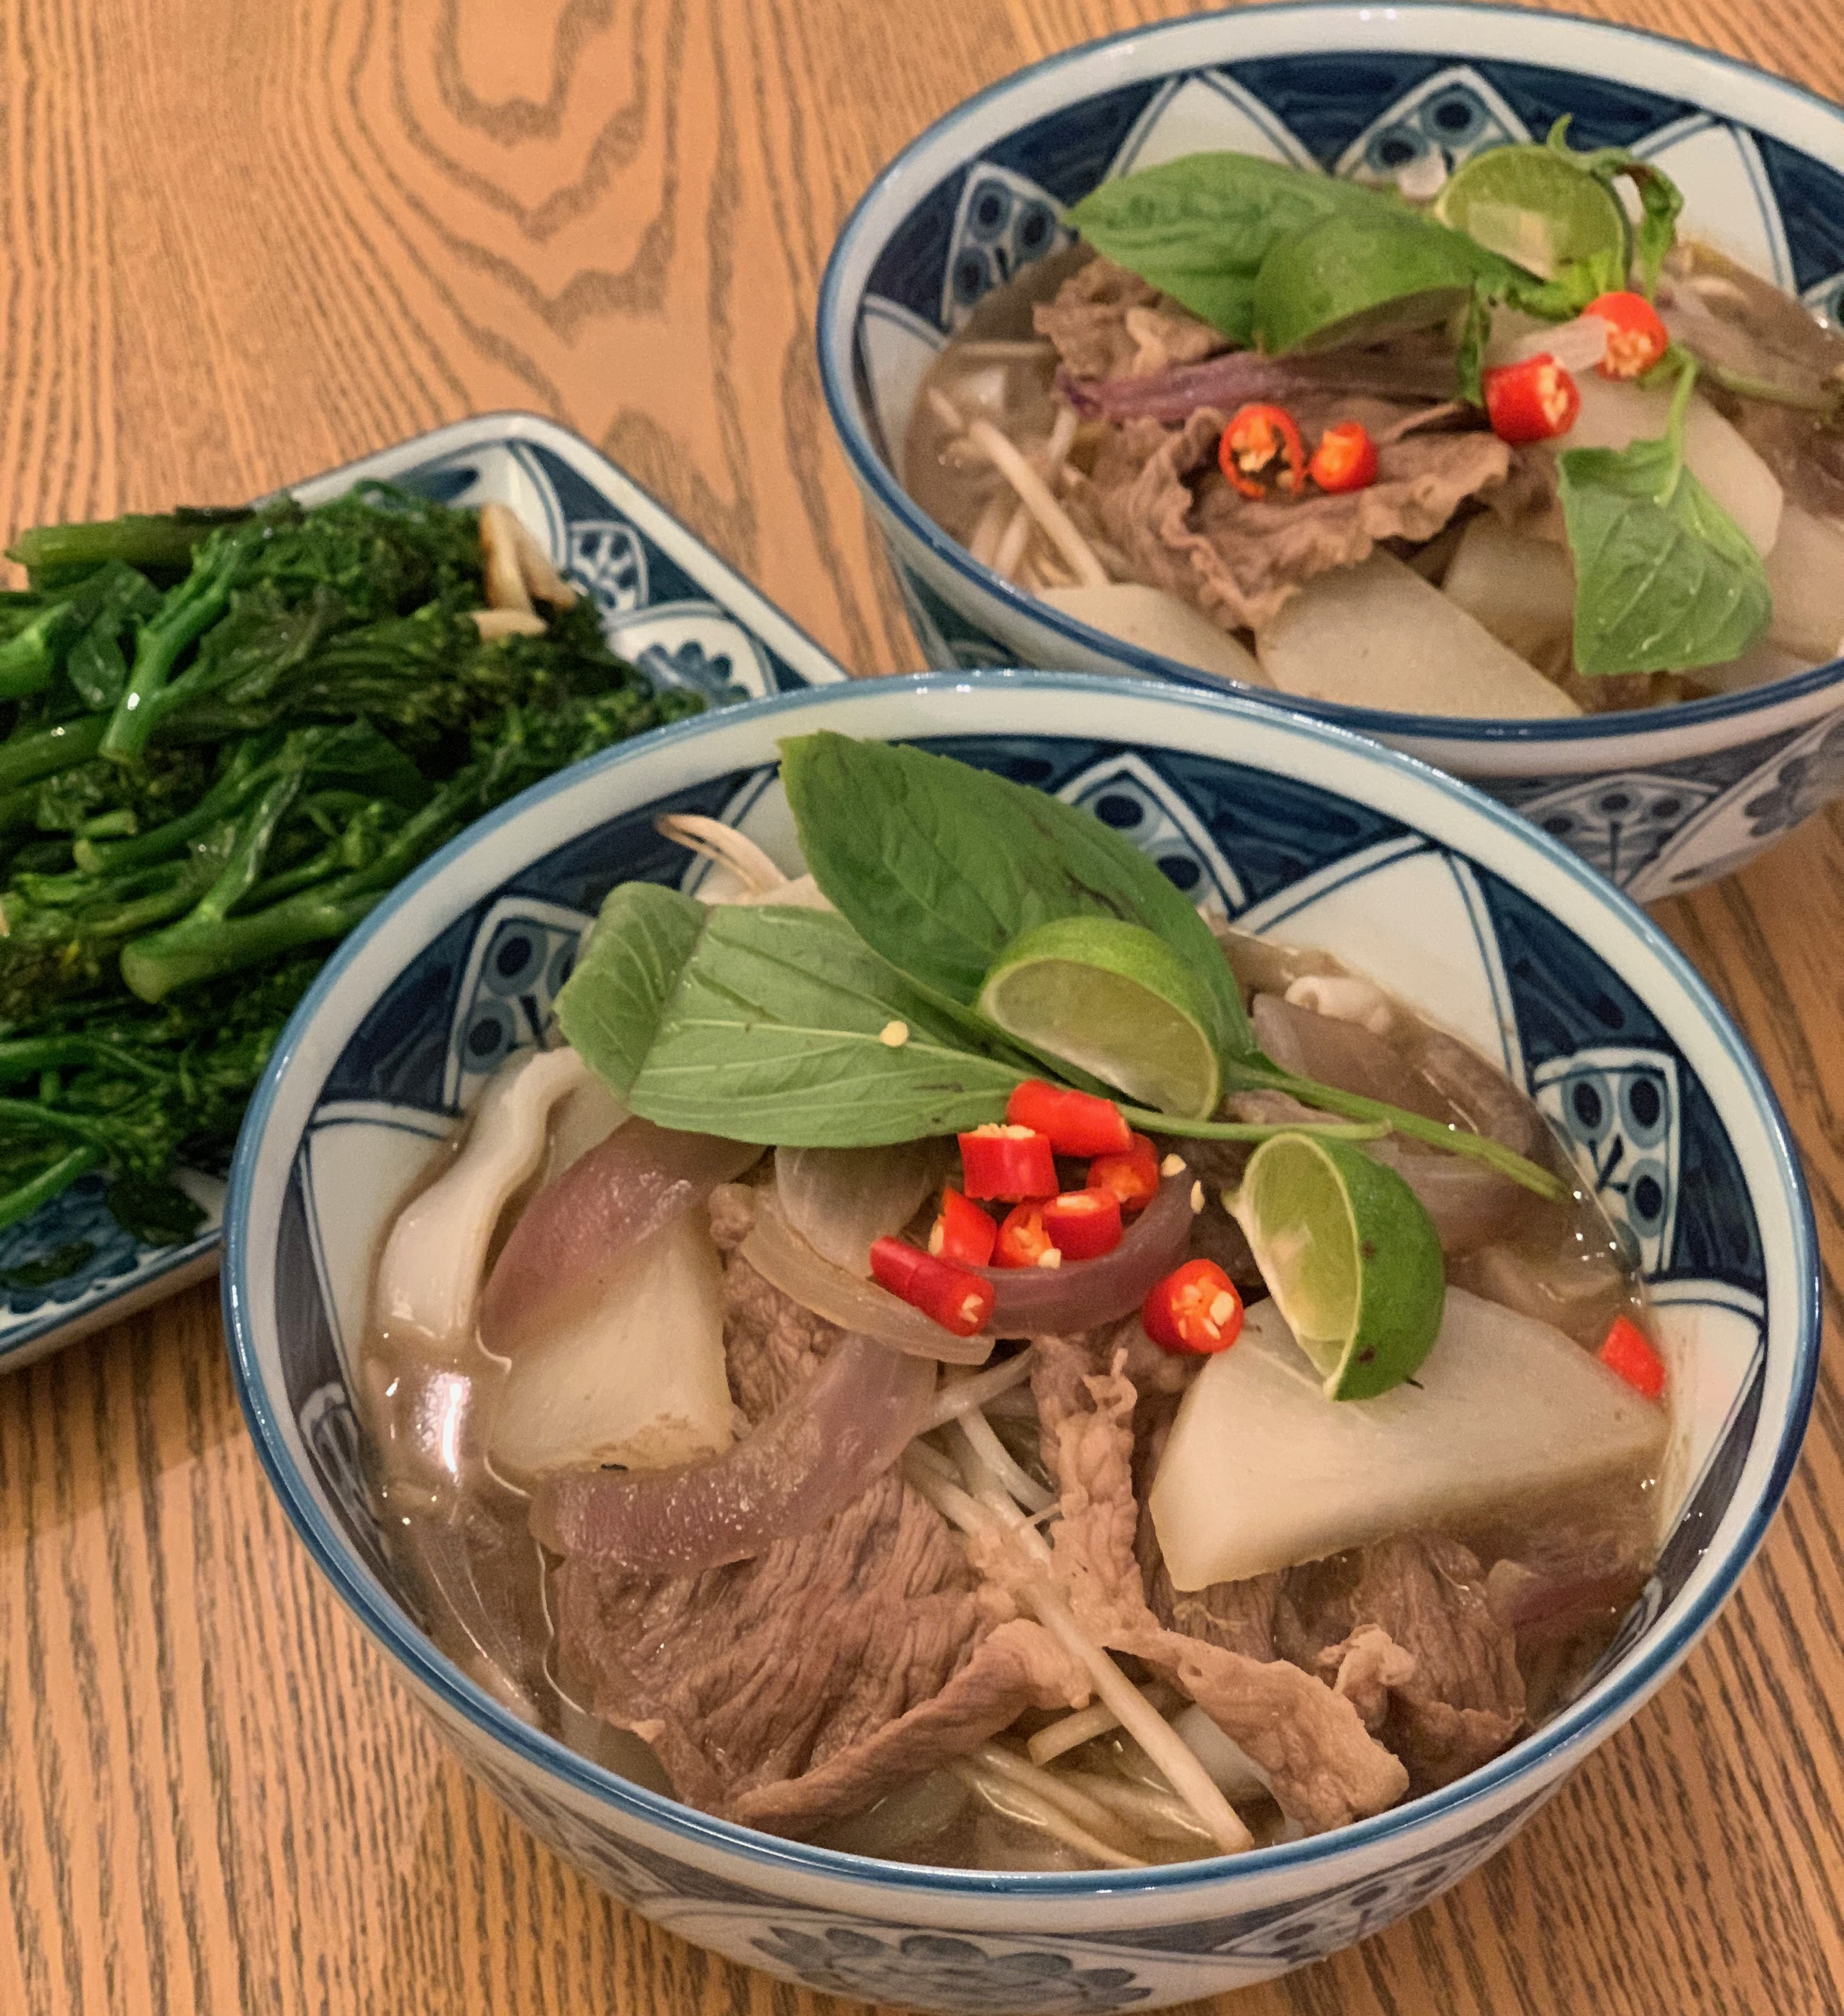
½ onion
400g mooli (daikon)*
1 piece thumb-sized ginger
1 reduced salt beef stock cube
500ml hot water
1 x 15ml spoon fish sauce
1 x 15ml spoon peppercorns
1 x 15ml spoon star anise
1 x 15ml spoon cloves
Spray oil
300g beef strips or slices
50g beansprouts

Toppings
1 lime
1 chilli pepper
1 small bunch Thai basil

* If mooli is unavailable white turnips can be used or red radishes which have a stronger, peppery taste.

Equipment
Chopping board, vegetable knife, vegetable peeler, kettle, measuring jug, measuring spoons, 2 x large saucepans, colander, serving spoons, serving bowls.

Method
- Prepare the ingredients:
- peel and slice the onion;
- peel and halve the mooli lengthways, then cut into slices;
- peel and slice the ginger;
- make up the beef stock by dissolving the stock cube into the water and add the fish sauce.
- In a large saucepan, toast the peppercorns, star anise, cloves and ginger for around 3 to 4 minutes.
- Add the spray oil, then the onion slices. Cook for 1 minute.
- Pour over the beef stock mixture and reduce to simmer for 5 minutes.
- Add the mooli slices, continue to simmer for another 10 minutes.
- Add the beef strips to cook for 5 minutes.
- Cook rice noodles according to packet instructions. Drain well. Divide between 2 serving bowls.

- Prepare the toppings:
  - quarter the lime;
  - cut the chilli in half, deseed and slice. Do not touch face or eyes and thoroughly wash and dry hands after touching raw chilli;
  - remove leaves from the stalk of the Thai basil.
- Strain the broth through a colander and remove the spices. Reserve the broth. Be careful, the meat and vegetables will be hot!
- In the serving bowls, divide and layer the beansprouts, onion and mooli slices, and beef strips over the noodles.
- Pour over the broth.
- Add the toppings and serve whilst hot.

Top tips
- Try making your own chicken pho by replacing the beef with skinless chicken thigh fillets and use a chicken stock cube.
- To make a vegetarian pho use 100g firm tofu cut into cubes or simply add other vegetables such as shitake mushrooms or bok choy. Use reduced salt soy sauce instead of fish sauce.

Food skills
- Weigh
- Measure
- Peel
- Slice
- Fry
- Simmer
- Drain

Did you know?
Daikon or mooli is a long, white (to light green) radish used in Japanese and other Asian cooking. The word daikon is derived from the Japanese words dai (large) and kon (root). Use of this popular vegetable dates back to the 8th century.

The term pho actually refers to the noodles, not the soup itself. Whilst originally from Vietnam it is now a popular dish across Asia and round the world.

Often pho is served with garnishes on the side. These should be added to the soup before eating - it is common to sip the broth of the pho and eat the noodles separately with chopsticks.

This recipe has been kindly donated by Georgine Leung.

