Fruity flapjacks
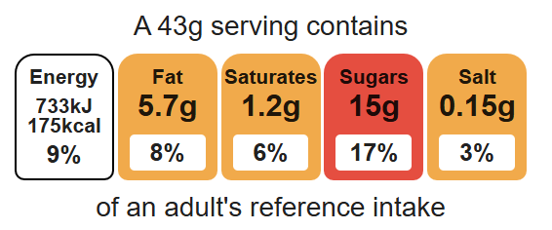
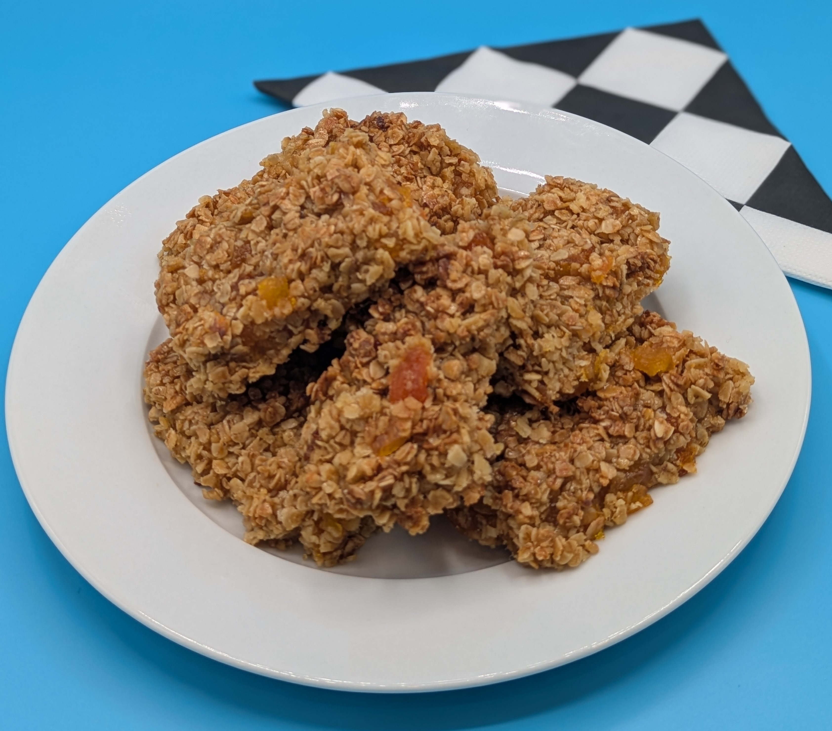
Complexity: medium- high

Equipment

Weighing scales

Baking tray

Chopping board

Sharp knife

Measuring spoons

Saucepan

Heat resistant spoon

Spatula

Palette knife

Ingredients (serves 8)
75g dried apricots
150g oats
50g caster sugar
50g reduced-fat spread
2 x 15ml spoons golden syrup

Method
- Preheat the oven to 180°C or gas mark 4.
- Line the baking tray.
- Chop the apricots into small pieces.
- Place the spread, sugar and syrup into a saucepan, stir and gently heat until it has melted.
- Remove the saucepan from the heat and stir in the oats and apricots.
- Pour the mixture into the lined baking tray.
- Pat and flatten down the mixture in the baking tray, using the palette knife.
- Bake for 15 - 20 minutes, until lightly browned.
- Remove from the oven and carefully cut into ‘bars’ in the baking tray while hot.

Top tips
- Turn up the flavour: Try adding 75g sultanas, figs, mixed dried fruit or add 1 x 15ml spoon cinnamon, ginger or mixed spices to the oat mixture.
- Reduce food waste: Add leftover grated fresh apple or carrot to the flapjacks.

Food skills
Weigh, measure, cut, chop, slice, dice and trim, melt, simmer and boil, mix, stir and combine, bake, portion/divide.

