Spinach, potato and chickpea curry
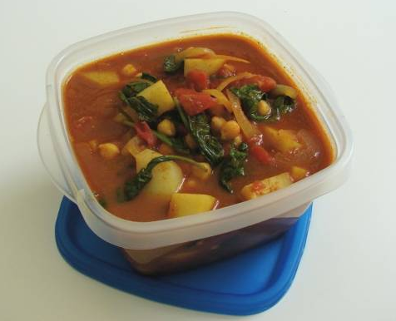
Complexity: medium

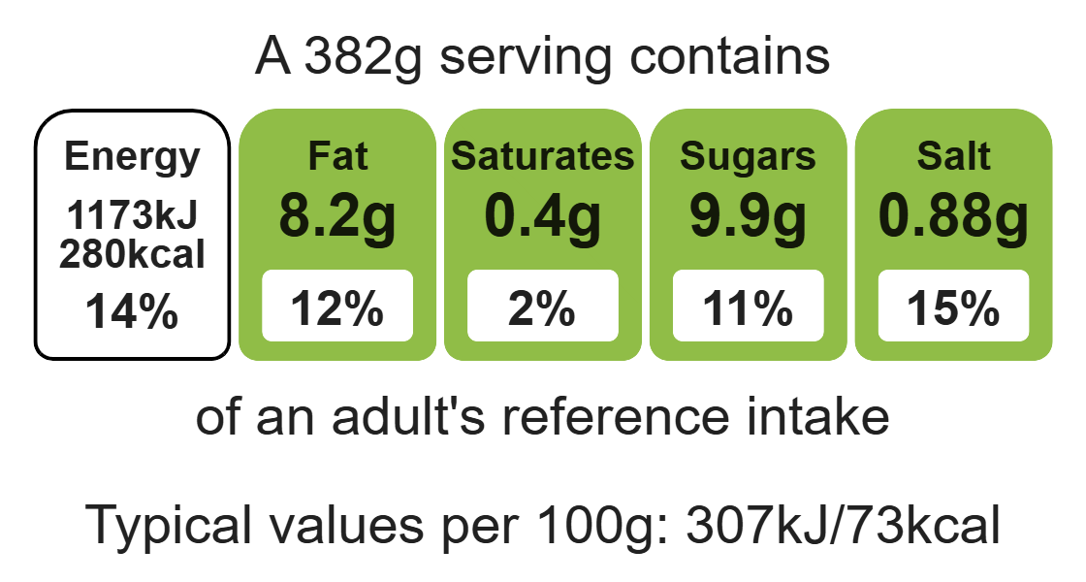

Ingredients (serves 3)
1 onion
1 clove garlic

Equipment

Weighing scales

Sharp knife

Chopping board

Garlic press

Frying pan

Measuring spoons

Measuring jug

Heat-resistant spoon

Can opener (optional)

1 x 5ml spoon oil
2 x 15ml spoons curry paste
300ml water
1 potato
400g chopped tomatoes
240g chickpeas, canned
3 handfuls of fresh spinach

Method
- Prepare the ingredients:
- peel and slice the onion;
- peel and crush the garlic;
- peel and cube the potatoes;
- drain the chickpeas.
- Add oil to the frying pan. Fry the onion and garlic for 2 minutes.
- Stir in the curry paste, water and potatoes.
- Add the tomatoes and chickpeas, then simmer for 20 minutes, until the potatoes are tender.
- Stir in the fresh spinach and allow to cook for a further 2 minutes.
- Serve.
Top tips
- Serving suggestion: serve with boiled rice, naan bread and a side salad.
- Focus on fibre: serve with brown rice to increase the fibre content.
- Beat the budget: batch cook and freeze portions of this curry.
- Vary your protein: why not try this recipe with chicken or strips of lean beef?

Food skills
Weigh, measure, peel, cut, chop, slice dice and trim, drain, fry and saute, mix, stir and combine, melt, simmer and boil.

