
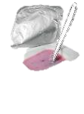
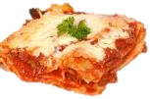
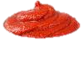
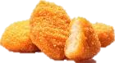
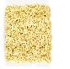
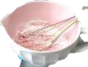
What is modified starch?

Modified starch is starch that has been changed either chemically, physically or by using enzymes. Treating starch in this way can allow it to have different functional applications in food products.

Uses of modified starches include:

- improving texture;
- protection against heat, cold, acid or physical force;
- improving flavour;
- increasing nutritional value;
- replacing or mimicking fat.

Many modified starches are authorised for use in Europe and have been widely tested to make sure they are safe.

Modified starches should not be confused with ‘genetically modified’ food.
What is starch?

Starches are large chains of sugar molecules which are used by plants as a way to store energy. Some starchy foods contain high amounts of starch, e.g. potatoes, wheat, corn and tapioca (cassava).
Modified starch information sheet
www.foodafactoflife.org.uk
© Food – a fact of life 2024
Modified starches can be used to ‘mimic’ the creamy feeling of fat in products such as yogurt. This means that products can contain far less fat without changing how they taste and feel.
Modified starches can prevent pre-prepared foods from dripping and separating when they are defrosted.
Modified starches can thicken sauces and help them bind together.
Pregelatinised starches are used in products such as instant desserts, to increase viscosity (thickness) without having to heat the food.
Modified starches can help to improve the texture of foods (e.g. by causing batter to become more ‘crisp’ upon frying).
Pregelatinised starches are added to products such as dried instant noodles to hydrate them rapidly.

