Simit bread

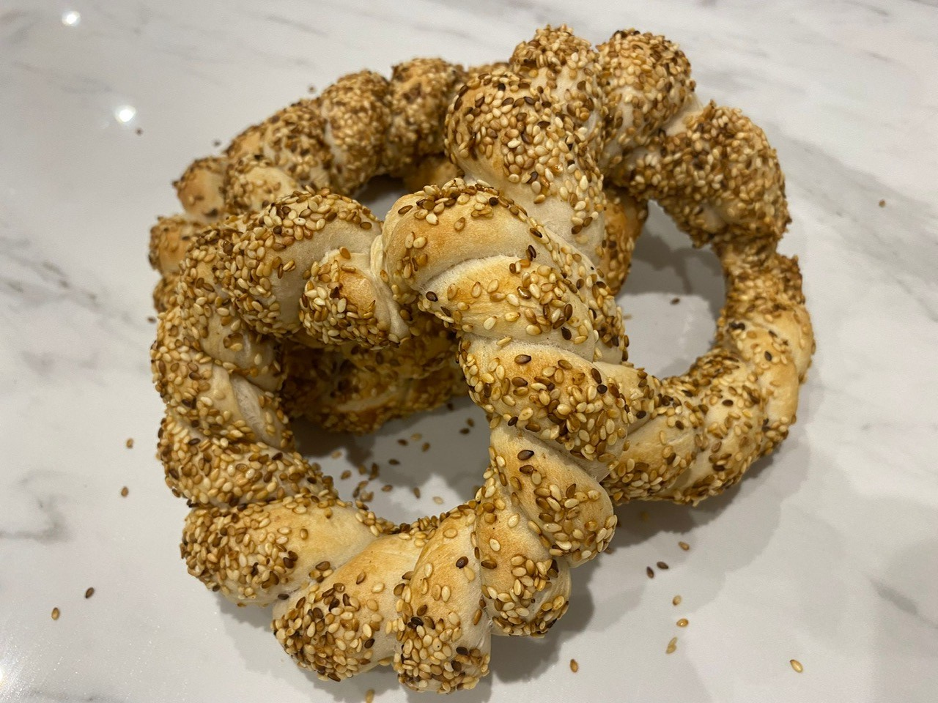
Ingredients
Complexity: medium

250g strong white flour

1 x 7g sachet fast action dried yeast

1 x 5ml spoon sugar

1 x 5ml spoon salt

150ml warm water

50g sesame seeds

50ml molasses

50ml water

Equipment
Baking tray, greaseproof paper, small frying pan, mixing spoon, large plate, sieve, 2 x mixing bowls, measuring spoons, measuring jug, mixing spoon.

Method
- Line a baking tray with greaseproof paper.
- Gently dry fry the sesame seeds in a frying pan over a low heat for 3-5 minutes, until lightly toasted. Remove from the heat and spread on a large plate.
- Mix the molasses and 50ml water in a bowl large enough to dip the shaped simit bread in.
- Sieve the flour, yeast, sugar and salt into a large mixing bowl. Stir well.
- Add enough warm water to flour mixture to make a soft dough. Mix with a spoon at first and then use one hand to bring together as a dough. Use the other hand to hold onto the bowl.
- Knead the dough firmly for ten minutes.
- Cut the dough into eight equal pieces. Roll each piece into a long sausage, approximately 30cm in length.
- Squeeze the ends of two strands together. Twist the strands over each other and then loop into a ring. Squeeze the ends together to secure. Repeat with the remaining strands to create four twisted bread rings.
- Dip one of the bread rings into the molasses and water mixture, turning over so that both sides are covered.
- Dip the ring into the sesame seeds, again turning over to make sure that both sides are well covered. Place on the lined baking tray.
- Repeat with the remaining rings.
- Place the baking tray into a COLD oven and turn up the temperature immediately to the highest setting.
- Remove from oven after approximately 15 – 20 minutes and cool on a cooling rack.

Top tips
- Use sunflower, poppy or flax seeds as an alternative to sesame seeds. There is no need to toast these before using.
- Pomegranate or grape molasses is traditionally used in Turkey. However, honey or maple syrup can be used instead of molasses.

Food skills
- Weigh
- Measure
- Sift
- Mix
- Knead
- Portion and divide
- Form and shape
- Bake

Did you know?
Simit bread is also known as Turkish bagel, Gevrek or Koulouri, and is a popular ‘street food’ for breakfast or a snack in Turkey. Drinking tea with Simit is traditional but it is also common to have Simit with a glass of cold Ayran (Turkish yogurt drink). It can be eaten plain or served with other food such as fruit preserves, feta cheese, eggs, cucumber, tomatoes dates, figs and olives.

The coating is traditionally grape or pomegranate molasses, it is used to stick on the seeds, and it gives the bread a shiny surface. It also helps to keep the bread moist and soft and gives Simit its characteristic flavour and golden colour.

