Megrim with a creamy mushroom sauce

Served with spinach and asparagus spears
Complexity: medium-high
Ingredients
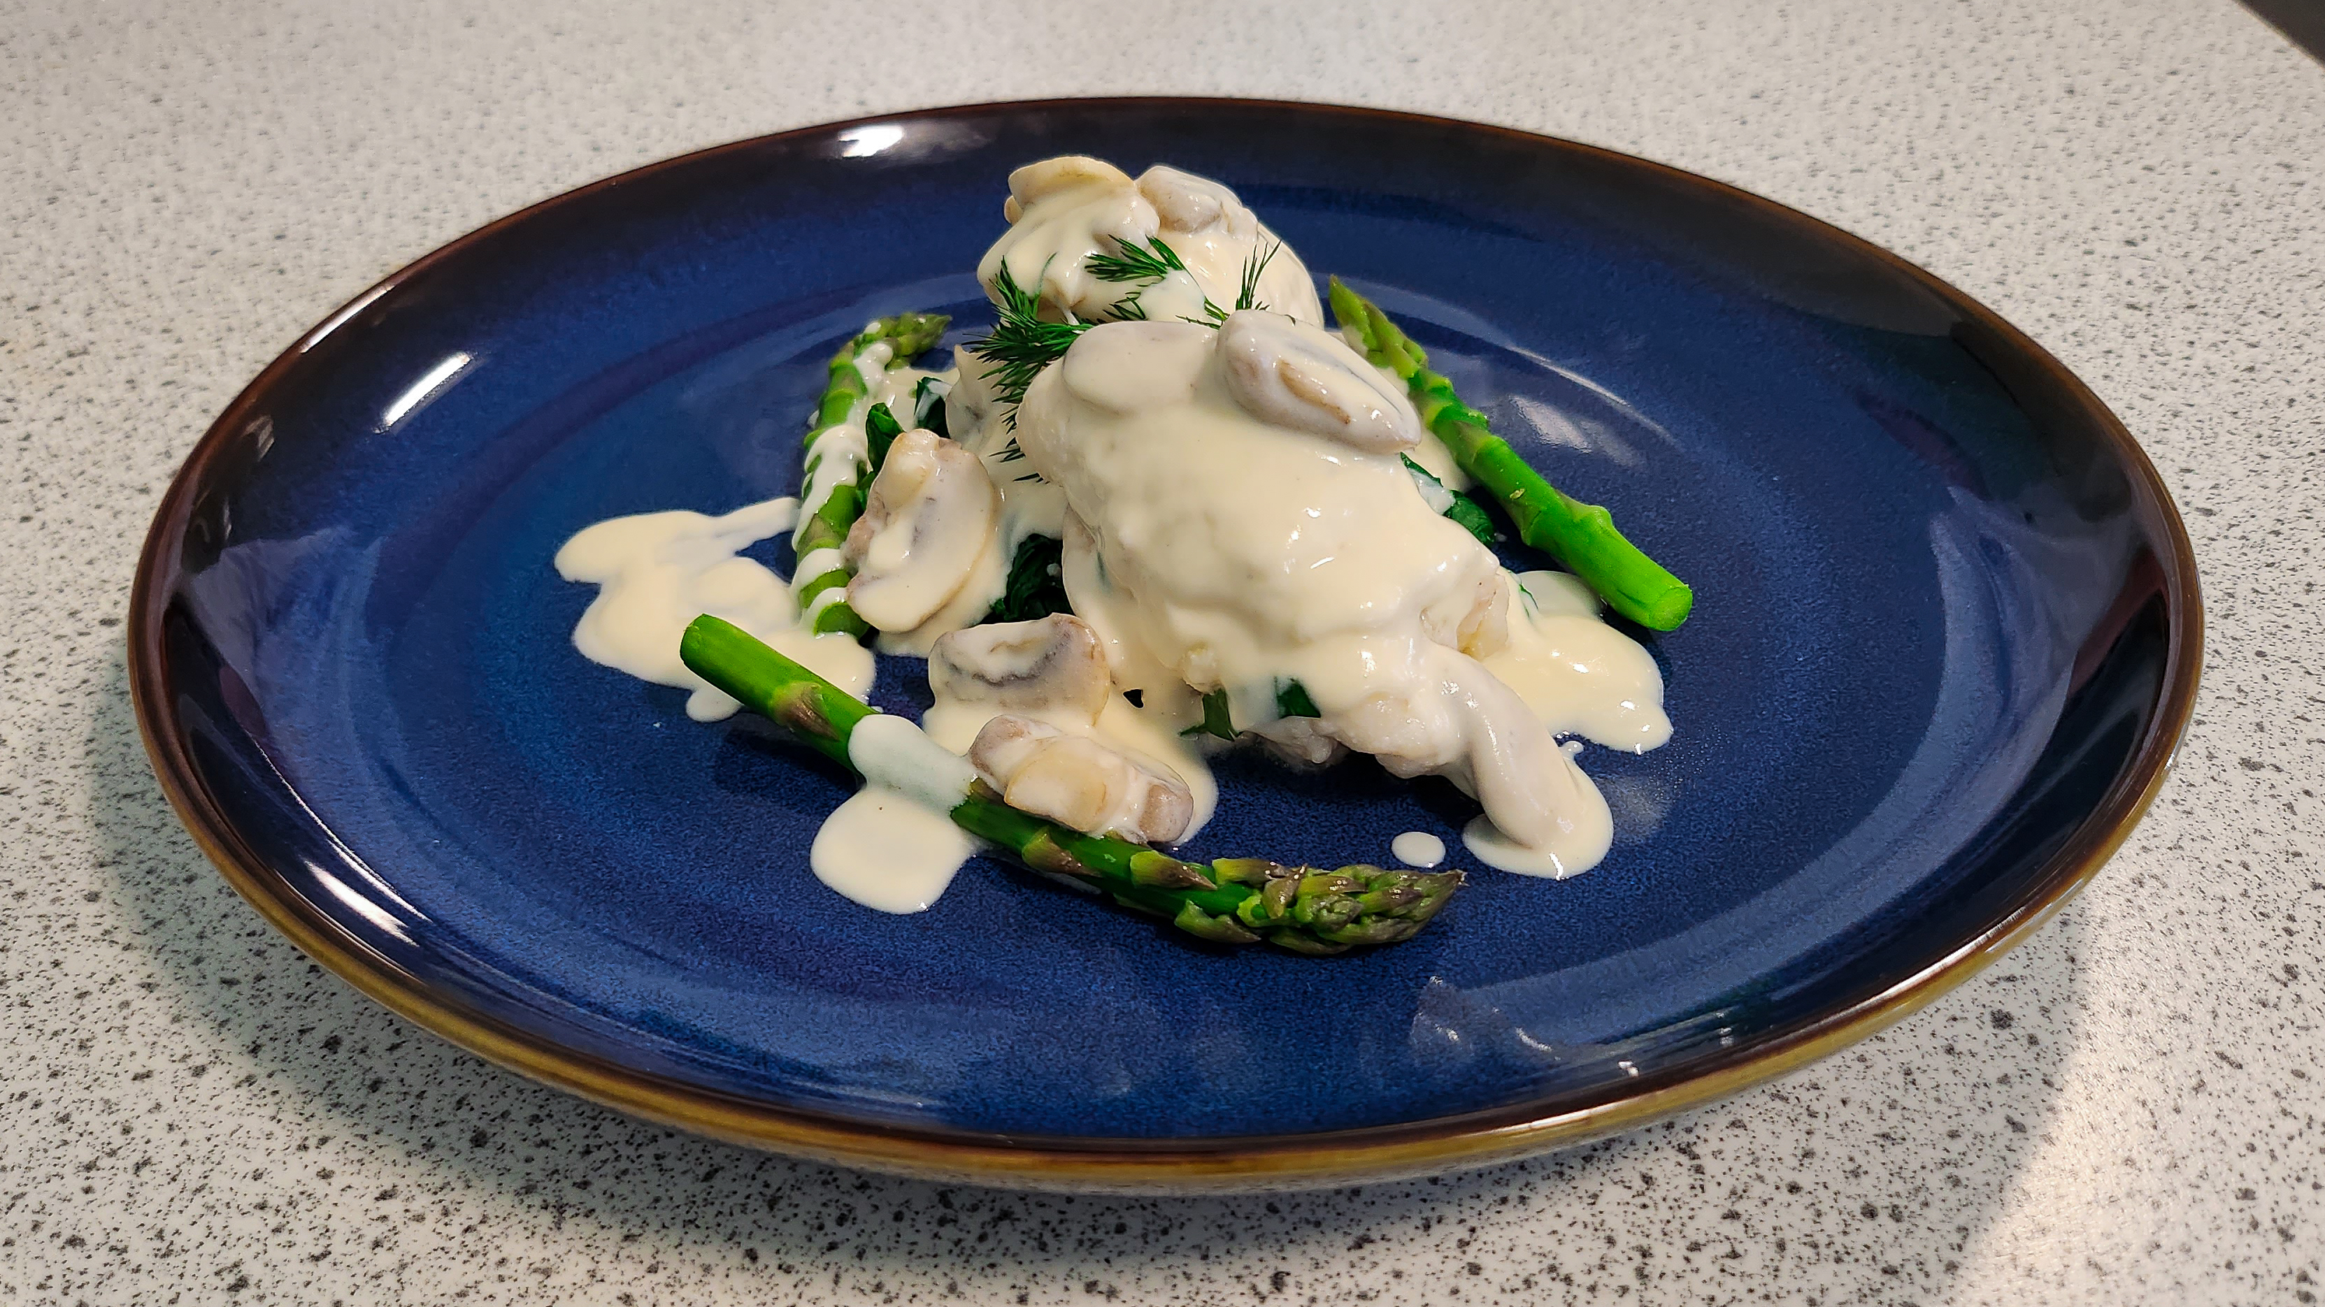
100g baby spinach
3 stems asparagus
100g button mushrooms
1 x 5ml spoon oil
200ml fish stock
2 quarter fillets of megrim (skinless)
15g butter
2 tbsp crème fraiche
Pepper to taste
2 sprigs of dill
Equipment
Large bowl, colander, chopping board, vegetable knife, frying pan with lid (or tinfoil if pan has no lid), mixing spoon, plate, small saucepan, serving spoon.

Method
- Prepare the vegetables:
  - blanch the spinach and squeeze out excess water;
  - blanch and refresh the asparagus;
  - thinly slice the mushrooms.
- Heat the oil in a frying pan and gently fry the mushrooms for approximately 2-3 minutes.
- Add the fish stock to the frying pan.
- Bring to the boil and cook until half of the liquid has evaporated.
- Roll the megrim, starting from the tail end. Add the fillets to the stock and cover with a lid (or tinfoil).
- Reduce the heat and gently poach for 4 minutes.
- Remove the fish and keep it warm on a plate.
- Continue to simmer the liquid, reducing it by a further half.
- Add the crème fraiche and warm through.
- Melt the butter in a saucepan and add the spinach and season with pepper to taste.
- Add the asparagus to the saucepan and reheat.
- Plate the dish:
  - place the spinach in the centre of the plate;
  - add 3 stems of asparagus on top, placing them at angles so the spears point outwards;
  - place the fillet on top of the spinach and asparagus;
  - spoon the mushroom sauce over the fish and around the plate;
  - garnish with the fresh dill.

Top tips
- Why not try other sustainable white fish such as plaice, dab or witch?
- Substitute the mushrooms with a fresh herb such as dill or tarragon. Add with the crème fraiche.

Food skills
Weigh and measure
Drain
Slice
Sauté
Melt, simmer and boil
Garnish

This recipe was kindly donated by Food Teachers Centre, through their FISH (Fish in School Hero) programme.

