Macaroni cheese
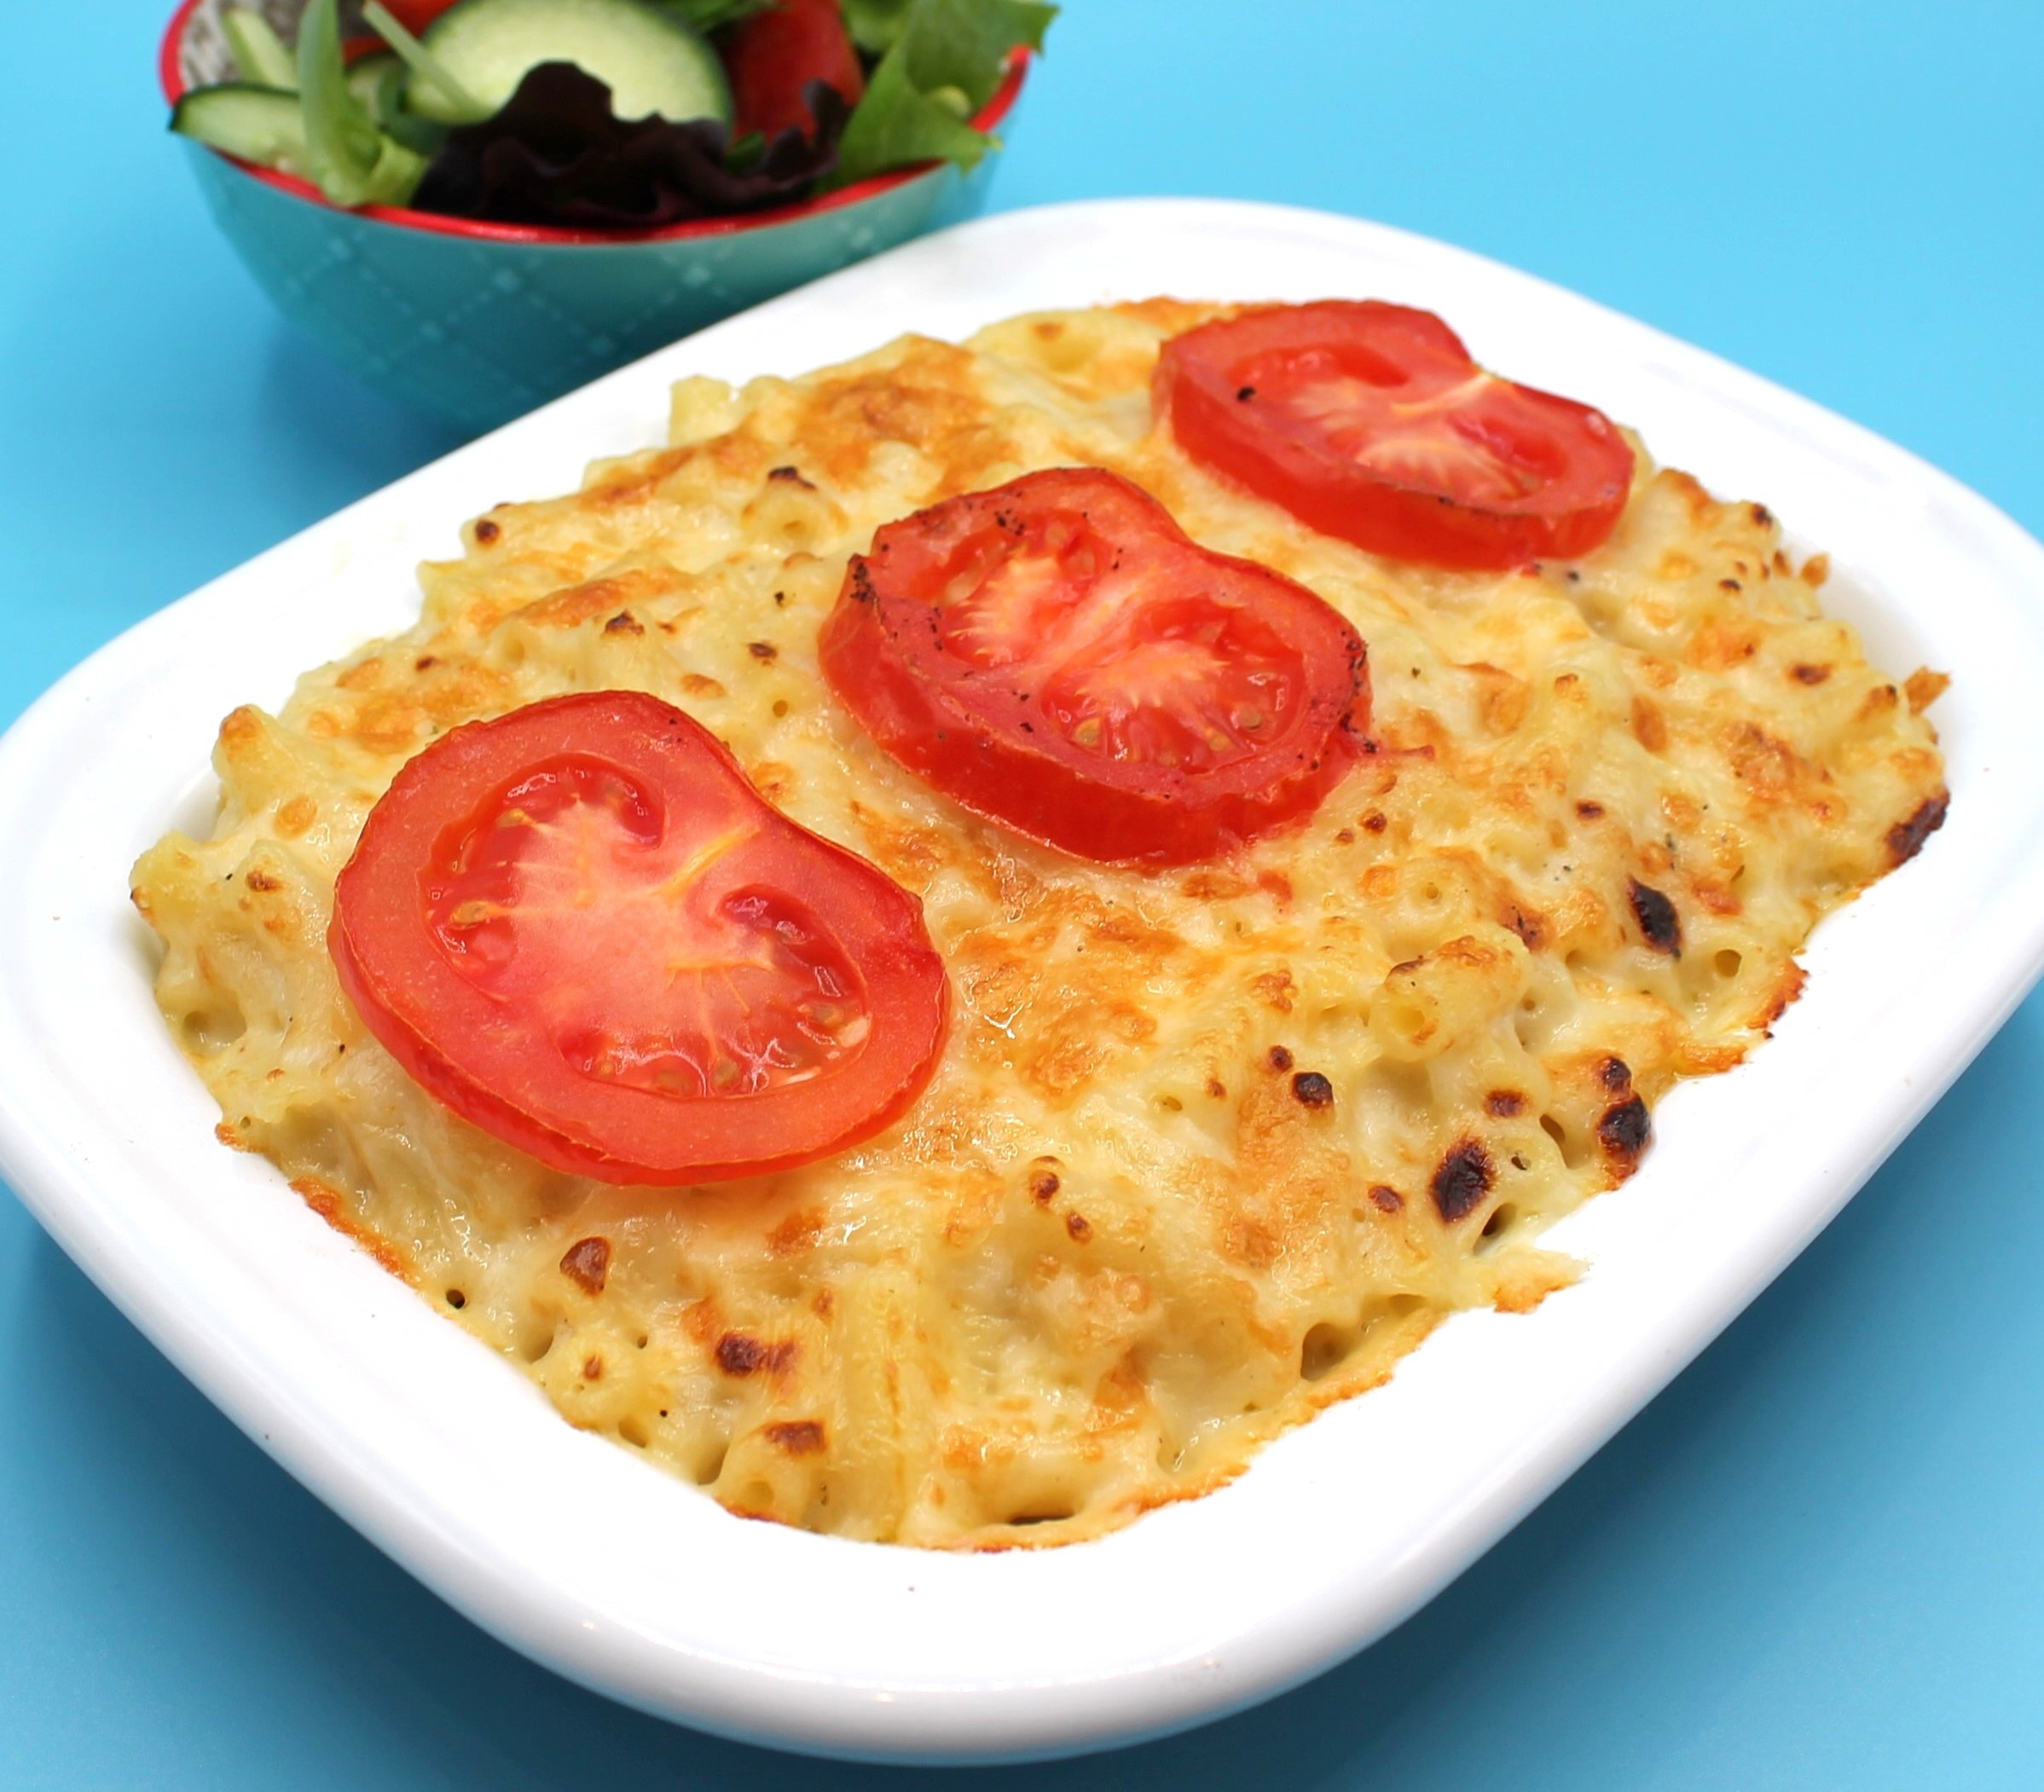
Complexity: medium

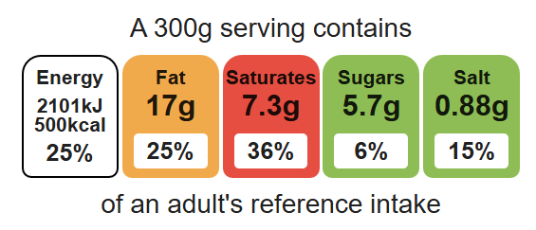

Ingredients (serves 3)

Equipment

Two saucepans

Weighing scales

Grater

Chopping board

Sharp knife

Colander

Measuring jug

Heat resistant spoon

Whisk

Ovenproof dish (21cm) or foil tray

250g macaroni
25g reduced-fat spread
25g plain flour
250ml semi-skimmed milk
100g reduced-fat cheddar cheese
Black pepper

1 tomato

Method
- Bring a saucepan of water to the boil and add the macaroni. Cook for about 10 – 12 minutes, until al dente.
- Grate the cheese and slice the tomato.
- While the pasta is cooking, make the sauce:
All in one method:
- place the fat, flour and milk into a small saucepan;
- bring the sauce to a simmer, whisking all the time until it has thickened;
- off the heat, stir in 75g of the grated cheese.
Roux method:
- melt the fat;
- add flour and cook for 1 minute;
- remove from the heat and gradually add milk, stirring constantly;
- return to the heat and bring to a boil, then reduce to simmer and allow sauce to thicken;
- off the heat, stir in 75g of the grated cheese.
- Preheat the grill.
- Drain the macaroni into a colander in the sink.
- Stir the drained macaroni into the cheese sauce and add a few twists of black pepper.
- Pour the macaroni into an oven-proof dish (or foil tray).
- Arrange the tomato slices over the macaroni. Sprinkle the cheese on top.
- Place under a hot grill until the cheese is melted and golden brown.

Top tips
- Focus on fibre: Use wholemeal pasta to increase the fibre content.
- Reduce food waste: Add broccoli, cauliflower florets, frozen peas or mixed veg. Cook with the macaroni.
- Serving suggestion: Serve with a seasonal side salad.

Food skills
Weigh, measure, grate, cut, chop, slice and dice, mix, stir, combine, drain, melt, simmer and boil, decorate and garnish, grill.

