Cooking
Before a cooking session with pupils, there are a number of factors that you need to consider. For example, think about:
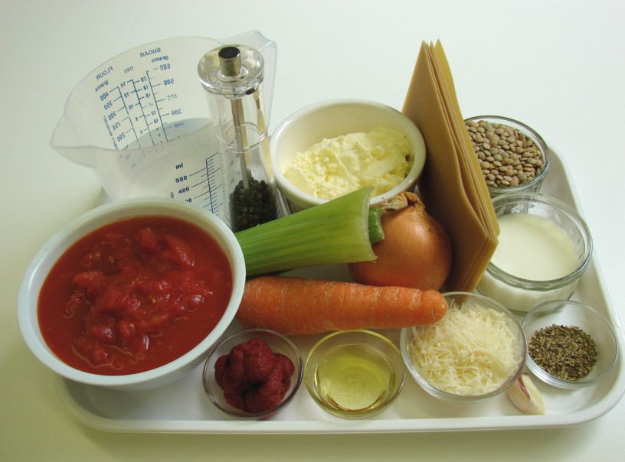
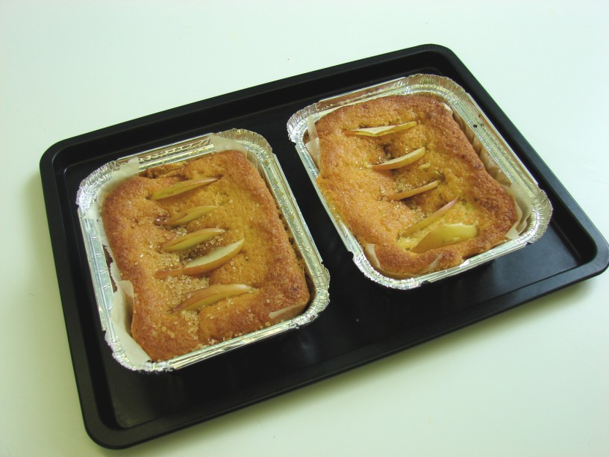
Recipe
For each of the 16 practical sessions in Licence to Cook, a number of recipes are suggested that provide a platform to teach key basic cooking skills. If one of these recipes is not used, then you may use another, as long as the learning objectives for that unit are being met.
You will also need to check whether pupils have an allergy to an ingredient or cannot handle or eat a food on religious or ethical grounds. The recipe may need to be adapted or alternative ingredients provided.
Once you have decided on a recipe, you will need to consider how it is given to the pupils for them to follow. For example, it could be printed-out and laminated or projected onto an interactive whiteboard and played throughout the lesson.
You could get your pupils to modify the basic recipes provided throughout Licence to Cook, developing their own creative ideas. If so, the recipe writing frames could be used.
Ingredients
Your school will have its own policy on ingredient provision. Some schools provide all pupils' ingredients, others charge a small fee and provide the ingredients (with pupils on free school meals being exempt) and some have a policy of pupils bringing in their ingredients from home. If you do not, then you should work with the Senior Management Team in the school to devise one.
If the school provides the ingredients, you may wish to set these out before the start of the lesson (or keep refrigerated – check the label first).
If pupils bring in ingredients from home, ensure that either an ingredient list is given to them in good time or they have decided what they would like to use. Student may also require an appropriate area to store their ingredients before the lesson, e.g. cupboard, fridge. You will need to decide what activities pupils undertake if they forget to bring in their own ingredients.
Containers
Your school will have its own policy on the provision of containers for food cooked on the premises. For example, you may supply appropriate plastic, paper or foil containers or pupils may bring in their own containers from home.
You may need to provide a supply of containers in case pupils forget to bring in their own. Some schools provide these free-of-charge, while others charge a small fee, e.g. 5-10p.
A more sustainable solution if for all pupils to use recycled food containers brought in from home. Sticky labels are useful to help identification and also provide important storage, cooking or reheating information.
Ensure that pupils know the type of container needed before the lesson, e.g. a flask for soup and a plastic tub for scones.
Cooking area
Before the cooking session, check that:
- the room is clean and ready to use;
- equipment each student needs is available;
- cookers are in good working order, if appropriate;
- washing-up bowls, liquid and cloths are out;
- ingredients are ready, if applicable.
Most established food rooms at school have equipment clearly laid out so that pupils can easily find what they need.
Depending on room layout and student numbers, equipment could be:
- labelled in cupboards and drawers (with words and images), e.g. saucepans, mixing bowls, grater;
- available on the work surfaces, e.g. kettles, weighing scales;
- in cutlery trays, holding basic equipment, such as vegetable knifes, peelers and spoons;
- in tubs, trays or holders, allowing you to know exactly the number of items going out/in, e.g. knife block;
- placed out before the lesson, as it might be a specialist piece of equipment or kept locked in a cupboard, e.g. food processor, zesters, baking tins.
Having a common layout around the room allows pupils to quickly learn where equipment is kept, and where it should be replaced. It also means that you can check that equipment is replaced easily - as usually there is a maximum number of items per cupboard, drawer or cutlery tray.
Waste
Most of the waste generate during a cooking session can be composted or recycled. Your local council will be able to let you know what they collect.
In a lesson you could provide bins for:
- recyclables (such as glass, paper, card, cans and plastic);
- kitchen waste, such as fruit and vegetable peelings for the school compost, if you have one;
- non-recyclables (such as polystyrene, tetra-pack and waxed cartons) and other kitchen waste, e.g. cooked food, raw meat, plate scrapings.

How the school manages its waste and recycling policy can play an important role model to inform pupils habits at home and in the future.

Food allergy and intolerance
A food allergy or intolerance is an adverse reaction to a particular food or ingredient and can be represented by a range of different symptoms. Food intolerance and food allergy are not the same thing. Food intolerance is used as an umbrella term for an unpleasant reaction to a specific food, but it does not cause an immune reaction e.g. lactose intolerance. If an abnormal, immune reaction occurs to a particular food then this is called a food allergy.

The 14 main allergens are:
- celery
- cereals containing gluten – including wheat (such as spelt and Khorasan), rye, barley and oats
- crustaceans – such as prawns, crabs and lobsters
- eggs
- fish
- lupin
- milk
- molluscs – such as mussels and oysters
- mustard
- tree nuts – including almonds, hazelnuts, walnuts, brazil nuts, cashews, pecans, pistachios and macadamia nuts
- peanuts
- sesame seeds
- soybeans
- sulphur dioxide and sulphites (if they are at a concentration of more than ten parts per million)
Since December 2014 food products that contain any of these ingredients must be clearly labelled to inform affected consumers which products they should avoid.

Food intolerance and food allergy are perceived by the public to be much more common than they actually are. Food intolerance is currently estimated to affect 5-8% of children and 1-2% of adults. Food allergies are even less common than this.
Common food intolerances and food allergies
Lactose intolerance is an intolerance to the sugar found in milk. People with this condition are unable to digest lactose resulting in a range of symptoms including abdominal pain, bloating and diarrhoea.

Lactose intolerant sufferers should avoid all sources of lactose including cows’, sheep and goats milk. However, as a person gets older they often find they can tolerate small amounts of lactose in their diet, particularly from cheese and yogurt. Milk and dairy products are an important source of calcium in the diet so it is important that a suitable, fortified alternative, such as fortified soya milk, is used to replace these foods.

Coeliac disease is the main form of wheat intolerance affecting about 1 in 300 people. Gluten is a protein that is found in wheat, rye, barley and oats. The presence of gluten in the diet damages the lining of the small intestine often resulting in chronic diarrhea which can lead to chronic malnutrition. People diagnosed with coeliac disease must adopt a life long gluten free diet. Coeliac UK is a charity that supports people with gluten intolerance. It works with manufacturers to produce a regularly updated list of foods that do not contain gluten that coeliacs can consume.
It is important to note that wheat-free products are not the same as gluten free as they may contain other cereals, such as rye or barley. This might mean that they are not suitable for someone with coeliac disease unless they are also labelled ‘gluten free’.
Peanuts are one of the most common causes of food allergy and can cause a range of reactions. Mild symptoms include tingling in the mouth and lips, facial swelling or skin rash. However, for some people reactions are more severe and may even be fatal, such as anaphylactic shock. For some people even very tiny amounts of peanut can cause a reaction.
Peanut allergy tends to be life long, and as there is no cure. Those diagnosed must avoid all sources of peanuts. Many people who are allergic to peanuts carry an epipen which helps to prevent a severe reaction occurring if they are exposed to a peanut allergen.
What does this mean for you?
If you have children in your class who have been diagnosed with a food intolerance or allergy they should still be able to participate in food lessons. For example, fruit smoothies can be made using soya milk instead of cow’s milk. There are also now many products on the market that are gluten free, so if a child in your class has been diagnosed with coeliac disease try using gluten free pasta or bread. This means they can still participate in the lesson and try the food they make.

If possible, talk to the child and the parents affected. They can tell you the types of foods they can have and which ones should be avoided, as well as what to do if an allergic reaction occurs. You may also find it useful to send a letter home before you carry out any food practical work to find out whether pupils in your class are intolerant or allergic to a specific food. This will help you to plan the lesson and know which foods to avoid or alternatives to try.

