Energy worksheet

- Fill in the names of the macronutrients for each of the recommended energy intakes.
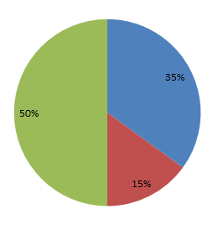

- List these in order of least to most energy used. (1 = least, 6 = most)


- Describe why the body needs energy.

- List five reasons why someone’s energy needs might change over their life.
1.
2.
3.
4.
5.

- List how many kilocalories per gram do each of these provide.

- Carbohydrate
- Fat
- Protein
- Alcohol

- Describe the activity recommendations for:
- Children

- Adults

