Session 7 (extension) Perfect pastry
Welcome
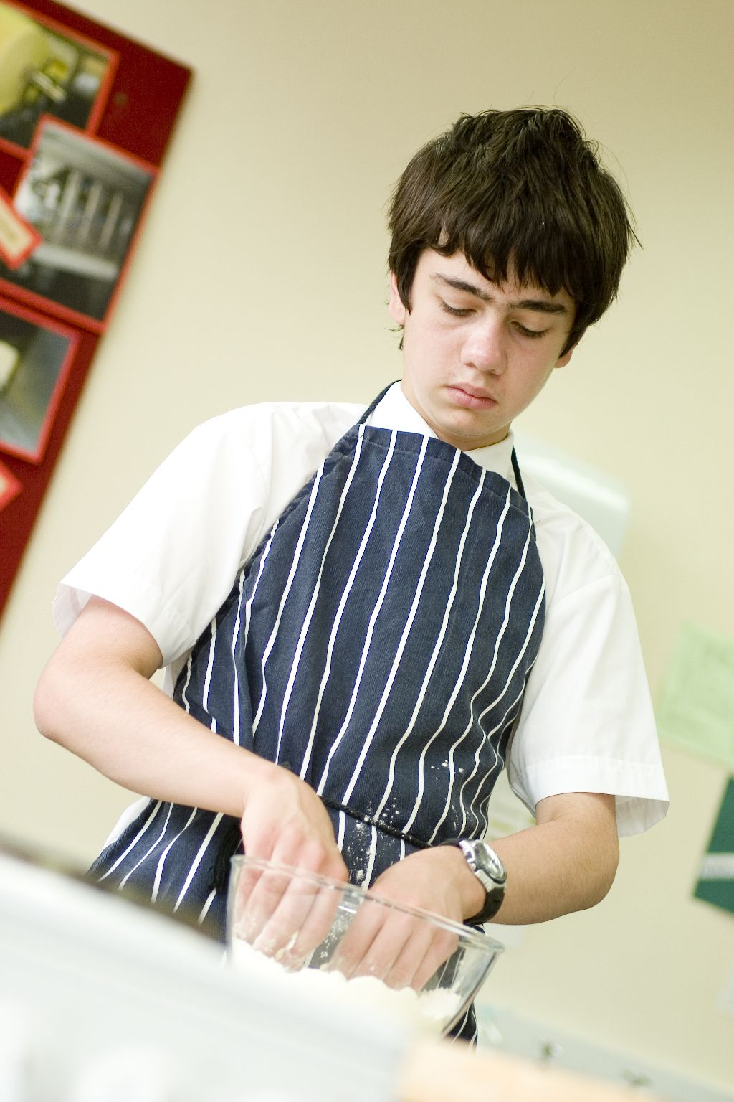
This is an extension to session 7. By this stage students should be confident in the cooking area, know the use of many different types of equipment and becoming more creative in their cooking. During this unit, students consolidate their understanding of the rubbing in technique by making a pastry based dish and prepare a range of ingredients for tasty fillings.

You may wish to observe students’ practical work using the practical observation sheet. The result of this observation, along with their previous practical work, goes towards their ‘licence to cook’.

During this unit, students will make either cheese and onion triangles or a tomato and basil tart. These have been chosen as they allow students to make shortcrust pastry, which uses the rubbing-in technique. It also provides the opportunity for students to roll out pastry and either line a flan ring/sandwich tin with pastry or make pasties.

There is lots of room for students to be creative, selecting different types of ingredients that could be combined into the dishes. You could get your students to use the cheese and onion triangles or tomato and basil tart recipe writing frames before cooking to develop their own ideas. The students’ own recipe creations could then be used in this unit.

If you have an established lesson plan and/or recipe, which supports the aims and objectives of this unit, feel free to use it instead. Look at the support materials provided within this unit as they support this activity and may well be useful in your own lessons, e.g. worksheets, PowerPoint presentations.

This unit can act as a stand-alone lesson, focusing on pastry making and the safe use of the oven. Alternatively, it could be integrated into a series of lessons, e.g. exploring different types of pastry that can be made, plus how these pastries can be used in a range of different dishes.

Aims and objectives

Aim
For students to:
- become more confident by extending their competence in preparing more complex dishes.

Objectives
Students should be able to:
- measure ingredients;
- make shortcrust pastry, using the rubbing in technique;
- prepare a range of ingredients for fillings, e.g. slicing;
- combine filling ingredients uniformly;
- roll out pastry, ready for use;
- line a baking dish or make/seal pasties;
- use the oven safely;
- make a pastry dish, e.g. cheese and onion triangles or tomato and basil tart.

Cooking session
Two cooking session plans, based on Licence to Cook recipes are supplied within this unit.

If you have your own tried and tested pasty or tart recipe, feel free to use it instead. In addition, you may wish to make other types of dishes, such as Jamaican patties, Cornish pasties, apple turnovers or quiche lorraine.

Each plan refers to aspects of healthy eating, wise food shopping and food safety and hygiene which are themes which run through each unit.

Before the cooking session
There are a number of factors that you need to consider before the cooking session. More detailed guidance is available in the Cooking session guide.

You will need to consider:
- Ingredients: who will be providing the ingredients and where will they be stored?
- Recipe: are pupils going to use a printed-out copy or follow instructions on an interactive whiteboard? The triangles recipe calls for beaten egg for a glaze. It may be easier for the school to provide the eggs for students to share.
- Equipment: is all the equipment needed for the session available, clean and in good working order? Check that all the ovens have two shelves available, plus oven gloves are at hand. Weighing scales and cooling racks should also be provided for students use. For the tarts, students can use a 20cm flan ring and baking tray or a sandwich tin. For the pasties, use a non-stick baking tray, preferably lined, e.g. grease proof or Teflon sheets.
- Aprons: do you have enough and are they clean?
- Hair: do you have ties/bands for long hair?
- Containers: will students be able to take away the pasty/tart they make? If so, in what?
- Waste: do you have adequate disposal facilities, including recycling or composting?
- Cooking area: is it clean and ready to use?

Differentiation and inclusion
Before this practical session, you will need to consider the age, ability, previous experience and any special requirements of your students. This will determine recipe selection, any advanced ingredient preparation and equipment used.

Do any of your students need:
- ingredients pre-measured, e.g. flour and butter?
- pre-prepared pastry or pastry cases, to help facilitate the lesson?
- support combining and rolling out pastry?
- to follow different recipes? The cheese and onion pasties recipe is easier than the tomato and basil tart.
- an extended range of ingredients for their fillings to challenge their preparation skills?

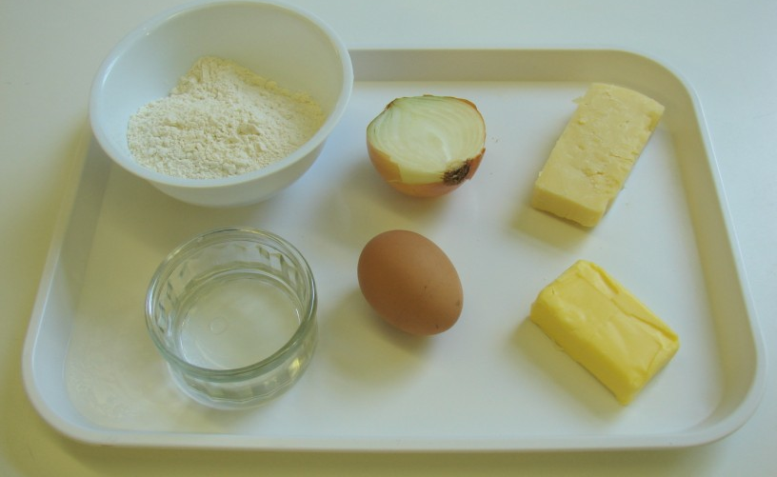
Demonstration
During the session you will be demonstrating how to make, roll out and use shortcrust pastry (using the rubbing-in technique). In addition, it will be important to show students either how to line a flan ring/sandwich tin or shape/make pasties. You may wish to remind students about the safe use of the oven.

Ensure that you have all the ingredients and equipment you need before the session, perhaps on trays for ease, for your demonstration.

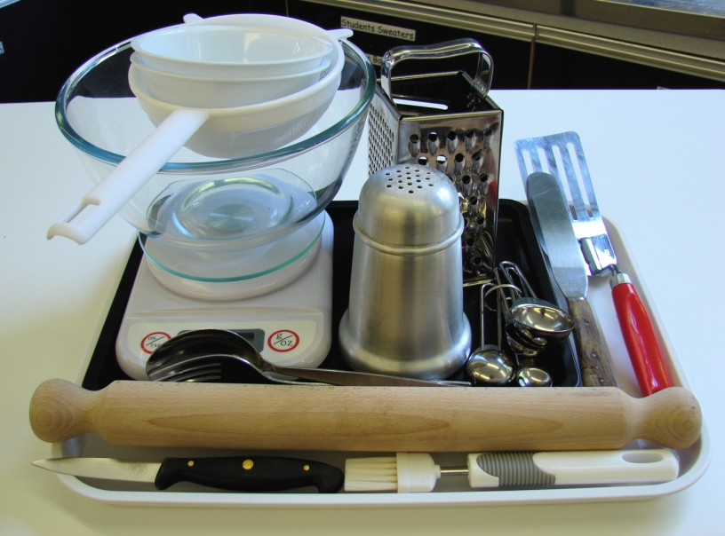
Think about:
- describing the ingredients and equipment used;
- highlighting the technique of rubbing-in, forming and shaping pastry;
- showing how to fold and form a pasty, or line a flan ring or sandwich tin;
- ensuring that students have followed and understood the method.

More detailed guidance is available in the Demonstrating guide.

Risk assessment
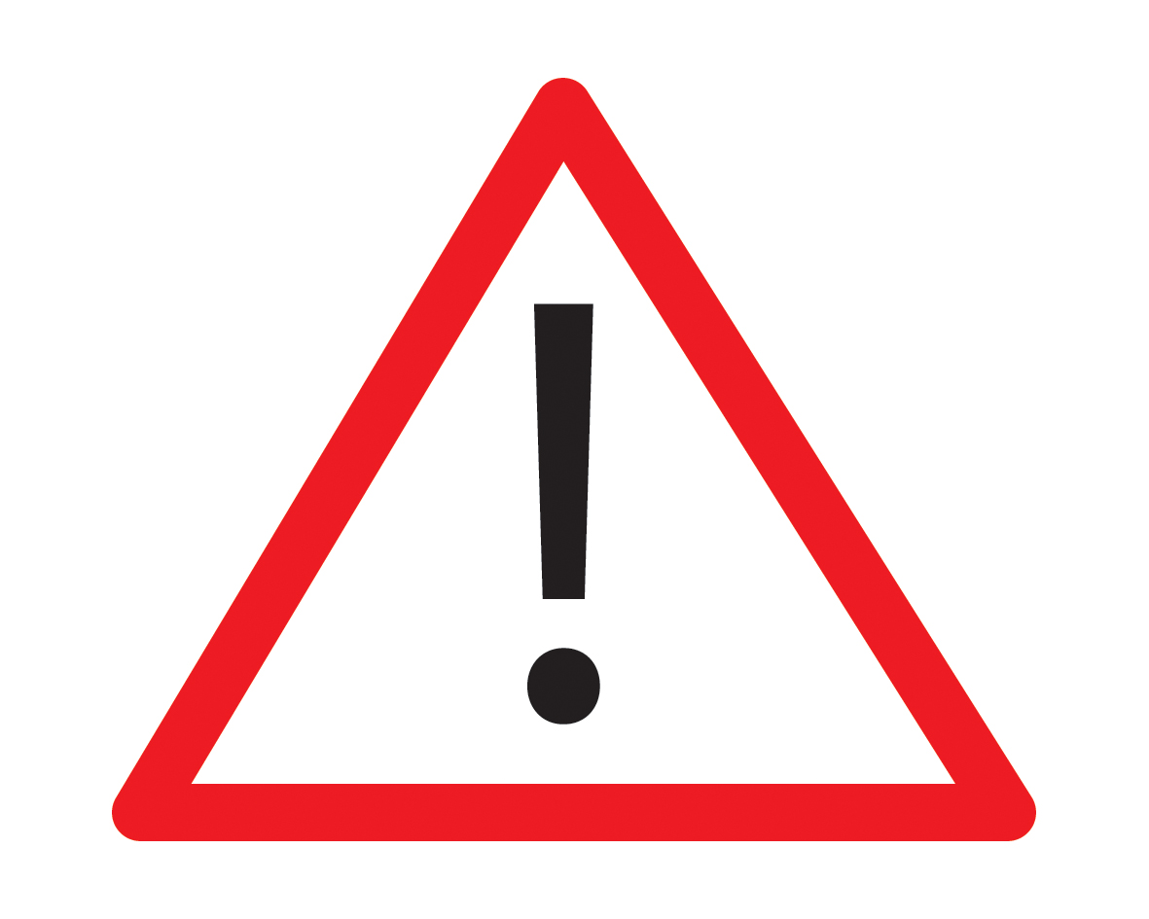
The two cooking session plans and recipes highlight a number of different hygiene and safety issues which need to be considered before, during and after the cooking session.

Before the cooking session, you will need to assess these risks in relation to the number of students being taught, as well as their experience, and consider measures that can be put into place to manage the risk. Below are examples of potential risks, along with preventative measures.

Cheese and onion triangles
Potential risk | Measure | Likelihood
 |  | Low
Cuts from using a knife unsafely | Demonstrate safe use of knives and monitor students’ use | Med

Tomato and basil tart
Potential risk | Measure | Likelihood
Food poisoning due to the presence of raw egg | Ensure that the egg mixture is completely cooked | Low/Med

Time
The session plans are based on a 60 minute session.

If you have less time available, you will need to modify the session plan to better suit your circumstances. For example, within this unit you might:
- demonstrate key aspects from the recipe, rather than every stage;
- have ingredients pre-measured and/or pre-prepared, e.g. butter or baking fat blocks, pre-sliced onions or pre-grated cheese;
- allow students to work with a partner.

During the lesson: Cheese and onion triangles
Time (mins) |  | Activity |  | Equipment/ Resources
0 |  | Registration.  Explain to the students that they will be making cheese and onion triangles. Go through the aims and objectives for the lesson. |  | PowerPoint Cheese and onion triangles recipe
5 |  | Gather the students around a demonstration area, with your tray of ingredients and equipment. Ensure that all students have their apron on, hair tied back and hands washed.  Briefly talk through the recipe – note your expectations, for example:  * measuring accurately;  *making shortcrust pastry, using the rubbing in technique;  * peeling and slicing an onion, and grating cheese;  * assembling the pasties;  * using the oven safely to bake the pasties;  * being hygienic and safe when preparing food.  Demonstration  * Place out the mixing bowl, sieve, palette knife, rolling pin and flour dredger.  * Remind students about pre-heating the oven. Remind students that when placing and removing items from the oven they must always wear oven gloves.  * Demonstrate the rubbing-in method. Explain that this technique is used to make shortcrust pastry. Sieve the flour into the bowl, and add the cold fat (cut into small pieces). The fat is cold so that it does not easily melt into your fingers and helps to form breadcrumbs. Start to push the fat into the flour using your fingertips – thumb pressing down onto the fingers. Repeat this, moving your hands above the bowl. Shake the bowl, on the work surface, to bring any large pieces of butter to the surface. Rub-in until it looks like fine breadcrumbs. Clean your hands before you continue. Stir in the sugar and dried fruit.  * Crack the egg into a separate bowl, then whisk with a fork.  * Next, make a well into the flour and add the egg - mix to form a soft, yet firm, dough. As you stir everything together, check that the mixture is not too sticky (if so, this can be corrected by adding a little flour) or not too dry (if so, you need to add a little water). |  | Aprons  Demonstration ingredient and equipment tray
* If you have time, you may wish to show the onion being peeled and sliced, and the cheese being grated. If not, have these two ingredients ready prepared, perhaps already mixed together.
* Put the bowl to one side and lightly use the flour dredger to sprinkle flour over the work surface. Place the dough on the floured surface. Sprinkle flour over the rolling pin. Gently roll over the dough. Turn it by 45º, then roll over it again. Continue this until the dough is about 2mm thick and square in shape. Use your hands to pat the dough into shape. If the dough sticks to the surface or rolling pin, sprinkle with flour. Do not use too much, as it will make the dough dry.

* Cut the square dough into four and place a spoon of cheese and onion filling near the centre of each. Make sure that you leave space for the triangle to be sealed together.
* Lightly brush beaten egg around the edges of each square. Then, fold over the outer most corner to the centre, making a triangle. Pinch the 2 inner sides to make a seal. Brush the top with egg.
* Place the triangles onto a baking tray, and using oven gloves, place in the oven.
15  25 | Ensure that all students wash their hands. Allow them to start making their cheese and onion pasties.  During this time, circulate the room to ensure that students are preparing ingredients and using the oven safely. In this time, students should:  * preheat ovens;  * measure their ingredients;  * make up the shortcrust pastry, using the rubbing-in technique.  At this stage most students should have made the pastry. Check the pastry before students continue. Then, students should:  * roll out the pastry into a square, and cut into four;  * grate cheese and slice the onion, and mix these together;  * fill and seal each pasty;  * place the pasties in the oven, using oven gloves. |  | Basic equipment  Frying pans  Saucepans  Ingredients
35 | All cheese and onion pasties should be in the oven. During this time students should be washing up, cleaning work surfaces and putting away equipment.
50 | Give a 5 minute time warning.  Remind students that all washing up should be completed, work surfaces should be clean, and their cheese and onion pasties should be on a cooling rack, ready to go in their containers.  Circulate the room, ensuring that sinks are clean, and equipment is put away properly.
55 | Plenary  Pose the following questions to the students:  * What were the main skills demonstrated today?  * Name 3 other types of filling that could be used.  * What might be served with the pasties to make a complete meal?
60 | Finish

After the session
Check that the room is clean and tidy. Students should leave the room as they find it.

The cheese and onion triangles will need to be stored after the lesson, due to their heat, and may need to be kept until the end of the school day. If so, ensure that each container is loosely covered and clearly labelled with the student’s name and group.

If the same students are with you for another cooking session in the next few days or week, remind them of the ingredients and/or containers they need to bring, if appropriate. You may wish to provide students with recipes or writing frames.

During the lesson
Time (mins) | Activity: tomato and basil tart | Equipment/ Resources
0 | Registration.  Explain to the students that they will be making a tomato and basil tart. Go through the aims and objectives for the lesson. | PowerPoint Tomato and basil tart recipe
5   | Gather the students around a demonstration area, with your tray of ingredients and equipment. Ensure that all students have their apron on, hair tied back, and hands washed.  Briefly talk through the recipe – note your expectations, for example:  * measuring accurately;  * making shortcrust pastry, using the rubbing in technique;  * lining a flan ring or sandwich tin;  * preparing the filling ingredients;  * assembling the tart;  * using the oven safely to bake the tart;  * being hygienic and safe when preparing food. | Aprons  Demonstration ingredient and equipment tray
 | Demonstration  * Place out the mixing bowl, sieve, palette knife, rolling pin and flour dredger.  * Remind students about pre-heating the oven. Remind students that when placing and removing items from the oven they must always wear oven gloves.  * Demonstrate the rubbing-in method. Explain that this technique is used to make shortcrust pastry. Sieve the flour into the bowl and add the cold fat (cut into small pieces). The fat is cold so that it does not easily melt into your fingers and helps to form breadcrumbs. Start to push the fat into the flour using your fingertips – thumb pressing down onto the fingers. Repeat this, moving your hands above the bowl. Shake the bowl, on the work surface, to bring any large pieces of butter to the surface. Rub-in until it looks like fine breadcrumbs. Clean your hands before you continue. | Aprons  Demonstration ingredient and equipment tray
 | * Demonstrate how to line the flan ring or sandwich tin. (If you are using a flan ring, ensure that it is greased and on a baking tray. Sandwich tins are easier to use, as the filling cannot escape while cooking.) Fold the pastry circle into quarters, lift and place the middle point into the centre on the ring/tin. Carefully unfold the pastry and push the pastry generously around the edges. Make sure that you do not stretch the pastry tight, as it will shrink when cooking.  * Use a palette knife to carefully remove excess pastry from around the edge of the ring/tin. Then, use a fork to prick holes in the base of the pastry – this is to stop the pastry from rising when cooking.  * If you have time, you may wish to show the filling being whisked together and assembled in the pastry case.  * Remind students to use oven gloves to place the tart into the pre-heated oven. | Aprons  Demonstration ingredient and equipment tray
15  25 | Ensure that students all wash their hands. Allow them to start making their tomato and basil tart.  During this time, circulate the room to ensure that students are preparing ingredients and using the oven safely. In this time, students should:  * preheat ovens;  * measure their ingredients;  * make up the shortcrust pastry, using the rubbing-in technique.  At this stage most students should have made the pastry. Check the pastry before students continue. Then, students should:  * roll out the pastry into a circle;  * line the flan ring or sandwich tin, trim its edges and prick the base;  * make up the filling and pour into the pastry case;  * place the tart in the oven, using oven gloves. | Recipe  Equipment  Ingredients  Baking trays
35 | All tarts should be in the oven, as they need 25 minutes cooking. During this time students should be washing up, cleaning work surfaces and putting away equipment.
50 | Give a 5 minute time warning.  Remind students that all washing-up should be completed, work surfaces should be clean and their tomato and basil tarts should be cooling down; ready to go into a container.  Circulate the room, ensuring that sinks are clean and equipment is put away properly.
55 | Plenary  Pose the following questions to the students:  * What were the main skills demonstrated today?  * Name 3 other types of cheese that could be used.  * What might be served with the tart to make a complete meal?
60 | Finish

After the session
Check that the room is clean and tidy. Students should leave the room as they find it.

The tomato and basil tart may need to be refrigerated until the end of the school day, if so, ensure that each container is covered and clearly labelled with the student’s name and group. The refrigerator should be between 0-5ºC. Only place in the refrigerator when cool.

If the same students are with you for another cooking session in the next few days or week, remind them of the ingredients and/or containers they need to bring, if appropriate. You may wish to provide students with recipes or writing frames.

Areas of learning

Healthy eating
- Try using wholemeal flour in the pastry to increase fibre content.
- Serve the pasties and tart with a large salad, as well as a glass of fruit juice.

Wise food shopping
- Free range eggs cost more than barn eggs. However, some people choose to buy free range for animal welfare and ethical considerations.

Food safety and hygiene
- When getting ready to cook, always wear an apron, tie back long hair, roll up long sleeves, remove any jewellery and wash your hands.
- Ensure that the egg in the tomato and basil tart is completely cooked.

Extending this activity
This unit provides a great opportunity to be integrated into existing lessons or be developed into a mini-scheme of work.

For example, you could:
- Explore different types of pastry that can be made, looking at uses for each;
- plan and create dishes which can be cooked for birthday parties or other special celebrations;
- evaluate different ways of using pastry as a casing.

Appropriate aspects of ICT could also be integrated, including:
- recording sensory data;
- creating a recipe plan or flow-chart;
- modelling recipe costs, looking at the consequences of changing ingredients;
- exploring the internet for pasty and tart recipes.

Shopping list

Cheese and onion triangles
Ingredient | x 1 | x 10 | x 20
Cheddar cheese | 100g | 1kg | 2kg
Onions (each) | 1 | 10 | 20
Plain flour | 100g | 1kg | 2kg
Butter or baking fat/block | 50g | 500g | 1kg
Eggs – for glazing (each) | 1 | 2-3 | 4-6

Tomato and basil tart
Ingredient | x 1 | x 10 | x 20
Plain flour | 100g | 1kg | 2kg
Butter or baking fat/block | 50g | 500g | 1kg
Tomatoes (each) | 3 | 30 | 60
Basil leaves | handful | a basil plant | 2 basil plants
Eggs (each) | 2 | 20 | 40
Semi-skimmed milk | 125ml | 1.25 litres | 2.5 litres
Cheese | 50g | 500g | 1kg
Black pepper | a few twists | a few twists | a few twists

Equipment list

Cheese and onion triangles
Weighing scales, chopping board, grater, knife, mixing bowl, sieve, measuring spoons, palette knife, flour dredger, rolling pin, spoon, fork, 2 small bowls, pastry brush, fish slice, baking tray.

Tomato and basil tart
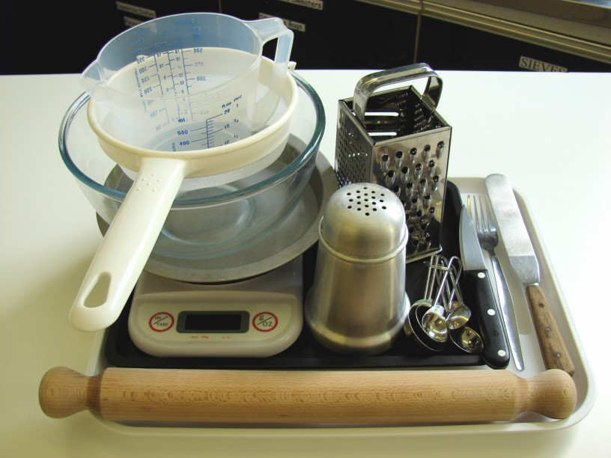
Weighing scales, sieve, mixing bowl, 20cm flan ring and baking tray or sandwich tin, palette knife, measuring spoons, measuring jug, rolling pin, flour dredger, small bowl, chopping board, knife, fork, grater.

Containers

If students take their pasties or tarts home, they will need to bring (or be provided with by the school) a suitable container, such as a plastic or foil container with a lid.

