Bunny chow

Ingredients
Complexity: medium-high

1 small onion

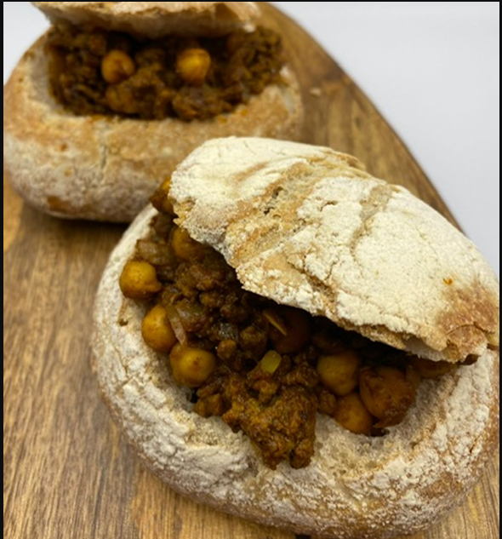
2 garlic cloves

200g canned chickpeas

250g minced beef or lamb

1 x 5ml spoon ground ginger
½ x 5ml spoon chilli powder

½ x5ml spoon ground turmeric

1 x 5ml spoon ground cinnamon

½ x 5ml spoon ground cumin

1 x 15ml spoon tomato puree

1 reduced salt beef stock cube

300ml boiling water

2 crusty rolls

Equipment

Chopping board, vegetable knife, measuring jug, sieve, large frying/sauté pan, mixing spoon, bread knife.

Method
- Prepare the ingredients:
- peel and dice the onion;
- peel and finely chop or crush the garlic;
- drain the chickpeas and rinse.
- Add the mince beef, onion and garlic to a large frying/sauté pan and dry fry until the meat is evenly browned and the onion softened.
- Add the ginger, chili powder, ground turmeric, ground cinnamon and ground cumin to the pan and cook for 2 minutes.
- Add the tomato puree to the pan and crumble in the stock cube.
- Pour over 300ml boiling water and stir well.
- Add the drained chickpeas and stir. Bring to the boil and simmer for 15-20 minutes until the liquid is reduced.
- Cut the top off the crusty rolls and hollow out the inside.
- Serve the meat mix in the hollowed-out bread rolls, with the top of the roll as a ‘lid’.

Top tips
- The filling could be served in a non-traditional way with rice or potatoes and vegetables.
- For a vegetarian version substitute the meat with red kidney beans and add 1 x 15ml spoon of finely chopped fresh ginger for extra zing!

Food skills
- Weigh and measure
- Peel
- Chop
- Cut
- Drain
- Fry
- Stir
- Boil
- Simmer

Did you know?
- Bunny chow is a popular South African street food created by the Durban Indian community in the 1940s. The term ‘bunny’ is a variation from the word “Bania“, an Indian class of traders who first sold this tasty street food.
- It was designed to be a portable dish; the curry is eaten out of the bread ‘dish’ and then the bread that has soaked up all the curry juices and flavour is eaten!
- The recipe can be adapted to make vegetable, bean, mutton, and chicken bunnies.

