Testing food for protein 1

Introduction
This is a simple test which shows whether a food contains soluble protein. If soluble protein is present in the food there is a colour change in the test strip. Test strips (Albustix) are made to test urine for the presence of protein.

They can be used for testing a restricted range of other dilute solutions for soluble protein but not for insoluble material.

You will need
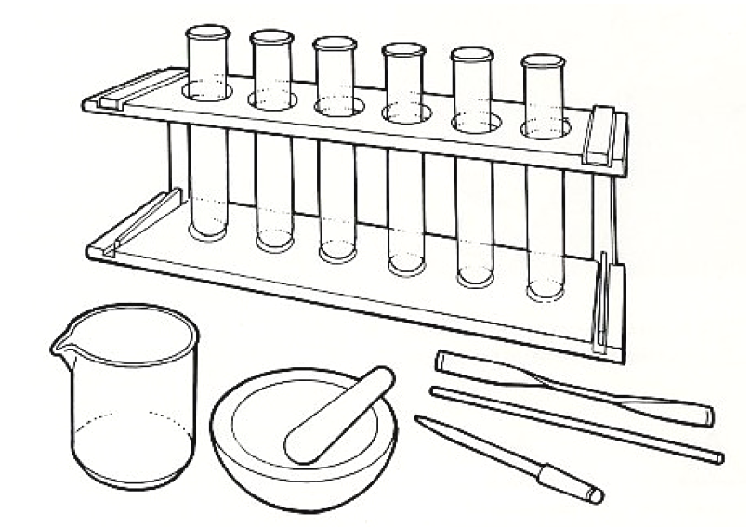
Equipment
Test tubes
Test tube rack
Glass rod
Spatula
Mechanical grinder or pestle & mortar
Dropping pipette
Beaker or dish

Material
Food samples
Distilled water
Albustix reagent strips (in container
with instructions)




Some people are allergic or intolerant to a particular food or ingredient. Refer to the 14 allergens and check against student records before completing this experiment.

Do not consume food in a laboratory, or any food used for experiments, because it may contaminated.

Method
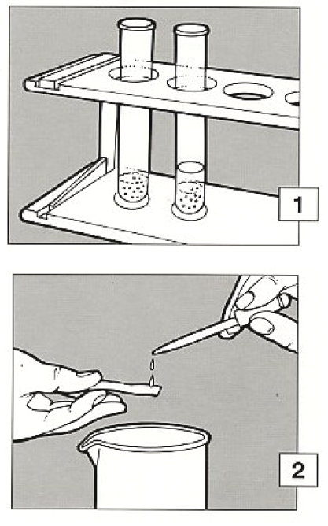
- If the food to be tested is liquid, go to 2. If the food to be tested is solid, make an extract. Grind, crush or chop a small amount and put it into a test tube to a depth of about 2cm. Add a similar amount of distilled water and stir with a glass rod. Allow to stand for a few minutes.

- Draw up some of the clear liquid into a pipette and then, holding an Albustix reagent strip horizontally over a dish, drop a little of the strip to wet the coloured test area.

- Shake off any excess liquid and wait for the time stated by the instructions. Then compare the colours shown on label of the Albustix container.

- Decide if the colour indicates that protein is present in the sample. Compare the depth of colour to estimate whether the sample contains a little, a moderate amount or a lot of protein.

Extension work
To test for protein which may be in food in very small amounts, begin with a much larger sample, such as a whole fruit or vegetable. Crush and pound it thoroughly and squeeze the pulp out through a sieve to get as much liquid as possible. Then follow the method from stage 2.

