Asian forest greens

Ingredients
Complexity: low-medium

100g brown mushrooms

80g seafood (Enoki) mushrooms (or another available kind)

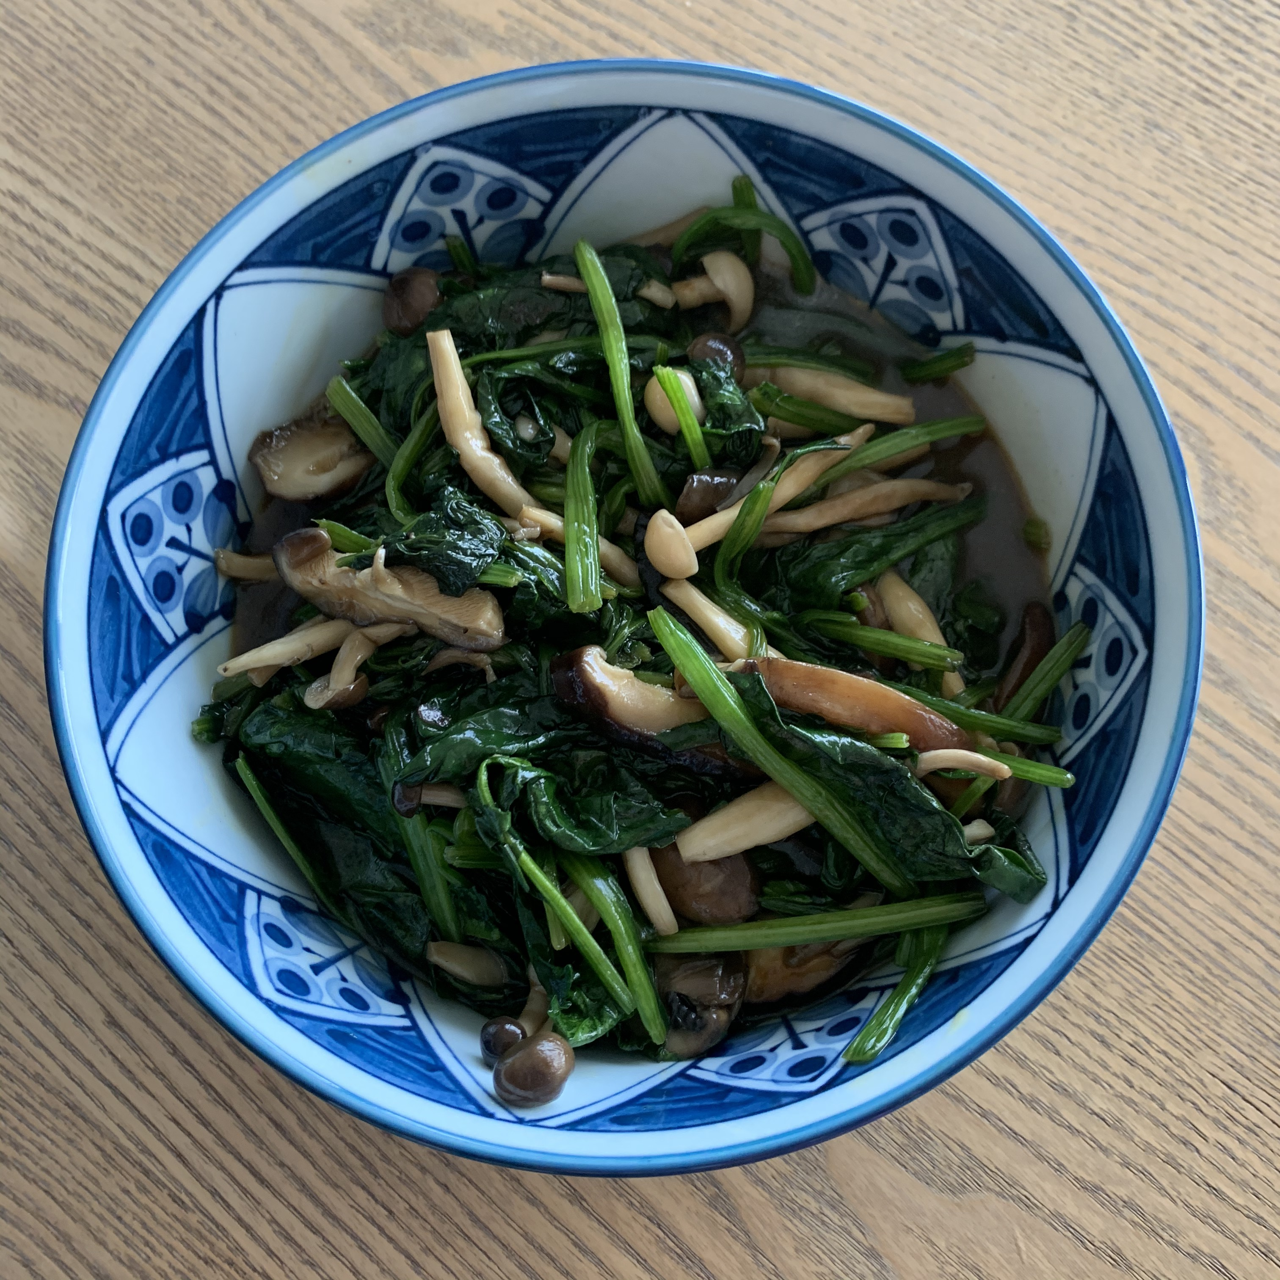
1 garlic clove

Spray oil

1 x 15ml spoon water

100g spinach leaves

2 x 5ml spoon oyster sauce (or vegetarian alternative)

Equipment

Chopping board, vegetable knife, saucepan, measuring spoons, mixing spoon.

Method
- Prepare the ingredients:
- slice the brown mushrooms;
- remove the end of the seafood mushrooms;
- peel and finely chop the garlic.
- Heat the oil in a saucepan.
- Add the garlic and mushrooms, fry gently for 3 to 4 minutes.
- Add the water.
- Add the spinach leaves, stir well until they wilt.
- Add the oyster sauce (or vegetarian alternative).
- Mix well, cook for 2 to 3 minutes.
- Serve warm as a side dish.

Top tips
- This is a versatile recipe which works with many other leafy vegetables, including broccoli. Why not try other kinds of mushroom as well?
- Vegetarian/vegan alternatives to oyster sauce include mushroom-based soy sauce, hoisin sauce or sweet soy sauce.

Food skills
- Weigh
- Measure
- Cut
- Chop
- Peel
- Mix
- Stir
- Fry

Did you know?
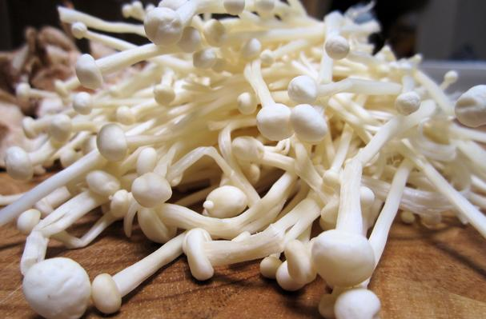
Enoki mushrooms, sometimes referred to as “seafood” mushrooms are white with long white stems and small white convex caps. They are usually sold in clusters. Seafood mushrooms are traditionally used for soup but can also be used for salad and other dishes. They have a crispy texture after being cooked.

This recipe has been kindly donated by Georgine Leung.

