Anzac biscuits

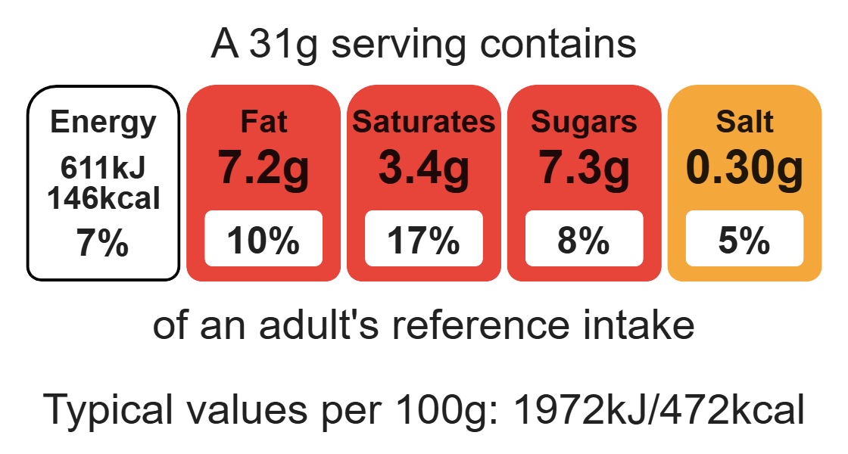
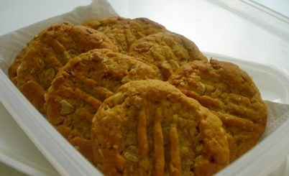

Ingredients (makes 8)
Complexity: low - medium
100g plain wholemeal flour
25g oats

Equipment

Baking tray

Weighing scales

Mixing bowl

Sieve

Saucepan

Heat-reistant spoon

Measuring spoons

Kettle

Small bowl

Spatula

Palette knife

Flour dredger (optional)

Fork

Cooling rack

30g caster sugar
25g desiccated coconut
20ml spoon golden syrup
50g baking fat/block
½ x 5ml spoon bicarbonate soda
10ml spoon boiling hot water

Method
- Preheat the oven to 160ºC or gas mark 4.
- Grease or line the baking tray.
- Sift the flour into the mixing bowl.
- Add the coconut, oats, and sugar into the mixing bowl and mix well.
- Melt the golden syrup and fat together on a low heat in a small saucepan.
- Mix the bicarbonate of soda with the boiling hot water and add to melted syrup and fat immediately.
- Add the wet mixture to the dry ingredients.
- Mix thoroughly until combined.
- Divide the mixture evenly into 8 portions using the metal spoon.
- Use lightly floured hands to shape the biscuits into round balls and place onto the prepared baking tray.
- Slightly flatten the biscuits with a lightly floured fork.
- Bake for 15-20 minutes, until golden brown.
- Cool on the baking tray for a few minutes, to allow the biscuits to firm, before transferring them to a cooling rack.

Top tips
- Reduce food waste: Use up any leftover fruit such as, apricots, berries, peaches, plums or pears. The fruit can be canned, dried or frozen.
- Turn up the flavour: Try adding ½ x 5ml spoon cinnamon to enhance the flavour.

Food skills
Weigh, measure, sift, mix, stir and combine, melt, simmer and boil, portion or divide, form and shape, bake.

