Vegan meat free chilli

Ingredients
Complexity: medium-high
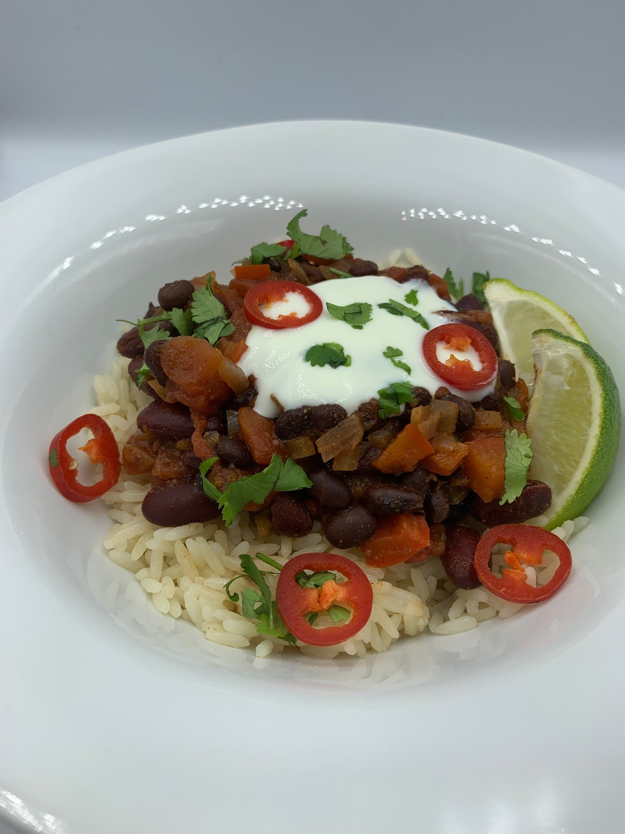
1 red onion
1 celery stick
1 red pepper
400g can red kidney beans in water
400g can black beans in water
1 lime
1 gluten-free, vegan stock cube
1 x 15ml spoon vegetable oil
1 x 15ml spoon smoked paprika
1 x 15ml spoon ground cumin
1 x 5ml spoon ground cinnamon
400g can chopped tomatoes

Optional – garnish
1 lime
2 x 15ml coriander
1 red chilli
4 x 15ml spoons diary-free coconut yogurt alternative

Equipment
Chopping board, vegetable knife, colander/sieve, juicer, measuring jug, large saucepan, measuring spoons, wooden spoon.

Method
- Prepare the ingredients:
  - peel and finely chop the onion;
  - finely chop the celery;
  - deseed and finely chop the pepper;
  - drain and rinse the kidney beans;
  - drain and rinse the black beans;
  - juice one of the limes;
  - dissolve the stock cube in 400ml boiling water, stir well.
- Heat the oil in a large saucepan over a medium heat
- Fry the onion, celery and pepper for 5 mins, stirring occasionally, until starting to soften,
- Add the paprika, cumin and cinnamon, cook for 1 minute.
- Stir in the kidney beans, black beans, tomato and stock.
- Bring to the boil, then reduce to a simmer, cover and cook for 20 minutes, stirring occasionally, until the sauce starts to thicken.
- Prepare the garnish, if using:
  - cut the lime into wedges;
  - chop the coriander;
  - finely slice the chilli into rings, carefully removing the seeds.
- Once cooked, stir in the lime juice.
- Serve topped with the coconut yogurt alternative, coriander and chilli, with lime wedges and rice on the side.
Food skills
- Measure
- Peel
- Chop
- Drain
- Juice
- Fry/sauté
- Stir
- Boil
- Simmer

Top tips
- Serve with brown rice for added fibre and a mixed green salad.
- This is an ideal recipe if vegetables have begun to go soft – prevent food waste and use anything you can find in your fridge!
- Make a fresh salsa to serve with the chilli: Take a red onion, a tomato and some fresh coriander. Chop finely and mix with the juice of a lime.

Did you know?
Black beans are legumes, which include beans, peas, lentils. There are a number of types of black beans, including Domino, Black Magic, Blackhawk, Condor, and Raven.

Black beans are also known as turtle beans, because of their hard shells, also frijoles negros, zaragoza, judía negra, poroto negro, caraota negra, or habichuela negra in Spanish; and feijão preto in Portuguese

It is a very popular bean in various regions of Brazil, and is used in the national dish, feijoada. It is also commonly used in Indian and Tamil cuisines.

This recipe was kindly donated by Co-op Group Limited.

