Carrot and cranberry muffins

Ingredients
Complexity: Low-medium

75g carrot, peeled and finely grated

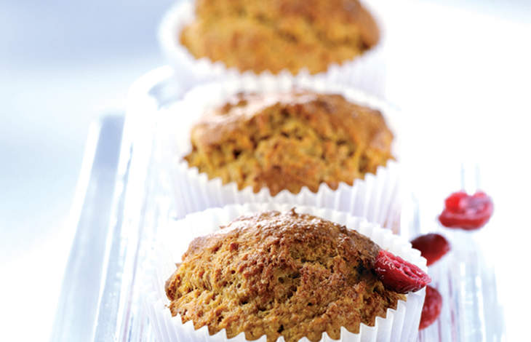
110g plain wholemeal flour

25g wheatgerm

2 x 5ml spoon baking powder

½ x 5ml spoon ground cinnamon

50g light soft brown sugar

50ml semi-skimmed milk

50ml oil

1 medium egg, lightly beaten

50g dried cranberries

Equipment
Grater, large bowl, spoon, muffin tray, muffin cases, skewer, cooling rack.

Method
- Preheat the oven to 200⁰C, Gas Mark 6.
- Place the grated carrot into a large bowl and stir in the flour, wheatgerm, baking powder, ground cinnamon and sugar.
- Gradually add the milk and oil followed by the egg and mix well until evenly blended.
- Finally stir in the cranberries.
- Divide the mixture into 6 muffin cases and bake in the oven for 20 minutes or until a skewer inserted into the centre comes out clean.
- Leave to cool slightly before serving.

Food skills
Grate
Mix, stir & combine
Portion & divide
Bake

