Pol mizeria (cucumber salad)

Ingredients
Complexity: low-medium
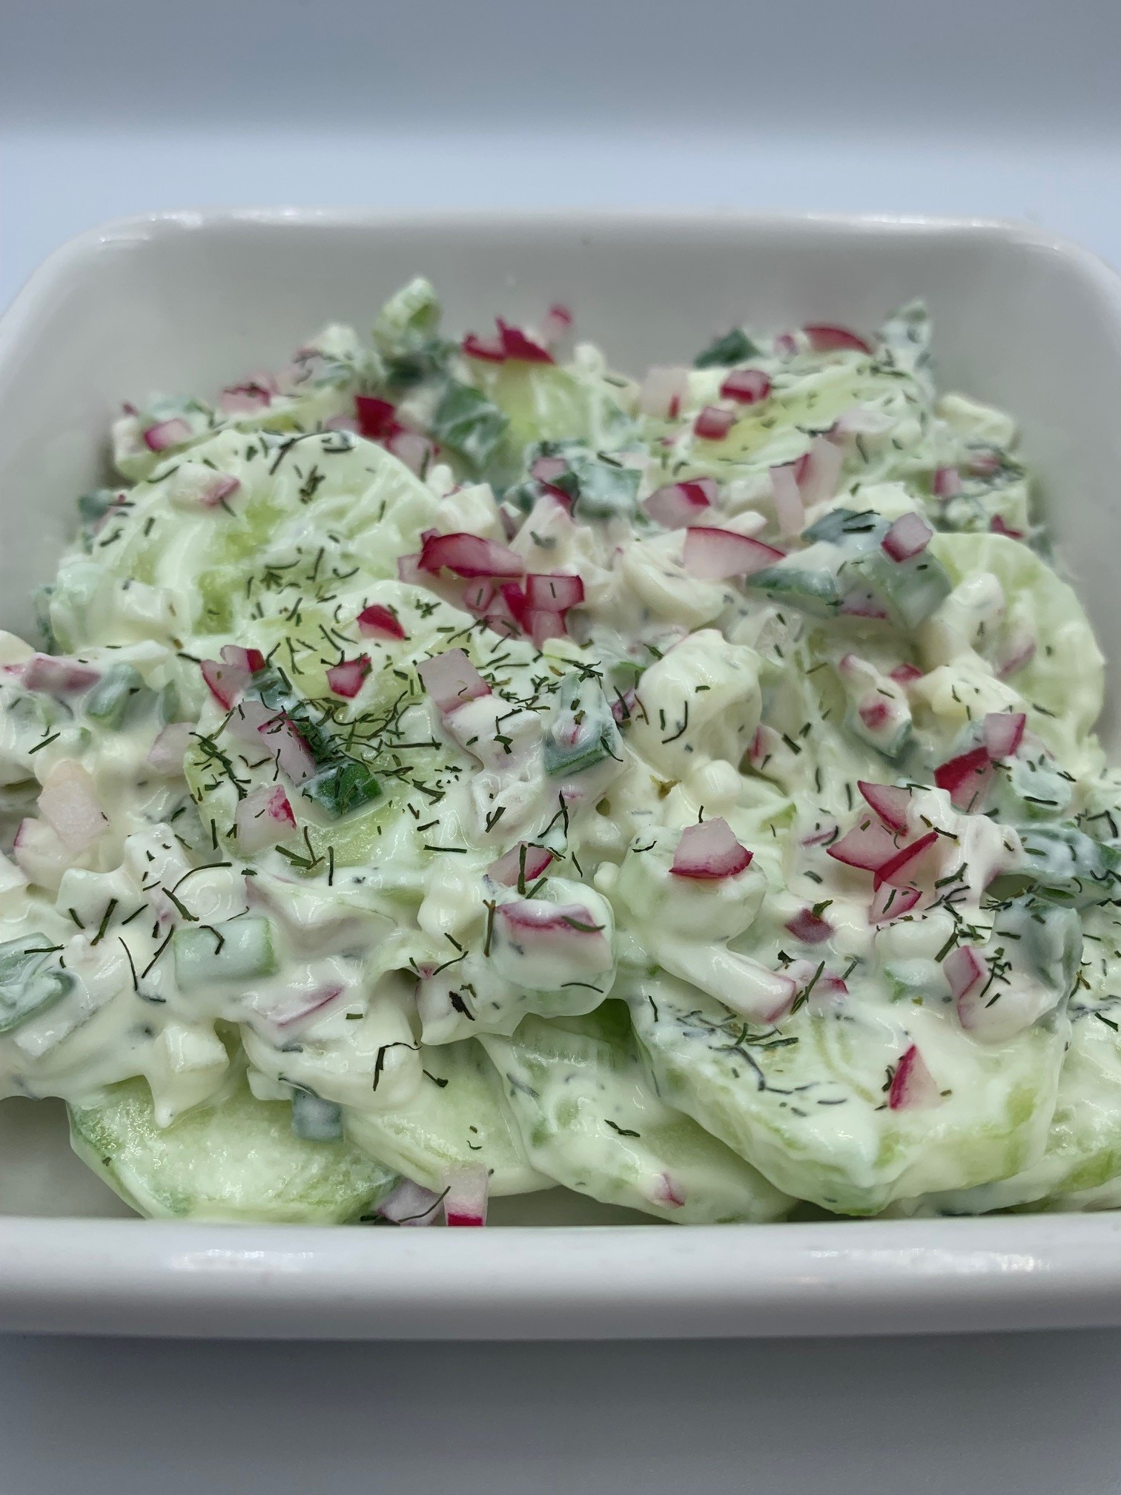
½ cucumber
2 spring onions
2 radishes
1 x 15ml spoon reduced fat thick natural yogurt
¼ x 5ml spoon dried or 1 x 5ml spoon fresh dill
Black pepper

Equipment
Vegetable peeler, vegetable knife, chopping board, kitchen scissors, mixing bowl, mixing spoon.

Method
- Prepare the ingredients:
  - peel and slice the cucumber;
  - snip the spring onions into rings;
  - top, tail and finely dice the radishes.
- Place the cucumber, spring onions, radishes, yogurt and dill in a bowl.
- Season with black pepper, mix well and serve.

Top tips
- For a simple version of cucumber salad, omit the radishes and dill.
- Try chopping half an onion and a bunch of chives and using this instead of the spring onions.

Food skills
- Measure
- Peel
- Slice
- Snip
- Dice
- Mix

Did you know?
The literal meaning of this traditional Polish dish is misery or poverty. The salad can be served as a stand-alone snack or as an addition to a main dish.

Each household in Poland has its own recipe, and each recipe can have variations depending on what is available at home. The essential ingredients are cucumber, thick yogurt (or thick cream) and seasoning.

This recipe was adapted from a recipe kindly donated by Lukasz Jedrzejek.

