Looking after our planet

Try some of these activities!
  Be a soil investigator  Dig a hole and carefully collect a few scoops of soil.  Take a look at your soil under a magnifying glass. List everything you can see!  Make a close up drawing of some of your soil. | 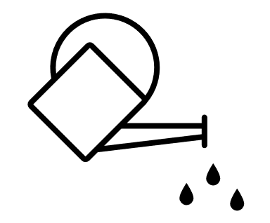  Collect water  Research water butts and find out how they collect rainwater.  Plan and build your own water butt.  Use the rainwater you collect to water indoor and outdoor plants.
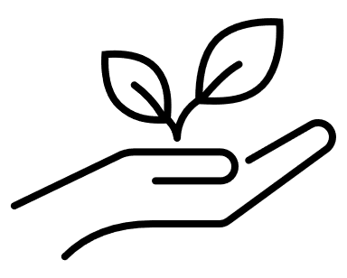  Get growing  Growing food is good for the soil, good for insects and wildlife, and good fun!  Have a go at growing some food! You could try growing potatoes, herbs, tomatoes, beans or courgettes, at school or home! | 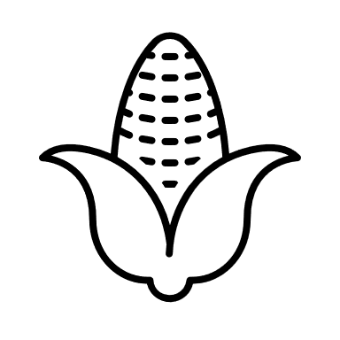  Seasonal eating  Take a look at the fruit and vegetables in your local shop or supermarket.  Find three that have been grown in the UK. Draw each one and write where it comes from. Search for the places on a map.  Are any of them near where you live?

