Ful medames

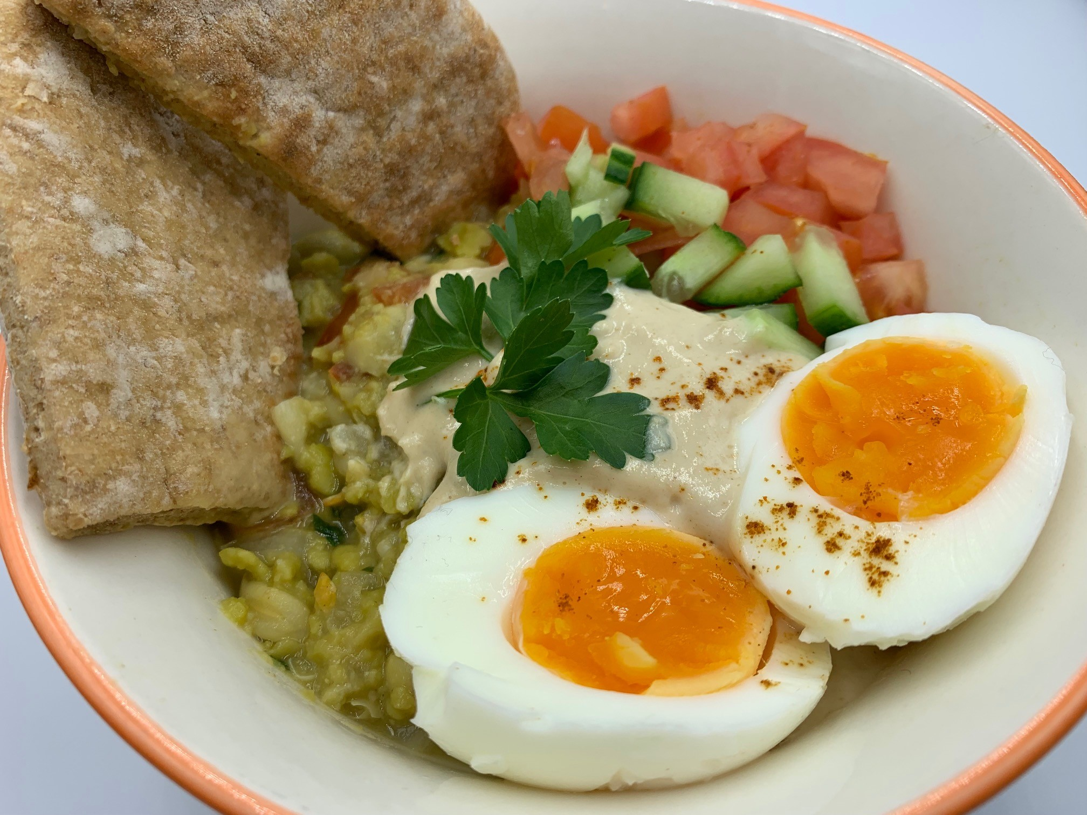
Ingredients
1 small onion
1 garlic clove
Complexity: medium-high

1 tomato

Spray oil

½ x 5ml spoon ground cumin
1 x 300g can fava beans or broad beans
2 x 15ml spoons lemon juice
100ml water
1–2 eggs per person

Wholemeal pitta bread

Tahini sauce - optional

50g tahini*

35ml water

2 x 5ml spoons lemon juice

Garnish – optional

10g fresh parsley

1 tomato

¼ cucumber

Cayenne pepper

Equipment

Chopping board, vegetable knife, garlic press, colander, 2 x saucepans, measuring spoons, fork or potato masher, small mixing bowl, mixing spoon.

Method – Ful medames
- Prepare the ingredients:
  - peel and dice the onion;
  - peel and crush the garlic;
  - dice the tomato;
  - drain and rinse the beans.
- Place the eggs in a pan of cold water. Bring to the boil and cook for ten minutes. After ten minutes, remove from the heat and run the eggs under cold water. Peel and cut in half.
- Spray a small saucepan with oil. Add the chopped onion and half the garlic and fry gently for 2-3 minutes.
- Add the ground cumin, beans, diced tomato, 2 x 15 spoons lemon juice and 100ml water.
- Bring to the boil and then simmer for 10 to 15 minutes.
- Remove from the heat and roughly mash the beans with a fork or potato masher.

Method – Tahini sauce (optional)
- Place the tahini, remaining garlic, 35ml water and 2 x 5ml spoons lemon juice in a small bowl.
- Whisk together until smooth. The mixture might split initially but will become smooth with further mixing.

Method – Garnish (optional)
- Chop the fresh parsley.
- Dice the tomatoes.
- Dice the cucumber.

*Tahini contains sesame seeds, nut butters such as cashew or almond can be used as an alternative. Natural or Greek yogurt can also be used, but these will give a milder taste to the sauce.

Top tips
- Add ¼ x 5ml spoon cayenne pepper for a spicy kick!
- Borlotti beans, kidney beans or butter beans could be used instead of fava or broad beans.
- Serve ful for breakfast with hot pitta or flat bread.

Food skills
- Weigh
- Measure
- Peel
- Crush
- Chop and dice
- Drain
- Fry
- Stir
- Boil
- Simmer

Did you know?
Fava beans are used nearly as much as chickpeas in Middle Eastern cuisine and particularly in Egyptian food. The word ful is, in fact, Egyptian for fava bean. Fava beans are often fried, salted and spiced and sold as a street food. Fava beans are grown in pods, which are usually removed before the beans are eaten or cooked. Fava beans can be eaten raw or boiled, steamed, fried or added to stews, soups and salads, and made into dips.

Tahini is used in many Mediterranean and Middle Eastern dishes. It is a paste made from ground sesame seeds and is often used in dips such as hummus and baba ghanoush (made with grilled or roasted aubergines). Tahini-based recipes appear widely in Armenian, Cypriot, East Asian, Greek, Indian, Iraqi and Turkish cuisines.

In Syria, ful medames is served with a red small amount of red pepper paste, made from Aleppo pepper (also known as Halaby pepper).

