Thai style mussels

Ingredients
Complexity: medium-high
100ml coconut milk
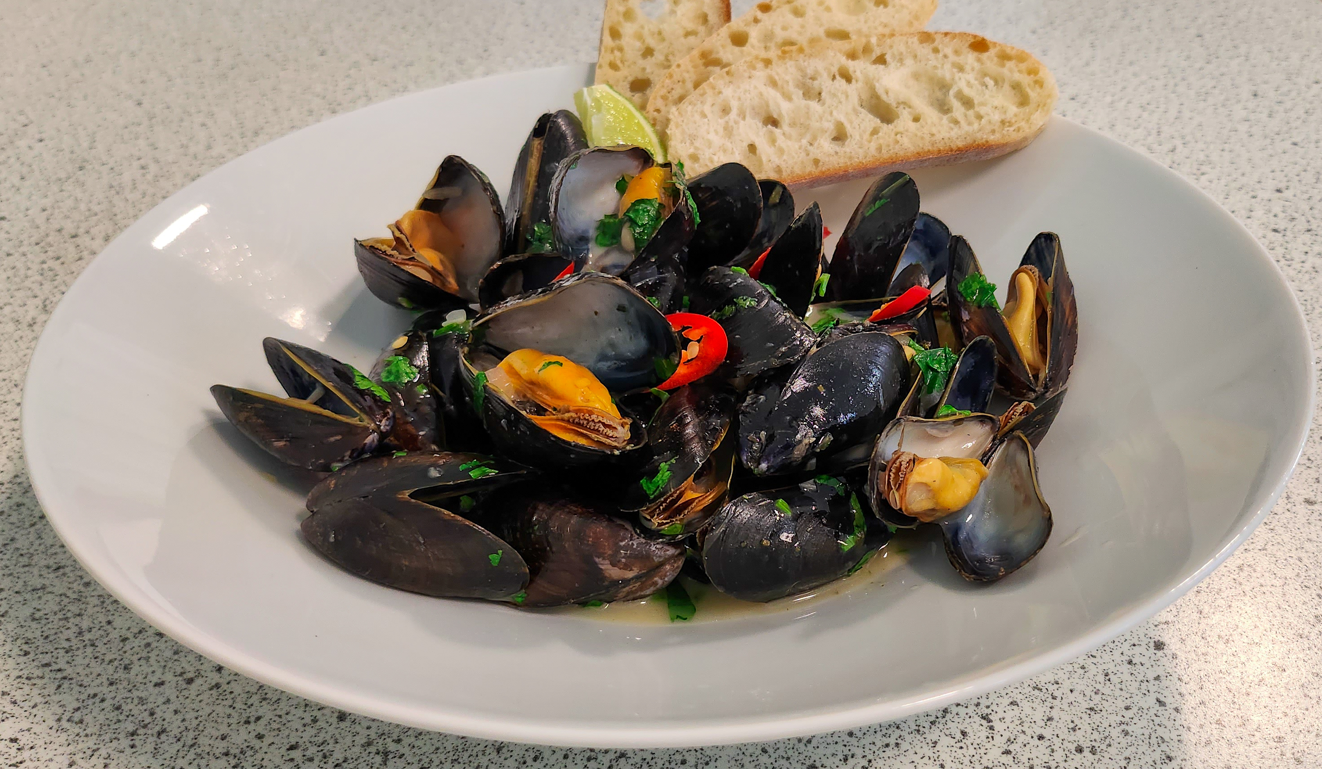
½ small onion
1 clove garlic
1/6 thumb ginger
1/8 fresh red chilli
1 small handful of fresh coriander
250g mussels
1 lime
1 x 15ml spoon olive oil
2 x 5ml spoons Thai green curry paste

Equipment
Chopping board, vegetable knife, measuring spoons, wok with lid (or foil to cover), mixing spoon, can opener (if needed), slotted spoon, two serving bowls.

Method
- Prepare the vegetables and mussels:
  - peel and finely dice the onion;
  - peel and finely dice the garlic;
  - peel and finely dice the ginger;
  - finely chop the chilli;
  - roughly chop the coriander leaves;
  - cut the lime into 4 evenly sized wedges;
  - clean the mussels thoroughly.
- Add the oil to the wok and heat. Add the onion garlic and ginger and sauté for 1 minute.
- Add the curry paste to the wok and cook for 1 minute.
- Pour in the coconut milk and turn up the heat to a simmer.
- Add the mussels, cover the wok and cook for 4 minutes.
- Serve the dish:
  - check the mussel shells have opened. Discard any unopened mussels;
  - squeeze lime juice from one wedge into the broth;
  - divide the mussels and broth into the serving bowls;
  - garnish with the chilli, coriander and the remaining lime wedges.

Top tips
- Check mussels are good to use before cooking. Discard any broken or ones that fail to close when gently tapped on a work surface.
- When preparing chilli peppers, do not to touch the eyes or similar areas that can be affected by the capsaicin (an irritant) that rubs off on hands. Wash your hands immediately after handling chilli peppers.
- To prepare remove the stem and slice the chilli pepper in half. With a teaspoon, carefully remove the ribs and seeds then slice or dice as needed.
- Serve with slices of crusty bread, or homemade flatbreads.

Food skills
Weigh and measure
Peel
Dice and chop
Fry and sauté
Simmer
Juice
Garnish

This recipe was kindly donated by Food Teachers Centre, through their FISH (Food in School Hero) programme.

