Where food comes from
- Food is sourced, processed and sold in different ways.
- Geography, seasonality, weather and climate influence the availability of food and drink.
All food must be grown, reared or caught
In the past food was grown, prepared and cooked at home or sold by small-scale producers or merchants.

Some people still grow food at home or on allotments. Food can also be bought from a wide range of sources, including:
- cafes/coffee shops;
- convenience stores;
- farmers markets;
- farm shops;
- markets;
Food availability
Some ingredients or foods are available throughout the year because they have been imported from other countries where they are in season at different times of the year.

Climate and terrain are two key factors that affect food availability and where food is grown, reared and caught.

There is a great variety of food grown all over Europe. The type of farming is partly determined by the climate and the geography of the country or region. The terrain or landscape determines which crops are grown or animals reared. Cereal crops are grown in flat plains, whereas sheep can be reared in hilly terrain.

Key terms
Food processing: Any deliberate change to food that happens to a food before it is available to eat.
Seasonality: Food grown at a particular time of year.
Food certification and assurance schemes: Defined standards of food safety, quality or animal welfare.
Food security: Having access to sufficient quantity of affordable, nutritious food.
Food provenance: Knowing where food was grown, caught or raised and how it was produced.

- on-line retailers;
- restaurants;
- supermarkets;
- takeaway outlets.

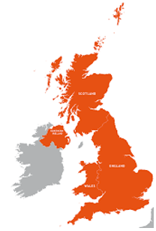
Food Processing
Food processing is any deliberate change to food that happens to a food before it is available to eat. Processing makes food safer to eat by killing existing bacteria and slowing bacterial growth.
Food is processed for a number of reasons:
- to extend shelf life;
- to add variety;
- for convenience;
- for consumer’s health.
Innovations in food processing have led to the development of functional foods; these provide benefits over and above the basic nutritional value, e.g. dairy products containing probiotic bacteria.

Map showing key growing areas in the UK – some parts of the UK have excellent soil for crops, while others are used for cattle, sheep, pigs and poultry.

Seasonality
Fruit and vegetables naturally grow in cycles and ripen during a certain season each year. Some meat and fish can also be seasonal. Advantages of buying food in season include:
- it is fresh;
- best flavour, colour and texture;
- optimal nutritional value;
- supports local growers;
- lower cost;
- reduced energy needed to
transport.

Many plant crops are grown in the UK, including:
- wheat, barley & oats;
- oil seed rape;
- potatoes;
- sugar beet;
- fruit & vegetables.

In the north-west of England, Wales and Scotland, farmers keep cattle and sheep. Sheep can survive the cold winters on the hills and moors.

In the east of England, wheat, barley and vegetables grow in large fields.
Food provenance
Food provenance is about where food is grown, caught or reared, and how it was produced. Food certification and assurance schemes guarantee defined standards of food safety or animal welfare. There are many in the UK, including:


Food security
Food security exists when everyone has access to enough affordable, safe and nutritious food to keep them healthy, in ways the planet can sustain in the future.

Climate change
There is worldwide concern about climate change and the increased number of extreme or unusual weather conditions.
Changes in temperature can affect plant growing seasons and livestock conditions. It is very likely to affect food security at a global, regional and local level.
Cattle, sheep, pigs and dairy are the largest commodity sectors in Northern Ireland.

In the south-east of England and the lowlands of Scotland, grain, potatoes and sugar beet are grown.
Most UK cauliflowers are grown in the south-east.

In the south-west of England, the rich grass is ideal for feeding dairy cows.

World food
A number of ingredients and foods that are now readily available have been introduced to the UK over a long period of time. Many are imported from other countries giving access to ingredients and foods that would not normally grow in the UK.
The availability of these ingredients and foods gives a wide choice throughout the year.

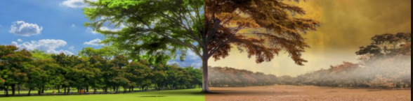
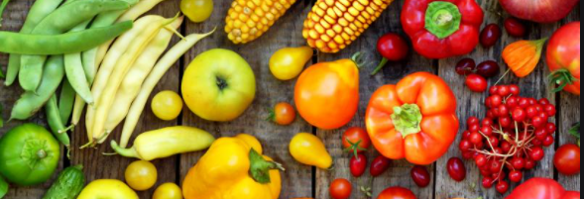
To find out more, go to: https://bit.ly/3rjJo6S

Tasks
- Choose a food commodity and research how it is produced and processed. Create farm to fork food chain cards to illustrate what you have found out.
- Research the following ingredients and state where in the world they are traditionally grown, reared or caught: avocado, lamb, nutmeg, oats, olive oil, spinach, squid, sugar beet.

