Savoury rice
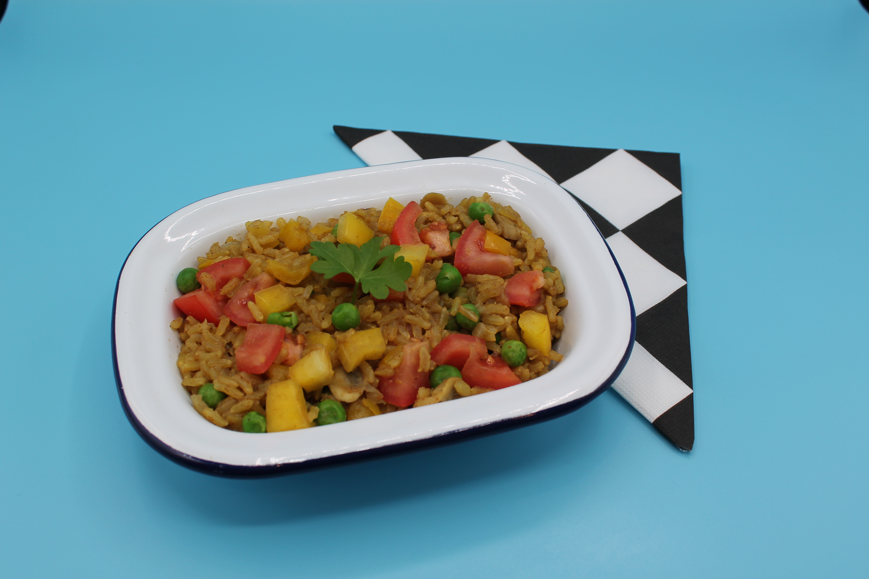
Complexity: medium

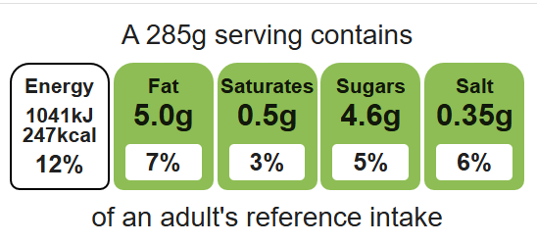

Ingredients (serves 3)
½ onion
3 mushrooms

Equipment

Chopping board

Sharp knife

Saucepan

Heat resistant spoon

Weighing scales

Measuring jug

Measuring spoons

½ pepper
1 tomato
1 x 15ml spoon oil or spray oil
150g wholegrain rice
550ml water, boiling
1 reduced-salt vegetable stock cube
50g frozen peas
1 x 10ml spoon curry powder
Black pepper

Method
Top tips
- 5 A DAY: Try different vegetables including frozen mixed vegetables or peas.
- Vary you protein: Add beans or pulses such as chickpeas to increase the protein and fibre content.
- Reduce food waste: Store any leftovers in the fridge and eat for lunch the next day.

- Prepare the vegetables:
- peel and dice the onion;
- slice the mushrooms;
- deseed and dice the pepper;
- chop the tomato.
- Add the oil to the saucepan and allow it to heat.
- Fry the onion until soft.
- Add the mushrooms and pepper and cook for a further 2 minutes.
- Stir in the rice.
- Crumble the stock cube into the boiling water and mix.
- Add the stock, peas and curry powder to the saucepan.
- Season with black pepper.
- Simmer for 15 minutes, stirring frequently, until the rice is tender.
- To serve place the rice in a bowl and sprinkle the chopped tomato on top.

Food skills
Weigh, measure, peel, cut, chop, slice, dice and trim, fry and sauté, mix, stir and combine, melt, simmer and boil.

