Standard alcoholic drinks
 | Drink |   Measure and units
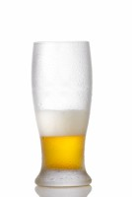 | ‘Low Alcohol’ drinks  Beer, Lager & Cider 2% | Bottle (330ml)  0.7 units | Can (440ml)  0.9 units | Pint (568ml)  1.1 units | Litre  2 units
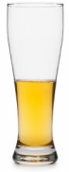 | Beer, Lager & Cider  4%  5%  6% | Bottle (330ml)  1.3 units  1.7 units  2 units | Can (440ml)  1.8 units  2.2 units  2.6 units | Pint (568ml)  2.3 units  2.8 units  3.4 units | Litre  4 units  5 units  6 units
 | ‘Super Strength’ Drinks  Beer, Lager & Cider 9% | Bottle (330ml)  3 units | Can (440ml)  4 units | Pint (568ml)  5.1 | Litre  6 units
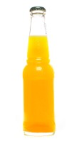 | Alcopops  5% | 1 bottle (275ml)  1.4 units | - | - | -
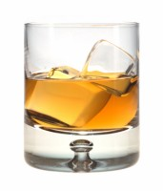 | Spirits  38 – 40% | Small measure (25ml)  1 unit | Large measure (35ml)  1.4 units | Small double measure (50ml)  1.9 – 2 units | Large double measure  (70ml)  2.7 – 2.8 units
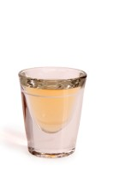 | Shots  38 – 40%  Tequila, Sambuca | Small measure (25ml)  1 unit | Large measure (35ml)  1.3 units | - | -
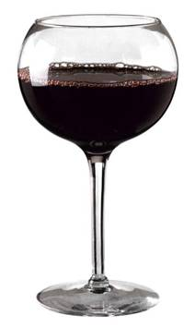 | Wine & Champagne  10%  11%  12%  13%  14% | Small glass (125ml)  1.25 units  1.4 units  1.5 units  1.6 units  1.75 units | Standard glass (175ml)  1.75 units  1.9 units  2.1 units  2.3 units  2.5 units | Large glass (250ml)  2.5 units  2.8 units  3 units  3.3 units  3.5 units | Bottle (750ml)  7.5 units  8.3 units  9 units  9.8 units  10.5 units
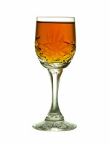 | Fortified wine  17.5 – 20%  Sherry & Port | Standard measure (50ml)  0.9 – 1 unit | - | - | -

For more information on the units in alcohol, visit What is an alcohol unit? | Drinkaware.

