Session 4: Soup-er!
Welcome
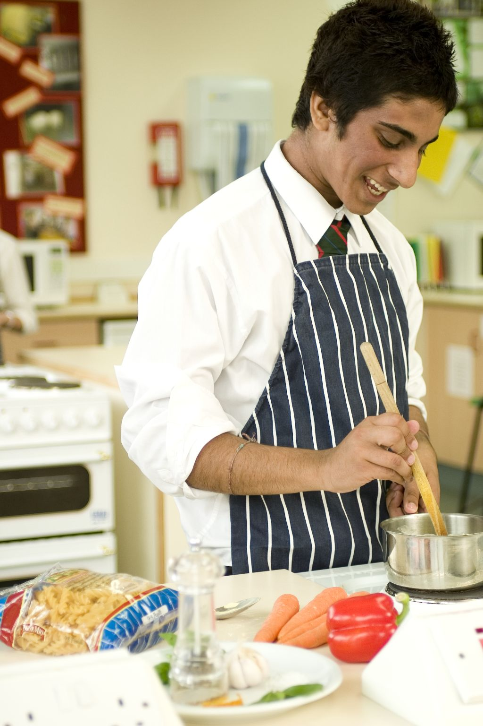
This session allows pupils to build confidence in using the hob. Although the hob may have been used in Session 3, this session concentrates on its safe use. In addition, it consolidates knife skills through the preparation of a variety of different vegetables. As with other sessions, it also provides opportunities to assess pupils’ practical capability. You could use the practical observation sheet to help.
During this session, pupils will make either a vegetable soup or minestrone soup. These have been chosen as they use a number of knife skills, in particular in the preparation of an onion, and the safe use of the hob.

There is lots of room for pupils to be creative, selecting different types of ingredients that could be combined into the dishes. You could get your pupils to use the vegetable soup or minestrone soup recipe writing frames before cooking to develop their own ideas. The pupils own recipe creations could then be used in this session.

If you have an established lesson plan and/or recipe, which supports the aims and objectives of this session, feel free to use it instead. Look at the support materials provided within this session as they support this activity and may well be useful in your own lessons, e.g. worksheets, PowerPoint presentations.

This session can act as a stand-alone lesson, focusing on the safe use of the hob and the preparation of a range of vegetables. Alternatively, it could be integrated into a series of lessons, e.g. exploring the different types of soups from around the world, e.g. gazpacho; creating soups and chowders which promote the use of fruit and vegetables.

Aims and objectives

Aim
For pupils to:
- develop competence in preparing and handling a variety of ingredients, and in using the hob safely.

Objectives
Pupils should be able to:
- prepare an onion;
- prepare a range of vegetables, e.g. slicing, dicing;
- measure liquids accurately, e.g. water, milk;
- use a hob safely;
- simmer the soup, ensuring that it does not boil over;
- make a soup, e.g. vegetable soup or minestrone.

Cooking session
Two cooking session plans, based on the Licence to Cook recipes, are supplied within this session.

If you have your own tried and tested vegetable soup or minestrone recipe, feel free to use it instead. In addition, you may wish to make other types of soups, such as roasted vegetable, pea and ham or tomato and lentil.

Each plan refers to aspects of healthy eating, wise food shopping and food safety and hygiene which are themes which run through each session.

Before the cooking session
There are a number of factors that you need to consider before the cooking session. More detailed guidance is available in the Cooking session guide.

You will need to consider:
- Ingredients: who will be providing the ingredients and where will they be stored?
- Recipe: are pupils going to use a printed-out copy or follow instructions on an interactive whiteboard?
- Equipment: is all the equipment needed for the session available, clean and in good working order? Check that the hobs are clean and in working order, and that there are enough saucepans for the pupils to use. You will also need trivets (pan stands) and ladles.
- Aprons: do you have enough and are they clean?
- Hair: do you have ties/bands for long hair?
- Containers: will pupils be able to take away the soup they make? If so, in what?
- Waste: do you have adequate disposal facilities, including recycling or composting?
- Cooking area: is it clean and ready to use?

Differentiation and inclusion
Before this practical session, you will need to consider the age, ability, previous experience and any special requirements of your pupils. This will determine recipe selection, any advanced ingredient preparation and equipment used.

Do any of your pupils need:
- ingredients partly pre-prepared, chopped onion?
- access to a food processor, to help prepare the vegetables?
- more time to prepare vegetables? If so, the soup could be cooked at a later time.
- less vegetables in their soup, allowing them to complete the recipe in the time?
- to follow different recipes? The vegetable soup recipe is slightly easier.
- assistance with practical work, e.g. using the hob, lifting heavy saucepans;
- extension activities, such as making oven baked croutons with their soup?

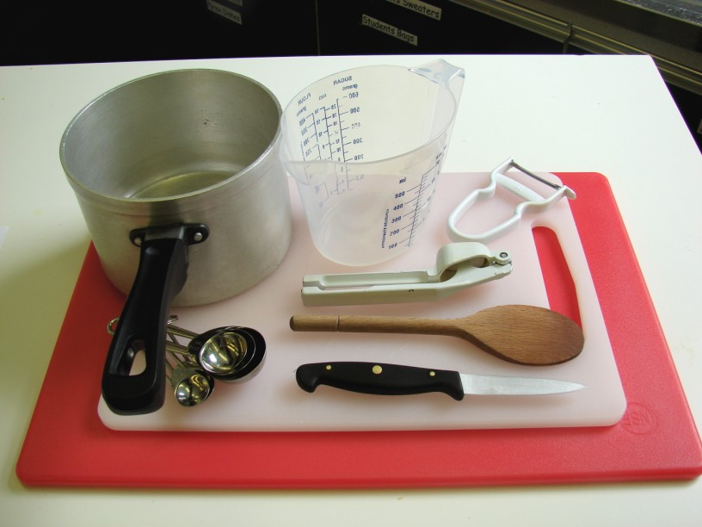
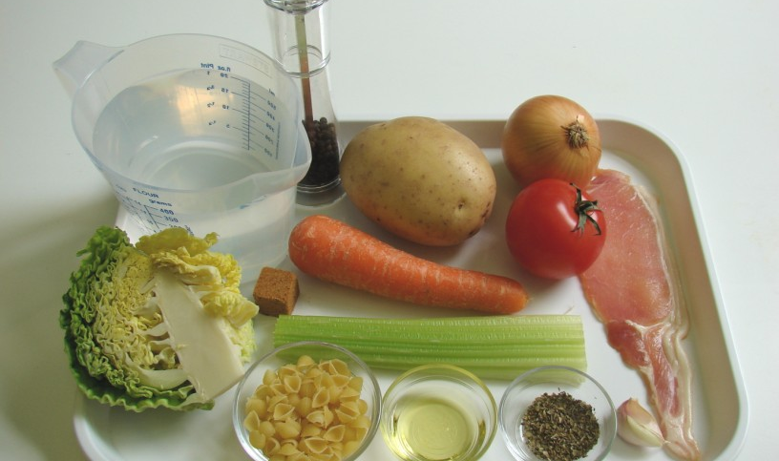
Demonstration
During the session you will be demonstrating the safe use of the hob and the preparation of an onion. If you have time, you could show the preparation of other ingredients, e.g. peeling and chopping a carrot. If you do not have the time during the session, have these ingredients prepared in advance.

Ensure that you have all the ingredients and equipment you need ready before the session, perhaps on trays for ease, for your demonstration.

Think about:
- describing the ingredients and equipment used;
- highlighting key techniques in preparing an onion safely;
- showing how to turn on the hob and regulating the temperature;
- ensuring that pupils have followed and understood the method.

Risk assessment

The two cooking session plans and recipes highlight a number of different hygiene and safety issues which need to be considered before, during and after the cooking session.

Before the cooking session, you will need to assess these risks in relation to the number of pupils being taught, as well as their experience, and consider measures that can be put into place to manage the risk. Below are examples of potential risks, along with preventative measures.

Vegetable soup
Potential risk | Measure | Likelihood
Peelings on floor leading to slippages | Container on work surface for peelings and other waste | Low
Cuts from using a knife unsafely while preparing the vegetables | Demonstrate safe use of knives and monitor pupils’ use | Med
Burn from using the hob and/or hot saucepan | Demonstrate safe use of the hob and monitor pupils’ use | Low/Med
Saucepan knocked off hob | Ensure that saucepan handles are turned away from the edge | Low/Med
Scold from boiling water in kettle | Demonstrate safe use of the kettle when pouring hot water | Med

Minestrone soup
Potential risk | Measure | Likelihood
Bacon is not refrigerated before use | Ensure bacon is refrigerated and wrapped | Low
Burn from using the hob and/or hot saucepan | Demonstrate safe use of the hob and monitor pupils’ use | Low/Med
Raw meat and vegetables prepared on same chopping board, leading to cross contamination | Use different chopping boards and knifes for raw meat other vegetables | Med
Bacteria from meat is transferred to handles and other work surfaces | Ensure that pupils wash hands periodically throughout the cooking session, especially after handling raw meat | Med
Saucepan knocked off hob | Ensure that saucepan handles are turned away from the edge | Low/Med

Time
The session plans are based on a 60 minute session

If you have less time available, you will need to modify the session plan to better suit your circumstances. For example, within this session you might:
- demonstrate the safe use of the hob at another time;
- teach weighing and measuring and/or knife skill techniques before this session;
- use fewer ingredients in the soup, cut small to cook quicker;
- demonstrate key aspects from the recipe, rather than every stage;
- have ingredients pre-measured;
- allow pupils to work with a partner.
During the lesson
Time (mins) | Activity: vegetable soup | Equipment/ Resources
0 | Registration.  Explain to the pupils that they will be making vegetable soup. Go through the aims and objectives for the lesson. | PowerPoint Vegetable soup
5 | Gather the pupils around a demonstration area, with your tray of ingredients and equipment. Ensure that all pupils have their apron on, tie back long hair and wash their hands.  Briefly talk through the recipe – note your expectations, for example:  * washing vegetables before use;  * measuring accurately;  * preparing an onion, as well as other vegetables;  * using the hob safely to fry, boil and simmer;  * combine ingredients together;  * being hygienic and safe when preparing food. | Aprons  Demonstration ingredient and equipment tray  (some ingredients could be pre-prepared)
Demonstration
* Place out the chopping board, vegetable knife and vegetable peeler. Have a small bowl or plate handy for peelings and other waste.
* Explain that you will be showing how to prepare an onion safely. Use the Claw grip to cut away one end of the onion (not the root). Then use the Bridge hold to cut the onion in half. Peel away the outer skin. Next, cut length ways into the onion – but do not cut through the root. The root will keep the onion together. Next, use the Claw grip to slice across the onion.
* Show pupils how to switch on the hob. If you have electric and gas hobs, you will need to show them both types.
* Demonstrate the onion frying in the oil. Emphasise that the saucepan handle should be turned away from the edge. The heat should be moderate, ensuring that the ingredients do not burn. Show the pupils how to regulate the heat for the hob.
* If you have time, show the preparation of the other vegetables. If you do not have time, quickly show how the vegetables should be prepared as a recap and then add to the saucepan. If you are using pre-prepared vegetables, add these to the saucepan.
* Measure the boiling water from the kettle. Pour slowly and carefully, paying attention to the amount and being safe.
* Add the water to the vegetables. As you add the water, steam may rise from the saucepan – this will be hot. Next, bring the soup to a boil. Ensure that pupils see this – the water in the pan should be rapidly bubbling. When this happens, reduce the heat and bring it to a simmer – a few bubbles. Put the lid on the saucepan.

15   | Ensure that all pupils wash their hands. Allow them to start making their vegetable soup.  During this time, circulate the room to ensure that pupils are preparing ingredients and using the hob safely. In this time, pupils should:  * measure their ingredients;  * prepare an onion, as well as other vegetables;  * fry the ingredients in the saucepan, paying careful attention to the hob;  * measure and add boiling water to the pan;  * simmer the soup, with a lid on the saucepan. | Basic equipment  Ingredients
35 | All soups should be simmering, as they take at least 20 minutes.
50 | Give a 5 minute time warning.  Remind pupils that all washing-up should be completed, work surfaces should be clean. Their vegetable soup ideally should be cooled before they are ladled into containers. If pupils are using flasks, the soup can be added straight away.  Circulate the room, ensuring that sinks are clean and equipment is put away properly. | Ladles
55 | Plenary  Pose the following questions to the pupils:  * What were the main skills demonstrated today?  * Describe the term ‘simmering’?  * Name 5 types of different soups.
60 | Finish

After the lesson
Check that the room is clean and tidy. Pupils should leave the room as they find it.

The vegetable soup will need to be stored after the lesson, due to their heat, and may need to be kept until the end of the school day. If so, ensure that each container is loosely covered and clearly labelled with the pupil’s name and group.

If the same pupils are with you for another cooking session in the next few days or week, remind them of the ingredients and/or containers they need to bring, if appropriate. You may wish to provide pupil’s with recipes or writing frames.
During the lesson
Time (mins) | Activity: minestrone soup | Equipment/ Resources
0 | Registration.  Explain to the pupils that they will be making minestrone soup. Go through the aims and objectives for the lesson. | PowerPoint Minestrone soup recipe
 | Gather the pupils around a demonstration area, with your tray of ingredients and equipment. Ensure that all pupils have their apron on, tie back long hair and wash their hands.  Briefly talk through the recipe – note your expectations, for example:  * washing vegetables before use;  * measuring accurately;  * preparing an onion, as well as other vegetables;  * cutting the bacon on a separate chopping board with clean knife or kitchen scissors;  * using the hob safely to fry, boil and simmer;  * combine ingredients together;  * being hygienic and safe when preparing food.  Demonstration  * Place out the chopping board, vegetable knife and vegetable peeler. Have a small bowl or plate handy for peelings and other waste.  * Explain that you will be showing how to prepare an onion safely. Use the Claw grip to cut away one end of the onion (not the root). Then use the Bridge hold to cut the onion in half. Peel away the outer skin. Next, cut length ways into the onion – but do not cut through the root. The root will keep the onion together. Next, use the Claw grip to slice across the onion.  * Show pupils how to switch on the hob. If you have electric and gas hobs, you will need to show them both types.  * If you have time, show the preparation of the other vegetables. If you do not have time, quickly show how the vegetables should be prepared as a recap and then add to the saucepan. If you are using pre-prepared vegetables, add these to the saucepan.  * Measure the boiling water from the kettle. Pour slowly and carefully, paying attention to the amount and being safe. | Aprons  Demonstration ingredient and equipment tray
 | * Add the water to the vegetables. As you add the water, steam may rise from the saucepan – this will be hot. Next, bring the soup to a boil. Ensure that pupils see this – the water in the pan should be rapidly bubbling. When this happens, reduce the heat and bring it to a simmer – a few bubbles. Put the lid on the saucepan.

15 | Ensure that all pupils wash their hands. Allow them to start making their minestrone soup.  During this time, circulate the room to ensure that pupils are preparing ingredients and using the hob safely. In this time, pupils should:  * measure their ingredients;  * prepare an onion, as well as other vegetables;  * chop the bacon on a separate chopping board, with a clean knife or kitchen scissors;  * fry the ingredients in the saucepan, paying careful attention to the hob;  * measure and add boiling water to the pan;  * simmer the soup, with a lid on the saucepan. | Ingredients  Basic equipment
35 | All minestrone soup should be simmering, as they take 20 minutes.
50 | Give a 5 minute time warning.  Remind pupils that all washing-up should be completed, work surfaces should be clean. Their minestrone soup ideally should be cooled before they are ladled into containers. If pupils are using flasks, the soup can be added straight away.  Circulate the room, ensuring that sinks are clean and equipment is put away properly. | Ladles
55 | Plenary  Pose the following questions to the pupils:  * What were the main skills demonstrated today?  * Describe the term ‘simmering’?  * Name 5 types of different soups.
60 | Finish

After the lesson
Check that the room is clean and tidy. Pupils should leave the room as they find it.

The minestrone soup will need to be stored after the lesson, due to their heat, and may need to be kept until the end of the school day. If so, ensure that each container is loosely covered and clearly labelled with the pupil’s name and group. Once cooled the soup should be stored in the fridge below 5°C.

If the same pupils are with you for another cooking session in the next few days or week, remind them of the ingredients and/or containers they need to bring, if appropriate. You may wish to provide pupils with recipes or writing frames.
Extending this activity
This session provides a great opportunity to be integrated into existing lessons or be developed into a mini-scheme of work.

For example, pupils could:
- explore different types of soup from around the world, noting ingredients used and methods of making;
- plan, and create new soup recipes for a range of different people’s needs, such as young children or at a celebration event;
- evaluate different recipes for health, looking at ways in which they could be modified.

Appropriate aspects of ICT could also be integrated, including:
- recording sensory data;
- creating a recipe plan;
- modelling cost of ingredients for making several batches of soup;
- exploring the internet for different types of cold soups.
Shopping list

Vegetable soup
Ingredient | x 1 | x 10 | x 20
Onion | 1 | 10 | 20
Oil | 1 x 10ml spoon | 100ml | 200ml
Carrot | 1 | 10 | 20
Leek | 1 | 10 | 20
Potato | 1 | 10 | 20
Celery (sticks) | 1 | 10 | 20
Stock | 500ml
Coriander | 1 x 15ml spoon | 10 x 15ml spoon | 20 x 15ml spoon

Minestrone soup
Ingredient | x 1 | x 10 | x 20
Onion | 1 | 10 | 20
Garlic (cloves) | 1 | 10 | 20
Bacon (rashers) | 1 | 10 | 20
Oil | 1 x 10ml | 100ml | 200ml
Carrots | 1 | 10 | 20
Celery sticks | 1 | 10 | 20
Potatoes | 1 | 10 | 20
Stock | 800ml
Tomatoes | 1 | 10 | 20
Cabbage | ¼ | 2 ½ | 5
Mixed herbs | 1 x 5ml spoon | 10 x 5ml spoon | 20 x 5ml spoon
Pasta | 25g | 250g | 500g

Equipment list

Vegetable soup
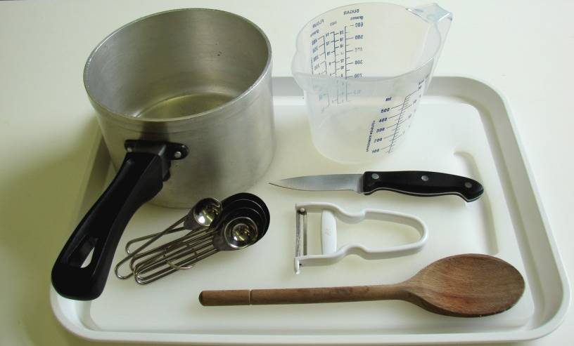
Chopping board
Knife
Vegetable peeler
Measuring spoons
Saucepan
Wooden spoon
Measuring jug

Minestrone soup

Chopping board x 2
Knife x 2 (or 1, but washed between preparing the vegetables and meat)
Garlic press
Vegetable peeler
Measuring spoons
Saucepan
Wooden spoon
Measuring jug
Weighing scales

Other
You will also need pot stands (trivets).
If you wish to blend the vegetable soup, you will need hand-held blenders or upright blenders.

Containers

If pupils take home their soup, they will need to bring (or be provided with by the school) a suitable container, such as a flask or plastic tub with a tight fitting lid.

