Savoury filled choux buns

Ingredients (serves makes 10)
Complexity: medium
60g strong wholemeal flour
Pinch of mustard powder
Pinch of cayenne pepper
2 eggs
50g baking fat/block
150ml water
25g parmesan cheese
Twist of black pepper
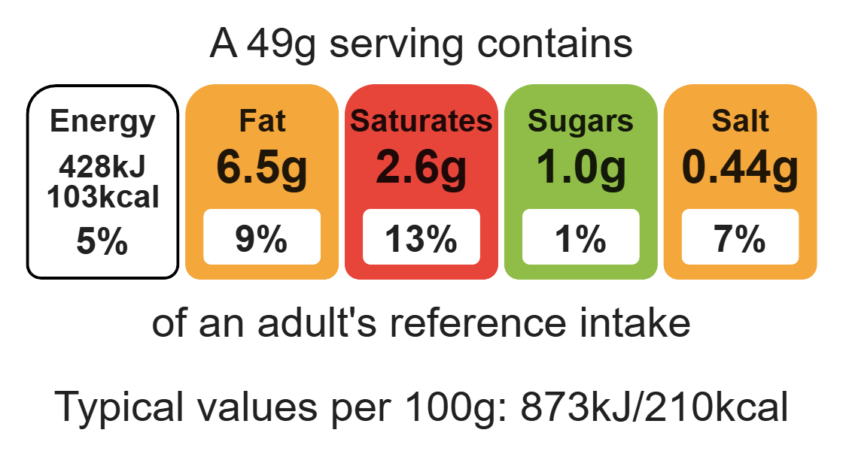
100g reduced-fat cream cheese
2 slices of ham
1 tomato

Equipment
Baking tray, greaseproof paper, pastry brush, weighing scales, sieve, 2 small bowls, fork, measuring jug, saucepan, heat-resistant spoon, grater, 2 x 10ml spoons, sharp knife, chopping board, cooling rack.
Top tips
- Flavour combination: Try adding a selection of different herbs or fillings e.g. garlic, chilli, smoked salmon.
- Focus on fibre: Use wholemeal flour in this recipe to boost the fibre content of the dish.

Method
- Preheat the oven to 200°C or gas mark 6.
- Grease or line the baking tray and sprinkle a little water on top.
- Sift the flour, mustard powder and cayenne pepper onto the piece of greaseproof paper or plate.
- Beat the eggs in the small bowl with the fork.
- Melt the baking fat in the water in the saucepan.
- When it starts to boil, remove from the heat and add in the flour.
- Beat the mixture until it is smooth and leaves the side of the pan.
Food skills
Weigh, measure, sift, beat, melt, simmer and boil, mix, stir and combine, grate, bake.

- Stir in the egg, a little at a time, to form a smooth paste.
- Grate the cheese.
- Add the cheese and black pepper to the mixture and mix until combined.
- Place 10 spoons of choux pastry onto the baking tray.
- Bake for 10 minutes. Increase heat to 220 °C, gas mark 7, and bake for 15 minutes.
- Slice with the knife and place on the cooling rack.
- Chop the ham and dice the tomato and mix with the so cheese in the small bowl.
- When the buns are cool, fill with the soft cheese mixture.

