Session 16: Meal appeal

Welcome

This is the final session in this module, i.e. sessions 11 – 16, and of the Licence to Cook course. By now, students should be confident and competent in preparing and cooking a range of different dishes, plus have the skills and knowledge to adapt these for the future. During this session, students consolidate this understanding by preparing and cooking a main meal dish.

You may wish to observe students' practical work using the practical observation sheet. The result of this observation, along with their previous practical work, goes towards their ‘licence to cook’.

During this session, students will make either a shepherd's pie, quick 'V' lasagne or spaghetti bolognese. These have been selected as they demonstrate greater time management and kitchen organisation skills. They also show how a simple meat or vegetable base can be transformed into many different types of main meal. Both start by making a base, to which other ingredients can be added to transform it into a variety of dishes, e.g. shepherd's pie, chilli-con-carne. If you have students who do not eat meat, but wish to make the shepherd's pie, replace the lamb with an alternative (e.g. TVP, myco-protein) or a mixture of lentil and beans.

There is lots of room for students to be creative, selecting different types of ingredients that could be combined into the dishes. You could get your students to use the shepherd's pie, quick 'V' lasagne or spaghetti bolognese recipe writing frames before cooking to develop their own ideas. The students' own recipe creations could then be used in this session.
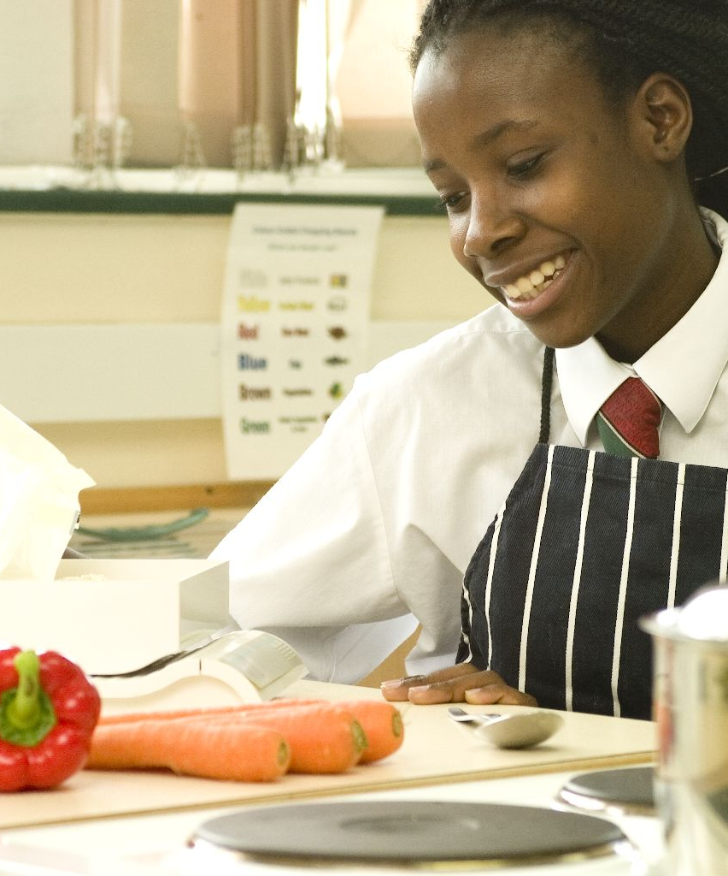
If you have an established lesson plan and/or recipe, which supports the aims and objectives of this session, feel free to use it instead. Look at the support materials provided within this session as they support this activity and may well be useful in your own lessons, e.g. worksheets, PowerPoint presentations.

This session can act as a stand-alone lesson, focusing on cooking main meals. Alternatively, it could be integrated into a series of lessons, e.g. exploring how the 'base' can be made into lots of different types of dishes.

Aims and objectives

Aim
For students to:
- demonstrate their confidence and competence cooking a main meal dish.

Objectives
Students should be able to:
- prepare a range of vegetables, e.g. peeling, slicing, dicing;
- make a meat or alternative base;
- combine the base with potato or sheets of lasagne;
- use the hob and oven safely;
- make a main meal dish, e.g. shepherd's pie, quick 'V' lasagne orspaghetti bolognese.

Cooking session
Two cooking session plans, based on the Licence to Cook recipes, are supplied within this session.Due to the 1 hour lesson length used in these session plans, it is more realistic to expect the shepherd’s pie and lasagne to be just assembled in the time available. This will depend on your school timetable.

If you have your own tried and tested shepherd's pie, spaghetti bolognese or lasagne recipe, feel free to use it instead. In addition, you may wish to make other types of dishes, such as a chill-con-carne or moussaka.

Each plan refers to aspects of healthy eating, wise food shopping and food safety and hygiene which are themes which run through each session.

Before the cooking session
There are a number of factors that you need to consider before the cooking session. More detailed guidance is available in the Cooking session guide.

You will need to consider:
- Ingredients: who will be providing the ingredients and where will they be stored? The recipes call for a little oil. It may be easier for the school to provide the oil for students to share.
- Recipe: are pupils going to use a printed-out copy or follow instructions on an interactive whiteboard?
- Equipment: is all the equipment needed for the session available, clean and in good working order? Check that all the hobs are in good working order and clean. Students will require the use of a frying pan - check that there are enough. Both dishes need to be cooked in oven-proof dishes – ensure that you have enough for each student, or ask them to bring in one from home. You may wish to use disposable foil trays for simplicity and remove the need for washing up.
- Aprons: do you have enough and are they clean?
- Containers: will students be able to take away the dishes they make? If so, in what?
- Waste: do you have adequate disposal facilities, including recycling or composting?
- Cooking area: is it clean and ready to use?

Differentiation and inclusion
Before this practical session, you will need to consider the age, ability and any special requirements of your students. This will determine recipe selection, any advanced ingredient preparation and equipment used.

Do any of your students need:
- ingredients pre-measured to allow them time to complete the recipe?
- to omit some vegetable ingredients to make the recipe easier?
- to use pre-prepared vegetables?
- assistance preparing ingredients?
- challenging, by making a roux sauce for the lasagne?

Demonstration
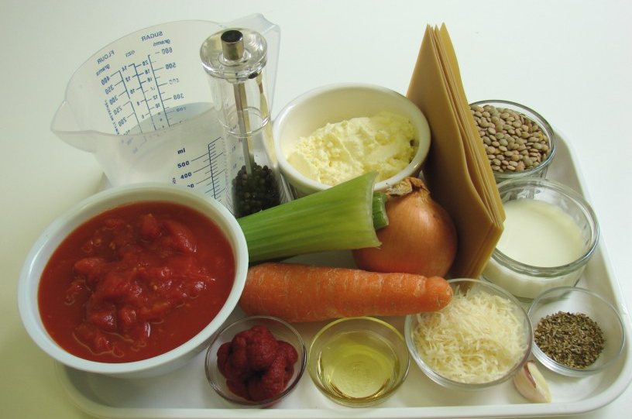
You should probably not need to demonstrate any knife skills or cooker use again at this stage. However, do remind students to prepare ingredients and cook safely.

Ensure that you have all the ingredients and equipment you need before the session, perhaps on trays for ease, for your demonstration.

Think about:
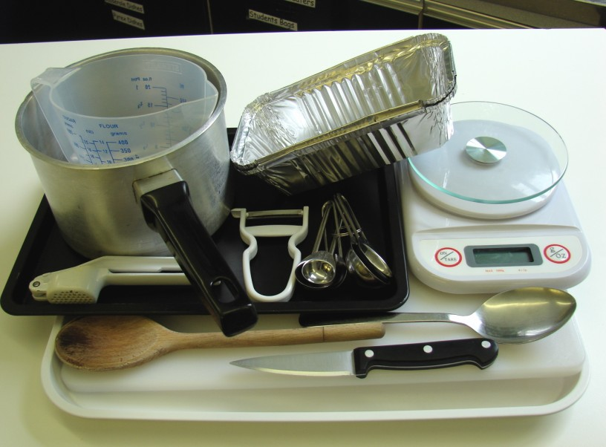
- describing the ingredients and equipment used;
- highlighting any safety points, e.g. handling raw meat;
- showing how to use the hob;
- ensuring that students have followed and understood the method.

More detailed guidance is available in the Demonstrating guide.

Risk assessment

The two cooking session plans and recipes highlight a number of different hygiene and safety issues which need to be considered before, during and after the cooking session.

Before the cooking session, you will need to assess these risks in relation to the number of students being taught, as well as their experience, and consider measures that can be put into place to manage the risk. Below are examples of potential risks, along with preventative measures.

Quick ‘V’ lasagne
Potential risk | Measure | Likelihood
Cuts from using a knife unsafely | Demonstrate safe use of knives and monitor students’ use | Low
 |  | Low/Med

Shepherd’s pie
Potential risk | Measure | Likelihood
Dirt or food poisoning bacteria present on raw food, causing cross contamination | Wash vegetables | Low
Cross contamination from meat handling | Use different chopping boards and knifes when preparing meat – keep covered in the refrigerator until needed  Thoroughly wash and dry hands after touching raw meat or packaging

Time
The session plans are based on a 60 minute session.

If you have less time available, you will need to modify the session plan to better suit your circumstances. For example, within this session you might:
- demonstrate the safe use of the hob and oven at another time;
- demonstrate key aspects from the recipe, rather than every stage;
- have ingredients pre-measured;
- get students to oven bake the dish at home, rather than at school;
- allow students to work with a partner.

During the lesson
Time (mins) | Activity: Shepherd's pie | Equipment/ Resources
0 | Registration.  Explain to the students that they will be making shepherd's pie. Go through the aims and objectives for the lesson. | PowerPoint Shepherd’s pie  recipe
5 | Gather the students around a demonstration area, with your tray of ingredients and equipment. Ensure that all students have their apron on, hair tied back and hands washed.  Briefly talk through the recipe – note your expectations, for example:  * preparing the ingredients carefully and accurately;  * boiling, draining and mashing the potatoes;  *dry-frying the mince, with the vegetables and simmering until cooked;  * assembling the shepherd’s pie;  * using the hob safely (and oven, if time permits);  * being hygienic and safe when preparing food. | Aprons  Demonstration ingredient and equipment tray
Demonstration
* Check whether any students need to be shown how to prepare any of the vegetables or use the cooker safely. If it is a large number, show the group. If a small number, allow the other students to start cooking.
* Get students to place their pies on baking trays when they put them in the oven (if time permits) - this will prevent any juices from the base spilling onto the oven floor.
15 | Ensure that all students wash their hands. Allow them to start making their shepherd's pie.  During this time, circulate the room to ensure that students are preparing ingredients and using the oven safely. In this time, students should:  * pre-heat ovens;  * prepare the vegetables;  * cook, drain and mash the potatoes;  * cook mince and vegetables;  * assemble and bake the pie;  * use the hob and oven safely. | Basic equipment  Saucepans  Ingredients
40 | Allow the students to prepare and cook the potato topping and meat base. Ensure that the meat base is cooked thoroughly.  Check that the pie is assembled correctly.  (If you have a longer time, students can cook their pies in the oven - they take 20-25 minutes to brown.)  During the remaining time students should be washing up, cleaning work surfaces and putting away equipment.
50 | Give a 5 minute time warning.  Remind students that all washing-up should be completed, work surfaces should be clean and their shepherd's pie should be placed in a container. Circulate the room, ensuring that sinks are clean and equipment is put away properly.
55 | Plenary  Pose the following questions to the students:  * What were the main skills demonstrated today?  * What other types of vegetables could be used in the base or potato topping?  * How could the potato topping be modified to add interest?
60 | Finish

After the session
Check that the room is clean and tidy. Students should leave the room as they find it.

The shepherd’s pie may need to be refrigerated until the end of the school day, if so, ensure that each container is covered and clearly labelled with the student’s name and group. The refrigerator should be between 0-5ºC.

Students may wish to reheat the pie at home. To microwave, loosely cover the pie and cook for full power for 3-4 minutes. Alternatively, place in a preheated oven (200ºC or gas mark 6) for around 20-25 minutes. Ensure that the dish is piping hot before eating.

If the same students are with you for another cooking session in the next few days or week, remind them of the ingredients and/or containers they need to bring, if appropriate. You may wish to provide students with recipes or writing frames.

During the lesson
Time (mins) | Activity: quick 'V' lasagne | Equipment/ Resources
0 | Registration.  Explain to the students that they will be making quick 'V' lasagne. Go through the aims and objectives for the lesson. | PowerPoint Quick V lasagne  recipe
5 | Gather the students around a demonstration area, with your tray of ingredients and equipment. Ensure that all students have their apron on, hair tied back and hands washed.  Briefly talk through the recipe – note your expectations, for example:  * preparing the ingredients carefully and accurately;  * cooking the vegetable and lentil base;  * making the crème fraiche based sauce;  * assembling the lasagne;  * using the hob safely (and oven, if time permits);  * being hygienic and safe when preparing food. | Aprons  Demonstration ingredient and equipment tray
 | Demonstration  * Check whether any students need to be shown how to prepare any of the vegetables or use the cooker safely. If it is a large number, show the group. If a small number, allow the other students to start cooking.  * Get students to place their lasagnes on baking trays when they put them in the oven, if time permits - this will prevent any juices from the base spilling onto the oven floor. | Aprons  Demonstration ingredient and equipment tray
15 | Ensure that students all wash their hands. Allow them to start making their quick 'V' lasagne.  During this time, circulate the room to ensure that students are preparing ingredients and using the oven safely. In this time, students should:  * pre-heat ovens;  * prepare the vegetables;  * cook the vegetables with the lentils;  * make up the crème fraiche based sauce;  * assemble and bake the lasagne;  * use the hob safely (and oven, if time permits). | Basic equipment  Saucepans  Ingredients
40 | Allow the students to prepare and cook the lasagne filling. Ensure that the lentils are cooked thoroughly.  Check that the lasagnes are assembled correctly.  (If you have a longer time, students can cook their lasagne in the oven - they take 20-25 minutes to brown.)  During the remaining time students should be washing up, cleaning work surfaces and putting away equipment. | Basic equipment  Saucepans  Ingredients
50 | Give a 5 minute time warning.  Remind students that all washing-up should be completed, work surfaces should be clean and their quick 'V' lasagne should be placed in a container. Circulate the room, ensuring that sinks are clean and equipment is put away properly | Basic equipment  Saucepans  Ingredients
55 | Plenary  Pose the following questions to the students:  * What were the main skills demonstrated today?  * What other types of vegetables, pulses or beans could be used in the base?  * How could the topping be modified to add interest? | Basic equipment  Saucepans  Ingredients
60 | Finish | Basic equipment  Saucepans  Ingredients

After the session
Check that the room is clean and tidy. Students should leave the room as they find it.

The quick ‘V’ lasagne may need to be refrigerated until the end of the school day, if so, ensure that each container is covered and clearly labelled with the student’s name and group. The refrigerator should be between 0-5ºC.

Students may wish to reheat the dish at home. To microwave, loosely cover the dish and cook for full power for 3-4 minutes. Alternatively, place in a preheated oven (200ºC or gas mark 6) for around 20-25 minutes. Ensure that the dish is piping hot before eating.

If the same students are with you for another cooking session in the next few days or week, remind them of the ingredients and/or containers they need to bring, if appropriate. You may wish to provide students with recipes or writing frames.

Areas of learning
These three areas of learning link to the face-to-face lessons and online tutorials for students. Where appropriate, these key messages could be integrated into the activity.

Healthy eating
- Serve with a crisp side salad and glass of fruit juice.
- Dry frying the lamb and using lower fat cheese and fromage fraise helps to control the total fat content of these dishes.

Wise food shopping
- Make the minced meat go further by adding baked beans to the mixture.
- Cook 2 pies or lasagnes and freeze one for another time.

Food safety and hygiene
- When getting ready to cook, always wear an apron, tie back long hair, roll up long sleeves, remove any jewellery and wash your hands.
- Wash fruit and vegetables before use.
- Use a different chopping board and knife after preparing raw meat to avoid cross contamination.
- Handle raw meat carefully. Wash hands and surfaces after handling.

Extending this activity
This session provides a great opportunity to be integrated into existing lessons or be developed into a mini-scheme of work.

For example, students could:
- explore how the 'base' can be made into lots of different types of dishes;
- plan and create different variations of main meal dishes made from a basic base to reduce costs;
- evaluate their own and their friends recipes and cooked dishes, in order to improve their making.

Appropriate aspects of ICT could also be integrated, including:
- recording how the dish is made using a digital camera;
- creating a recipe plan or flow-chart;
- modelling the sensory data from different class mates tasting sessions;
- exploring the internet for traditional recipes and techniques, which can be used in their own cooking sessions.

Shopping list

Shepherd's pie
Ingredient | x 1 | x 10 | x 20
Minced lamb, lean | 250g | 2.5kg | 5kg
Onion | 1 | 10 | 20
Carrots (each) | 2 | 20 | 40
Plain flour | 1 x 15ml spoons | small bag | small bag
Tomato puree | 1 x 15ml spoons | 1 tube | 1-2 tubes
Worcestershire sauce | 1 x 15ml spoons | 1 bottle | 1 bottle
Stock cube | 1 | 10 | 20
Potatoes | 700g | 7kg | 14kg
Savoy cabbage | 1/4 | 2.5 | 5
Semi-skimmed milk | 150ml | 1.5 litres | 3 litres

Quick 'V' lasagne
Ingredient | x 1 | x 10 | x 20
Onion | 1 | 10 | 20
Garlic (cloves) | 1 | 10 | 20
Oil | 1 x 10ml spoon | 100ml | 200ml
Carrots (each) | 1 | 1.5kg | 3kg
Celery | 2 sticks | 1-2 heads | 3-4 heads
Brown lentils | 200g | 2kg | 4kg
Tomatoes, canned | 1 | 10 | 20
Mixed herbs | 1 x 5ml spoon | small jar | small jar
Crème fraiche | 200ml | 2ltrs | 4ltrs
Cheese, hard | 25g | 250g | 500g
Semi-skimmed milk | 50ml | 500ml | 1 litre
Black pepper | a few twists | a few twists | a few twists
Lasagne sheets | 100g | 1kg | 2kg

Spaghetti bolognese
Ingredients | x 1 | x 10 | x 20
Onion (each) | 1 | 10 | 20
Garlic (cloves) | 1 | 10 | 20
Carrot (each) | 1 | 10 | 20
Celery (sticks) | 1 | 10 | 20
Oil | 1 x 15ml spoon | 150ml | 300ml
Lean minced beef | 250g | 2.5kg | 5kg
Canned chopped tomatoes (400g) | 1 | 10 | 20
Tomato purée | 1 x 15ml spoon | 150ml | 300ml
Water | 100ml | 1 litres | 2 litres
Mixed herbs | 1 x 5ml spoon | Small tub | Small tub
Black pepper | A few twists | A few twists | A few twists
Spaghetti (dried) | 150g | 1.5kg | 3kg

Equipment list

Shepherd's pie

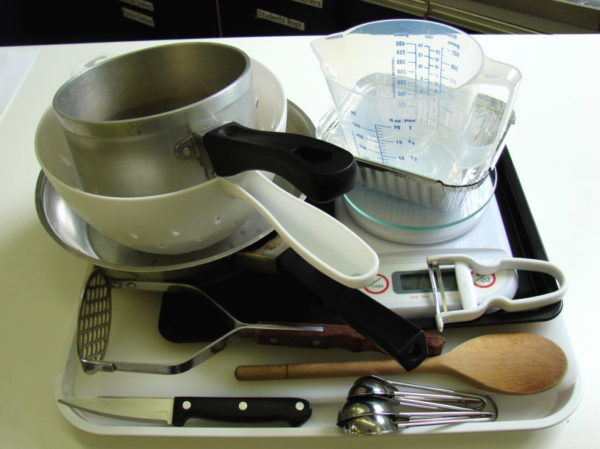
Chopping board, knife, vegetable peeler, weighing scales, saucepan, non-stick frying pan, wooden spoon, measuring spoons, kettle, measuring jug, colander, potato masher, ovenproof dish or foil tray, baking tray.

Quick 'V' lasagne
Weighing scales, chopping board, knife, peeler, garlic press, saucepan, wooden spoon, measuring spoons, measuring jug, metal spoon, ovenproof dish or foil trays.

Spaghetti bolognese

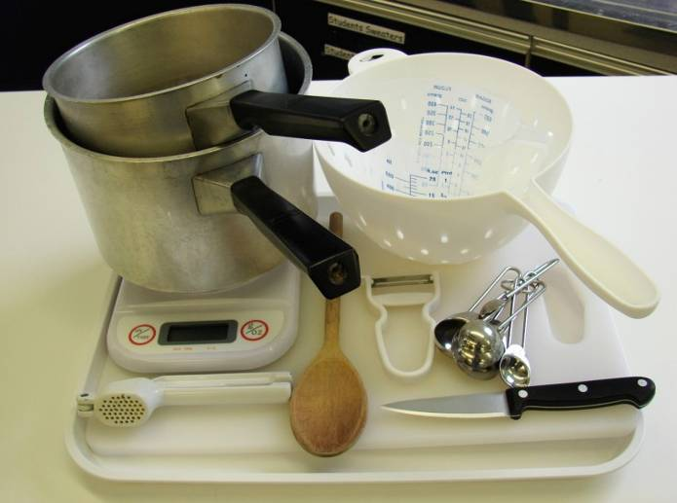
Chopping board, knife, garlic press, peeler, measuring spoons, 2 saucepans, weighing scales, measuring jug, wooden spoon, colander.

Containers

If students take their dishes, they will need to bring (or be provided with by the school) a suitable container, such as a foil container with a lid.

