Rice and peas

Ingredients
Complexity: low-medium

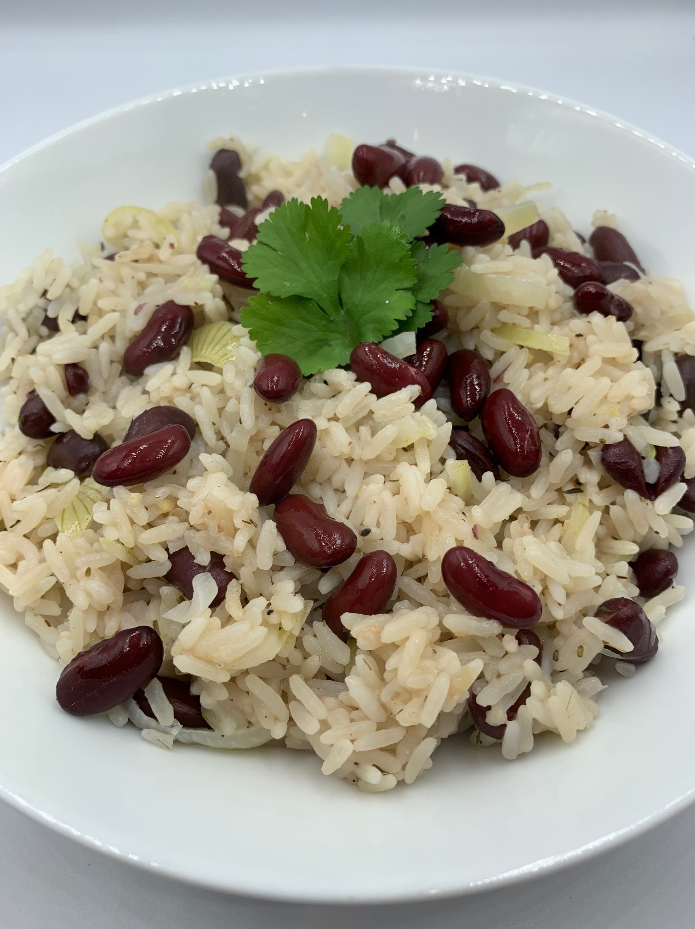
1 small garlic clove

½ small onion

125g canned red kidney beans or black eye peas

150g long grain rice
200ml light coconut milk
200ml water
¼ x 5ml spoon dried thyme
Black pepper

Equipment

Chopping board, vegetable knife, sieve, large saucepan, mixing spoon, measuring jug, measuring spoons.

Method
- Prepare the ingredients:
- peel and crush the garlic;
- peel and slice the onion;
- drain and rinse the beans/peas;
- rinse the rice in a sieve until the water runs clear.
- Place the coconut milk, garlic, onion, thyme and beans into a large pan and season with black pepper. Bring to the boil.
- Add the rice to the pan, reduce the heat and simmer for 8-10 minutes until the rice is cooked and the liquid absorbed. If the rice is not completely cooked add a little water to stop it sticking.
- Fluff up the rice with a fork before serving.

Top tips
- Use sliced spring onions as an alternative to the onion.
- Add ¼ 5ml spoon of allspice or chilli pepper for extra flavour.
- This recipe is a great way to use up any leftover coconut milk. However, coconut milk can be frozen in ice cube trays to use when you need it. Defrost and stir well before using.

Food skills
- Weigh
- Measure
- Peel
- Cut
- Slice
- Crush
- Drain
- Mix
- Boil
- Simmer

Did you know?
Rice and peas (or peas and rice) is a traditional food within the West Indian Caribbean islands. Rice and peas was adopted from Ghana and Ivory Coast in West Africa. The dish is known as Waakye in West Africa. Rice was popular in West African culture and enslaved people brought the recipe with them to Jamaica and passed on the knowledge to their descendants. The enslaved people cooked food that was familiar to them, including rice and peas.

The dish is popular in the Caribbean and is often served on Sunday’s and at special occasions. In the 1700’s, enslaved people were only allowed Sundays off and on this day, the best foods were served – one of the most popular was rice and peas.

