My favourite meal

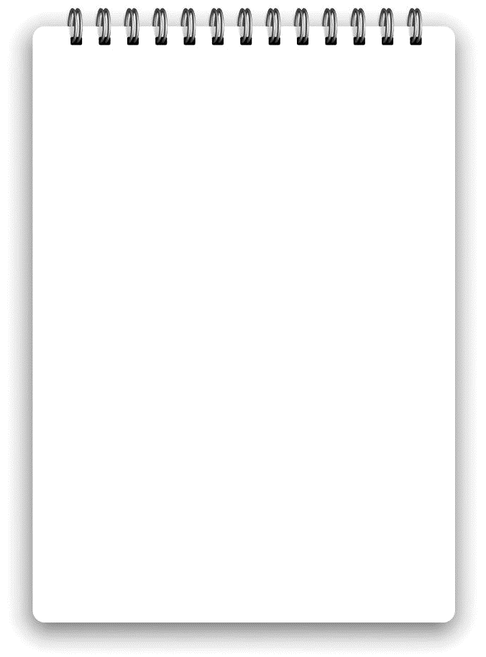
Ingredients list:

______________________________________________________________________________________________________________________________________________________

