Cheese and onion triangles
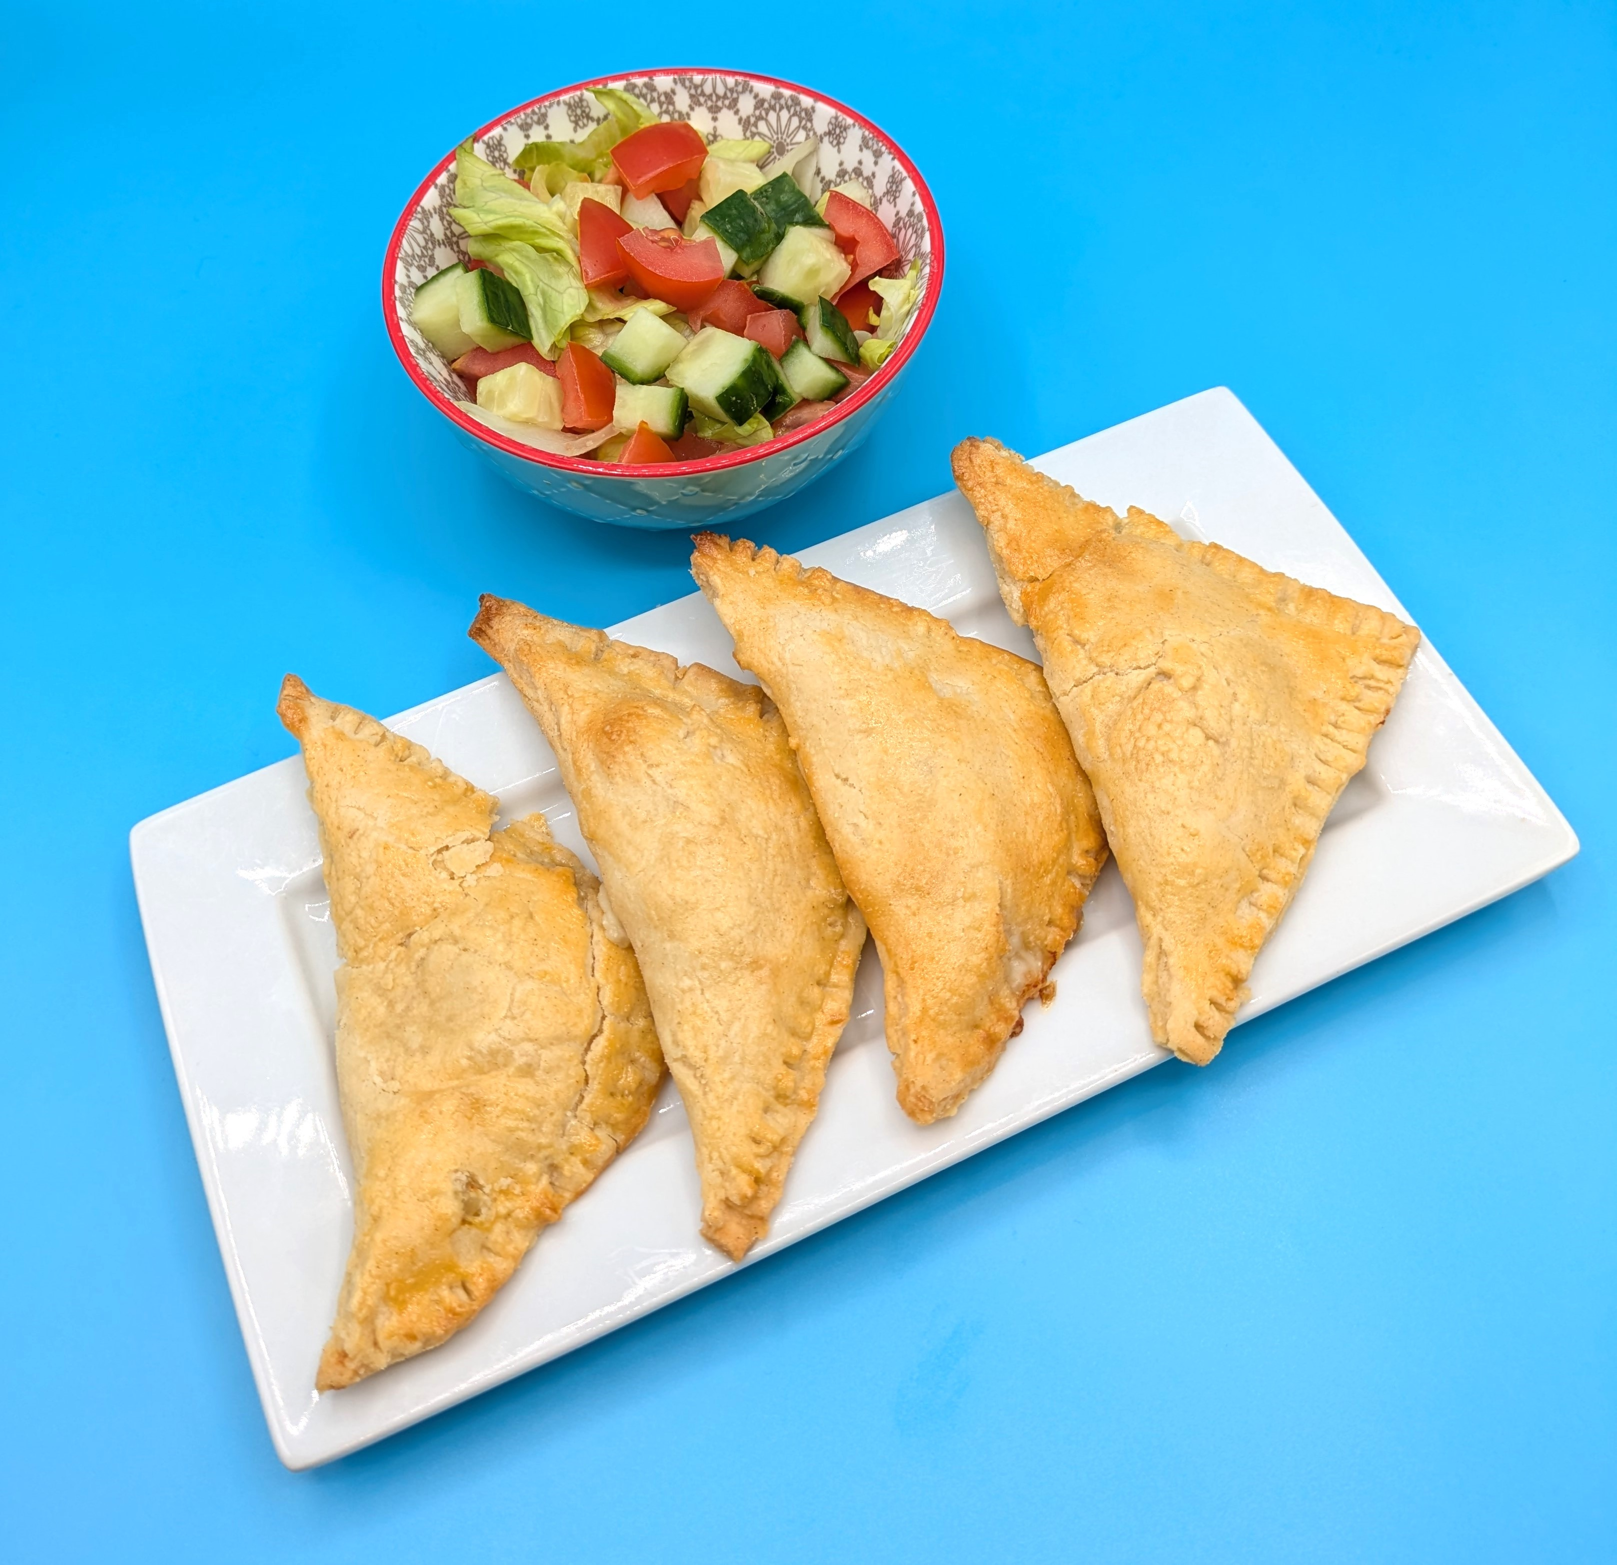
Complexity: medium

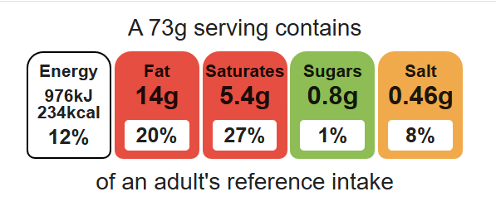

Ingredients (serves 4)
Equipment
Weighing scales
Chopping board
Grater
Sharp knife
Mixing bowl
Sieve
Measuring spoons
Palette knife
Flour dredger
Rolling pin
Metal spoon
Fork
Small bowl
Pastry brush
Baking tray
Cooling rack

50g reduced-fat cheddar cheese
½ onion
100g plain flour
50g baking fat/block
2–3 x 15ml spoons cold water
1 egg (optional - milk can be used)

Method
- Preheat the oven to 180°C or gas mark 4.
- Grease or line the baking tray.
- Prepare the cheese and onion filling:
- grate the cheese;
- peel and dice the onion;
- mix the cheese and onion together in a small bowl.
- Make the shortcrust pastry:
- sift the flour into the bowl;
- rub the fat into the flour, using your fingertips, until it resembles breadcrumbs;
- add the cold water and mix together;
- mix to form a firm, smooth dough.
- Roll out the pastry into a square, on a floured surface.
- Cut the square into quarters using the palette knife.
- Spoon a quarter of the cheese and onion filling in the middle of the square.
- Break the egg into a small bowl and beat with a fork, brush the edges of the pastry with beaten egg.
- Fold over to make a triangle and pinch the edges together all the way along using the edge of a fork.
- Glaze the top of the triangle with the leftover egg or milk.
- Transfer the triangles onto the baking tray.
- Bake for 20 minutes, until golden brown.

Top tips
- Turn up the flavour: Add spices and herbs for different flavour combinations.
- Focus on fibre: Replace half the flour with wholemeal. Remember to use a little more water.
- The triangles can also be baked in an air fryer at 180°C for 15 minutes.

Food skills
Weigh, measure, grate, peel cut, chop, slice, dice and trim, sift, mix, stir and combine, rub-in, roll out, form and shape, portion/ divide, bake.

