Picadillo

Ingredients
Complexity: medium
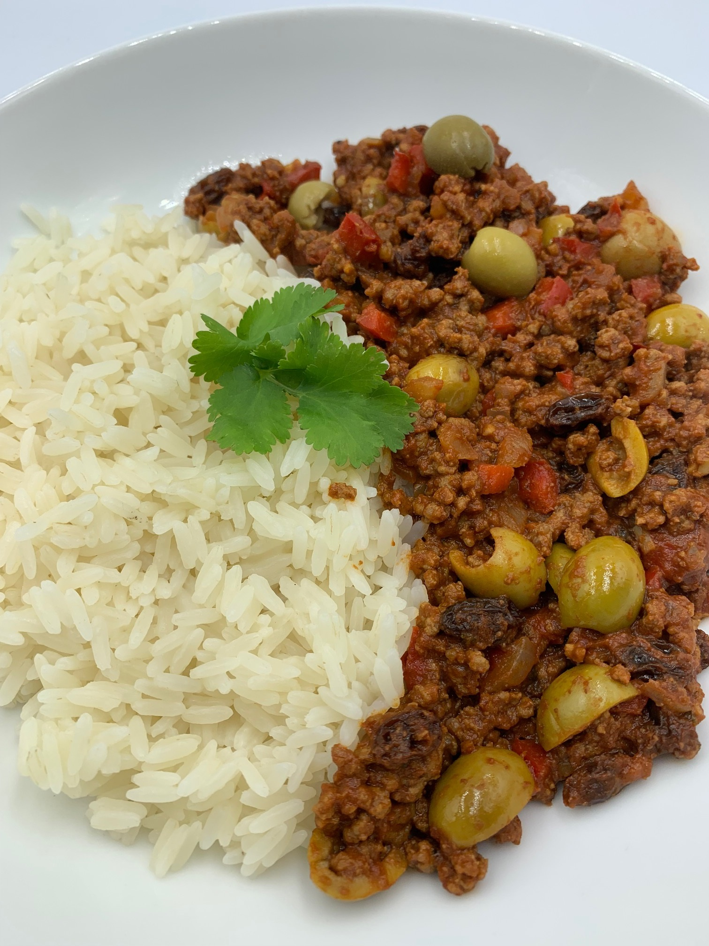
1 small onion
½ red onion
1 garlic clove
30g green pitted olives (optional)
250g lean beef mince
150ml pasatta
1 x 15ml spoon tomato purée
½ x 5ml spoon oregano
½ x 5ml spoon paprika
¼ x 5ml spoon cumin
50g raisins
Black pepper

Optional - garnish
25g parsley

Equipment
Chopping board, vegetable knife, garlic press, large saucepan with lid, mixing spoons, measuring spoons.

Method
- Prepare the ingredients:
  - peel and finely dice the onion;
  - deseed and finely dice the pepper;
  - peel and finely chop or crush the garlic;
  - halve the olives, if using;
  - roughly chop the parsley, if using.
- Add the mince, onion, pepper and garlic to the saucepan and gently fry until the mince is browned.
- Add the pasatta, tomato puree, raisins, oregano, paprika, cumin to the pan. Stir well. Add the olives if using.
- Season with black pepper.
- Cover with a lid and simmer for 15-20 minutes, until the sauce is reduced. Stir occasionally.
- Serve with boiled rice or as a filling for tacos, empanadas or stuffed peppers.

Top tips
- All purpose or sazon seasoning can be used as an alternative to the individual spices.
- For a vegetarian or vegan dish, replace the beef mince with a plant-based mince. There is usually no need to brown a plant-based mince, so add at stage 3.
- Serve with sliced plantain fried in a little spray oil.

Food skills
- Weigh
- Measure
- Peel
- Cut
- Slice
- Dice
- Crush
- Fry
- Simmer
- Mix

Did you know?
Picadillo is a beef dish popular in many Latin American countries, including Mexico, Cuba, and Puerto Rico. The word picadillo comes from the Spanish picar, or “to mince,” and picadillo is typically made with minced beef.

Ingredients vary by region, but picadillo usually includes tomatoes (or tomato sauce), raisins, onion, and peppers.

Picadillo can be served as a main dish with white rice, black beans, and plantains, or as a filling for burritos, croquettes, and roasted peppers.

Sazon seasoning can be used as an alternative to the individual spices in the picadillo recipe. To make your own sazon seasoning, mix 1 x 15ml spoons of ground coriander, ground cumin, ground turmeric, garlic powder, 2 x 5ml spoons oregano and 1 x 5ml spoon each of salt and pepper.

