Meal planning and free sugars

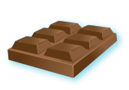



No more than 5% of the energy we consume should come from free sugars. The term free sugars relates to any sugar added to food or drink products by the manufacturer, cook or consumer including those naturally found in honey, syrups and unsweetened fruit juice.

Plan a week’s menu using what you have learned about reducing free sugars in the diet.

Explain your choices and highlight the foods and drinks that contain free sugars.

 | Breakfast | Lunch | Evening Meal | Snacks and drinks
Monday

Tuesday

Wednesday

Thursday

Friday

Saturday

Sunday

