Healthy lunch checklist
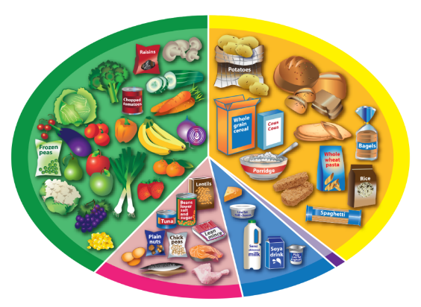
A healthy lunch should include foods from the four main Eatwell Guide food groups and a drink.

Use this checklist to help you plan a healthy lunch.

Sandwich:

- Bread

Choose wholemeal when you can! You could use sliced, wraps, rolls, pitta, gluten free.

- Spread

Reduced or low fat – you might not need spread if your sandwich filling is moist!

- A filling

For example, hummus, egg, tuna, cheese, ham, chicken.

- Fruit and vegetables

Add at least two types to your sandwich. For example, tomatoes, cucumber, peppers, sweetcorn, carrot, lettuce.

- Dressings

Low or reduced fat salad cream, mayonnaise, salad dressing. You don’t have to add these!

Other items:

- A drink
For example, water or milk.
- Extra fruit or vegetables
For example, carrot or pepper sticks, an apple, grapes.
- Diary or alternatives
For example, a yogurt, a cheese portion (or a dairy alternative fortified with calcium).

