Vegetable couscous salad
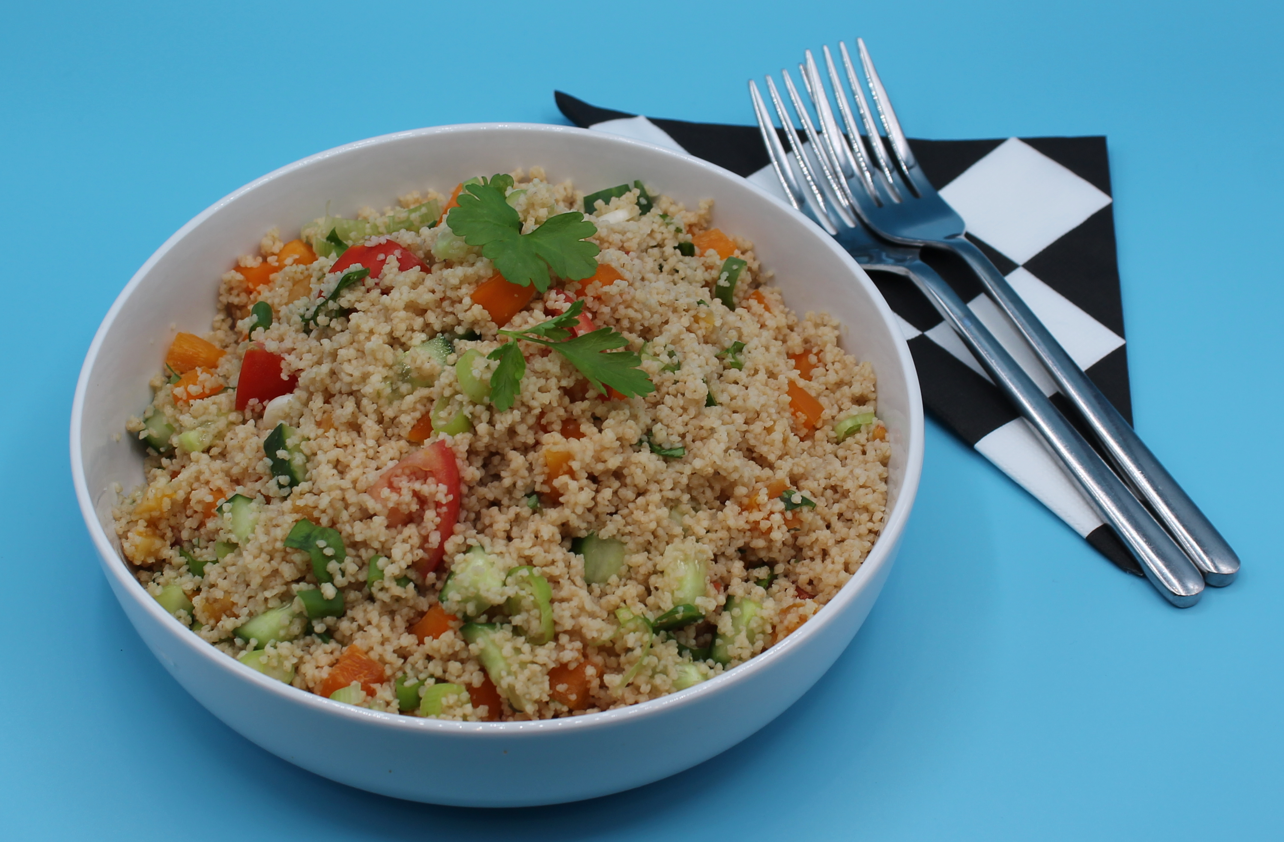

Complexity: low – medium

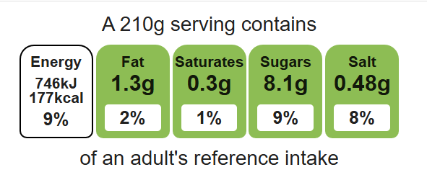

Ingredients (serves 1)
75ml boiling water

Equipment

Weighing scales

Kettle

Measuring jug

Fork

Large bowl

Chopping board

Sharp knife

Mixing spoon

Measuring spoons

½ reduced-salt vegetable stock cube
70g wholemeal couscous
1 tomato
1 spring onion
¼ cucumber
¼ pepper
2 dried apricots
1 x 15ml spoon parsley
1 x 15ml spoon low fat dressing

Method
- Make up the stock by dissolving the stock cube in the boiling water in the jug.
- Place the couscous in a large bowl and pour over the stock. Cover and leave for 2-3 minutes.
- Fluff with a fork and leave to stand for a further 5 minutes.
- Prepare the salad ingredients:
- chop the tomato;
- deseed and dice the pepper;
- dice the cucumber;
- slice the apricots;
- slice the spring onion into rings;
- chop the parsley.
- Add all the vegetables to the couscous and stir.
- Stir in the dressing.
Top tips
- Vary your protein: Try adding chickpeas, chopped cooked chicken, or tuna
- Reduce food waste: Use sweetcorn, peas, olives, mushrooms
- Turn up the flavour: Why not try dried cranberries or raisins?

Food skills
Weigh, measure, cut, chop, slice, dice and trim, mix, stir and combine

