Caramelisation

Learning
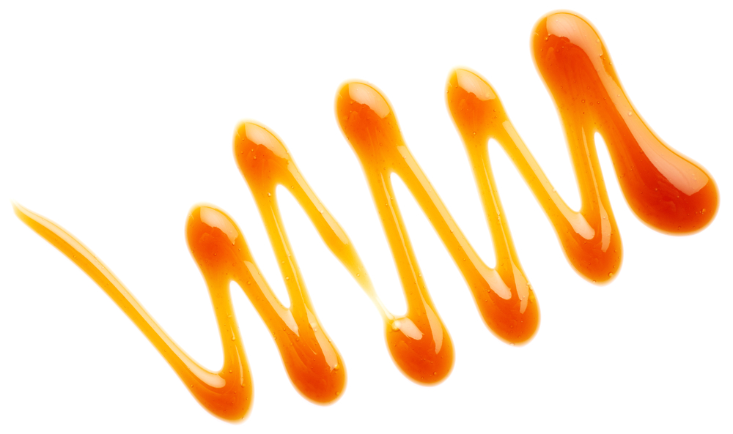
The aim of this session is to:
- demonstrate how sugars caramelise.

You will need:
- 200g white granulated sugar;
- 120ml water;
- 1-2g cream of tartar (optional);
- deep saucepan;
- baking parchment;
- long-handled spoon.

Instructions:
- Pour the sugar into the saucepan.
- Add 120ml of water (and 1-2g cream of tartar, if using), stir together.
- Bring the mixture to a boil, stirring to ensure all the sugar has dissolved.
- After five minutes, remove a small amount of the mixture with the long-handled spoon and carefully place it onto a corner of the baking parchment.
- Continue to boil the mixture and remove a small amount every 5 minutes.
- Eventually, the mixture will turn a golden-amber colour and give off a ‘caramel’ aroma. Remove the pan from the heat and take one last sample.
- Allow the samples to cool.
- Observe the differences in the fully cooled samples, comparing hardness, colour and taste (if appropriate).

Questions
Think about these questions after you have completed the experiment:
- Describe the differences between the cooled samples removed at each time point. Are they hard or soft? Are they colourless or coloured?
- Why does it take time for the sugar to become caramel?
- What needs to be removed by boiling to make this happen?
- Take a look at the different samples. Can you see how different confectionery could be made by removing samples at different stages?

