Savoury pancakes

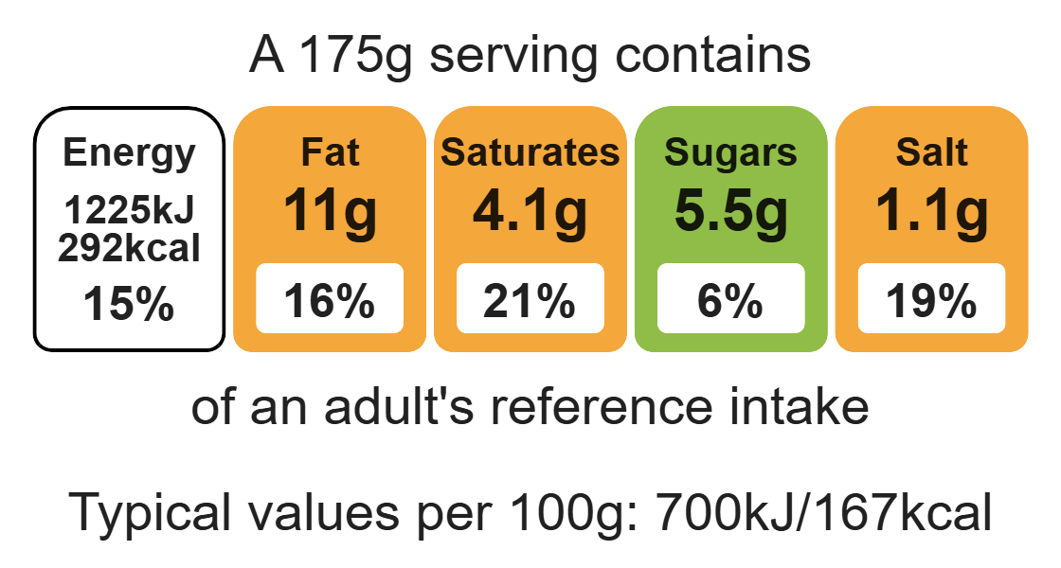
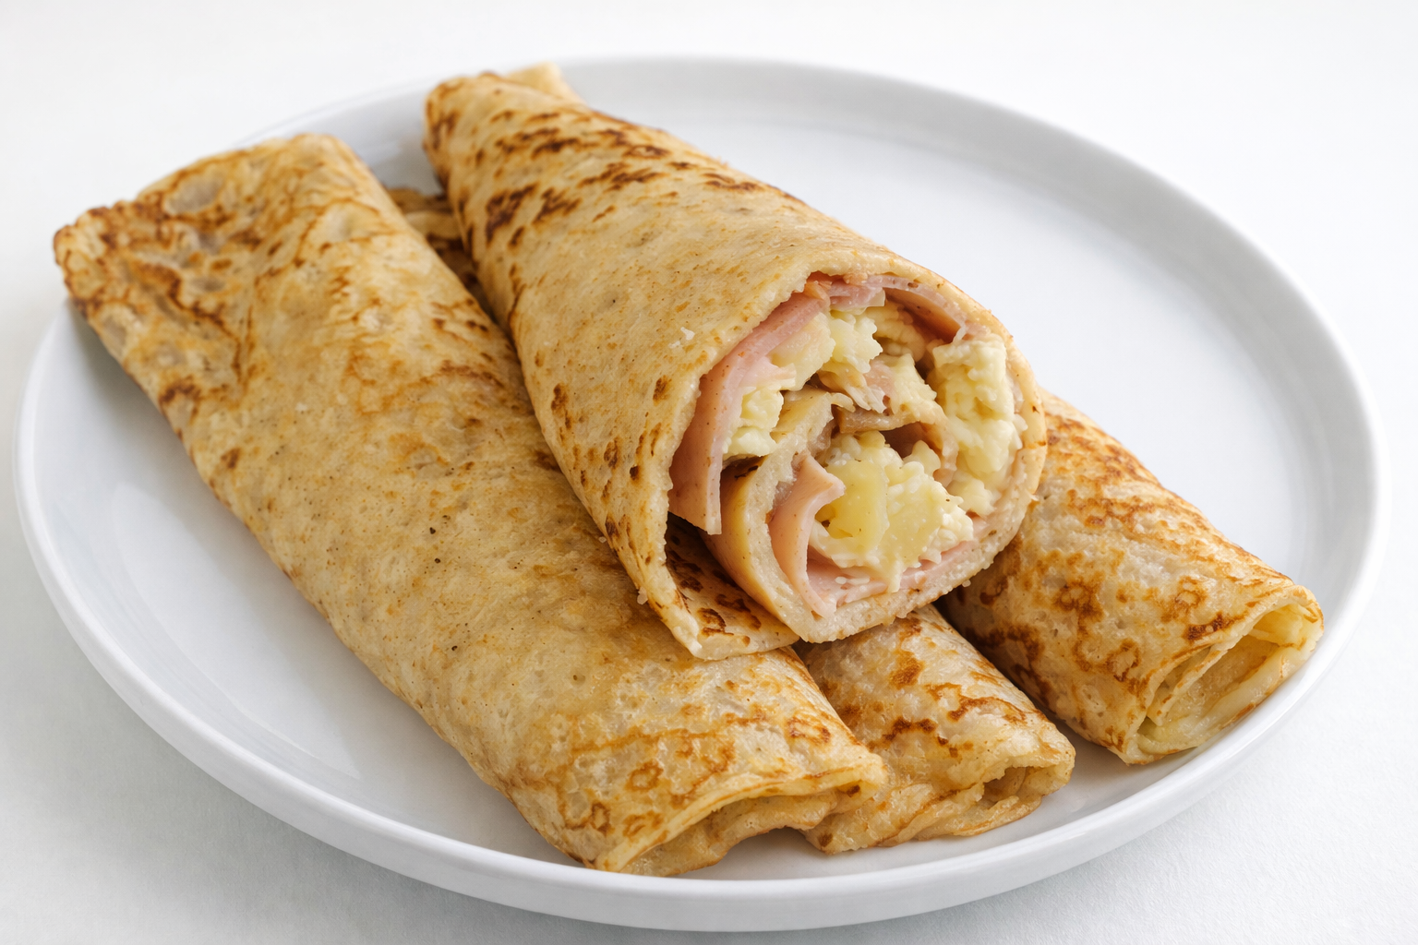
Complexity: low - medium

Ingredients (makes 4)
100g white plain flour
25g wholemeal plain flour

Equipment

Weighing scales

Equipment

Chopping board

Grater

Sieve

Mixing bowl

Small bowl

Fork

Mixing spoon

Measuring jug

Frying pan

Fish slice

Measuring spoons

Metal spoon

2 eggs
275 ml semi-skimmed milk
Pinch paprika powder
Spray oil for frying
6 slices of ham
60g canned pineapple pieces
60g reduced-fat cheddar cheese

Method
- Grate the cheese.
- Sift the flours and paprika into the mixing bowl.
- Break the eggs into the separate bowl and beat with the fork.
- Make a well in the flour and add the eggs mixing with the wooden spoon.
- Gradually add the milk, mixing well to remove any lumps.
- Pour the mixture into the measuring jug.
- Add a little spray oil to a frying pan on a medium heat.
- Pour three 15ml spoons of the mixture in the centre of the frying pan.
- Cook until bubbles appear on the surface and then turn using the fish slice.
- Cook the underside of the pancake for one minute or until golden brown.
- Grate the cheese and drain the pineapple.
- Roll up pancakes with the ham, pineapple and cheese.

Top tips
- Focus on fibre: Use 125g of wholemeal flour to boost the fibre content of the dish.
- Turn up the flavour: Different herbs, spices or fillings can be added to the pancake recipe for a different taste.

Food skills
Weigh, measure, grate, sift, beat, mix, stir and combine fry and sauté.

