Understanding the labelling of your egg

There are a number of food assurance schemes in the UK, and the British Lion Quality mark recognises eggs that have been produced to the highest standards of food safety. This includes vaccinating the hens against Salmonella Enteritidis and Salmonella Typhimurium both of which cause food poisoning.

Most eggs produced in the UK are now produced to British Lion standards.
British Lion Quality mark
Producer identity
A unique code denoting where the egg was produced

Best before date

Method of production
0 = Organic 1 = Free Range 2 = Barn 3 = Caged

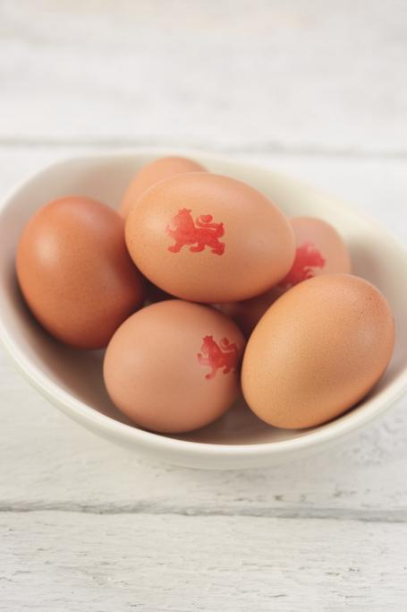

Information that you will find on British Lion Quality mark eggs:
Eggs are now sold in four different sizes: small, medium, large, and very large.
You may come across an older recipe that asks for an egg in size 0 – 7. The chart below shows the equivalent sizes.
Activity:
Use the internet to research either egg nutrition or egg safety.
Show your results in a creative way – why not design a poster, cartoon or a storyboard?

Weight | New size | Old size
73g and over | Very large | Size 0  Size 1
63 – 73g | Large | Size 1  Size 2  Size 3
53 – 63g | Medium | Size 3  Size 4  Size 5
53g and under | Small | Size 5  Size 6  Size 7

Activity:
Use the internet to research either egg nutrition or egg safety. Show your results in a creative way – why not design a poster, cartoon or a storyboard?

Activity:
Use the internet to research either egg nutrition or egg safety. Show your results in a creative way – why not design a poster, cartoon or a storyboard?

Weight | New size | Old size
73g and over | Very large | Size 0  Size 1
63 – 73g | Large | Size 1  Size 2  Size 3
53 – 63g | Medium | Size 3  Size 4  Size 5
53g and under | Small | Size 5  Size 6  Size 7

