The digestive system
Do you know the body parts involved in the digestion process?

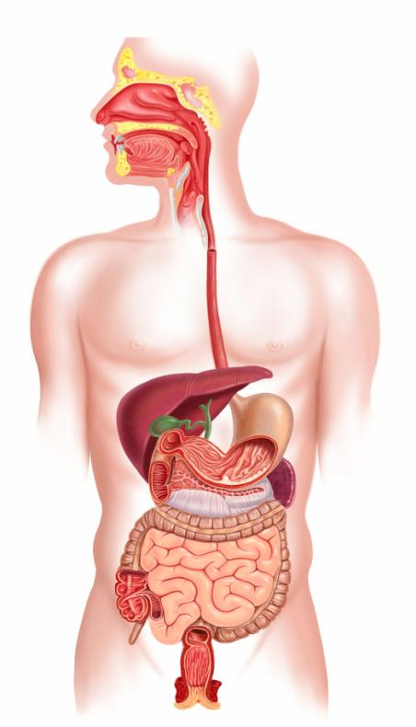
Draw lines onto the diagram and label the parts of the digestive system.

